CSSA STAGE 1 JUNIOR #14 NAME ___________________________________

The Family of Israel in Egypt

Multiple Choice: Circle ALL the Correct Answers!

1. Judah and his brothers brought these as a present to Joseph in Egypt:
a) myrrh b) pistachio nuts c) honey d) almonds

2. Judah convinced Jacob to let Benjamin go by offering:
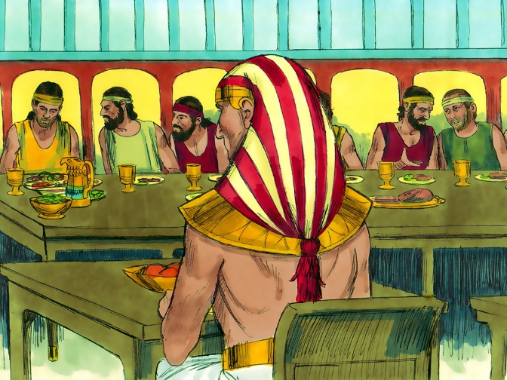
a) to kill his children if anything happened to Benjamin
b) to pay Jacob for the loss
c) to be surety for Benjamin
d) to bear the blame forever if anything bad were to happen to Benjamin

3. Joseph told his brothers they would dine with him:
a) in the evening
b) at noon
c) every day
d) once they had paid Joseph back

4. Joseph’s steward brought them to Joseph’s house and:
a) gave them water
b) washed their feet
c) gave their animals fodder
d) took their present to Joseph

5. Joseph commanded his steward to:
a) fill the brothers grain sacks b) put Benjamin’s money in his sack
c) put the silver cup in Judah’s sack d) put all the brothers in prison

True or False

_____ 6. Joseph’s brothers originally thought they were going to be made into slaves.

_____ 7. Joseph seated his brothers at the table in order of birth.

_____ 8. Benjamin was given twice as big of a portion.

_____ 9. Joseph had to leave his brothers presence to weep the first time Benjamin was brought to him.

_____10. Joseph recognized that God was working in all events of their life for good.

Short Answer

11. What did Joseph say when he made himself known to his brethren? ____________________

__________________________________________________________________________

__________________________________________________________________________

12. How did Joseph’s brother feel when he told them who he was? ________________________

__________________________________________________________________________

13. Joseph was not angry with his brothers for what they had done with him. Why? ___________

__________________________________________________________________________

14. What was Joseph’s last message about his bones? How does this show his faith?

___________________________________________________________________________

___________________________________________________________________________

___________________________________________________________________________

___________________________________________________________________________

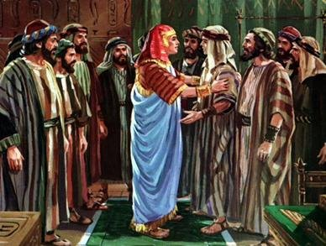
Who Said It

15. “With whomsoever of thy servants it be found, both let him die, and we also will be my lord's bondmen.” __________________________

16. “For how shall I go up to my father, and the lad be not with me? lest peradventure I see the evil that shall come on my father.”__________________

17. “Also regard not your stuff; for the good of all the land of Egypt is your's.”_______________

Thought Question

18. List as many ways as you can of how Joseph making himself known to his brothers points forward to the second coming of Jesus Christ ? _____________________________________

___________________________________________________________________________

___________________________________________________________________________

___________________________________________________________________________

