MANITOULIN MAIN CAMP 2016
Worksheet For Lesson 1

Facts about Saul / Paul

Saul was born in the city of __________________________

Saul was a JEW or GENTILE (circle the right one)

Saul was part of the tribe of __________________________________

Saul’s job … taught the trade of ___________________________________

What does persecute mean?

Jesus said unto Ananias,

“Go thy way: for he (Saul) is a chosen vessel unto me, to bear my name before the Gentiles, and kings, and the children of Israel.” Acts 9v15
MANITOULIN MAIN CAMP 2016
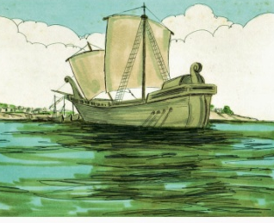
Worksheet For Lesson 5

Paul encouraged the people on the ship with these words:

Be of good ___________, for no one will lose his _________; but we will lose the _________. For the _________of God stood by me this night and said, ‘Fear not ______, thou must be brought before ___________: and lo, God hath given thee all of them that sail with you. Paraphrase of Acts 27v22-24

Who did Paul have complete trust in? ________________

What island did Paul and the prisoners swim to when their ship
became shipwrecked? The island of _______________________

How long did Paul and the prisoners stay on the island of Melita?
______________________________

What one question would you like to ask Paul in the Kingdom?
________________________________________________________________

________________________________________________________________
“… for the hope of Israel
I am bound with this chain.”
Acts 28v20

