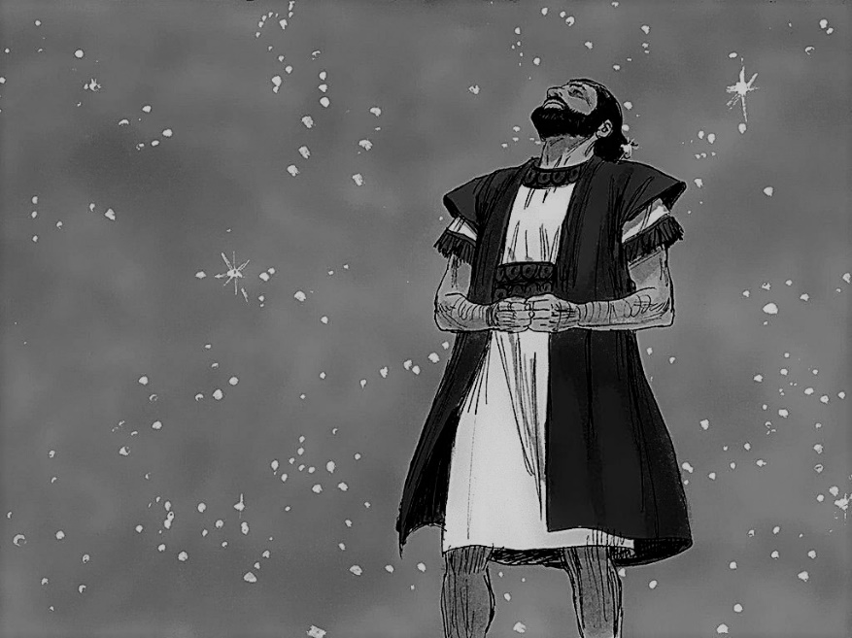
Abraham

By:_________________

Now the LORD had said to Abram: Get out of your country, from your family And from your father’s house, to a land that I will show you… So Abram departed as the LORD had spoken to him. – Genesis 12:1,2,4

Remember Lot’s wife! – Luke 17:32

“Look now toward heaven, and count the stars if you are able to number them.” And God said to Abram, “So shall your descendants be.” – Genesis 15:5

Is anything too hard for the LORD? At the appointed time I will return to you, according to the time of life, and Sarah shall have a son. – Genesis 18:14

My son, God will provide for Himself the lamb for a burnt offering. – Genesis 22:8

