CSSA STAGE 1 JUNIOR #1 NAME ___________________________________

The Bible: God’s Message to Man

Multiple Choice: Circle ALL the Correct Answers!
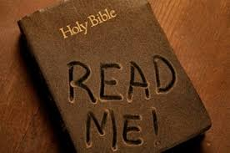
1. The Bible tells us:
a) what we need to know about God b) the future
c) how the world will end d) the past

2. The New Testament:
a) was written during the first 100 years after Jesus was born
b) has 39 books in it
c) tells about Esther
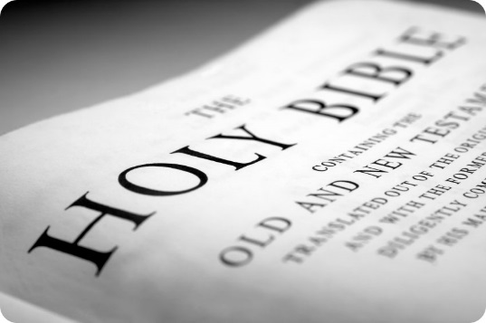
d) ends with Malachi

3. The Bible teaches:
a) God will punish the wicked
b) the Holy Spirit is God’s power
c) angels can die
d) believers will be raised
e) sinners must repent

4. The first thing Jesus will do when he returns is:
a) reign in Jerusalem for 1,000 years b) destroy the wicked
c) raise the responsible dead d) teach the world God’s righteous ways

Short Answer

5. List three prophecies that prove Jesus will return to the earth very soon.
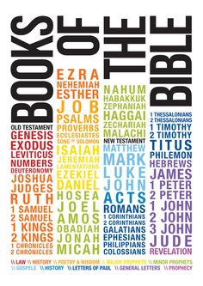
- ________________________________________________

________________________________________________

________________________________________________

- ________________________________________________

________________________________________________

________________________________________________

- ________________________________________________

________________________________________________

________________________________________________

True or False

_____ 6. The word “holy” means praise.
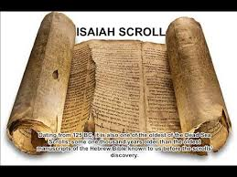
_____ 7. The Old Testament has 27 books.

_____ 8. God is the author of the bible.

_____ 9. The last book of the Old Testament is Zedekiah.

_____10. The Bible was written over a period of about 1,600 years.

_____11. Moses began to write the first 5 books about 1,500 years before Christ was born.

Fill in the Blank

12. The word “Bible” means ________________________________________________.

13. The Bible was written by men of God who spoke God’s thoughts by the power of the

____________________ _________________________.

14. God’s purpose is to fill the earth with His _________________________.

15. “The more we read the Bible, the more we will _______________________ God and try to

____________________ Him.”

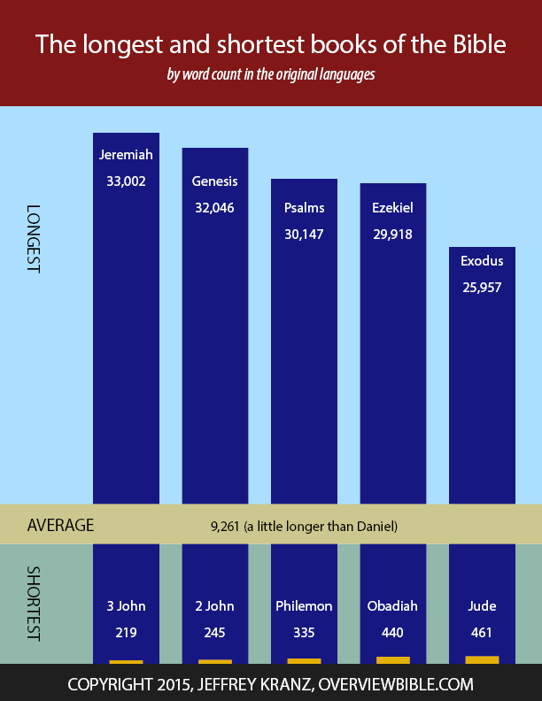
Thought Questions

16. How does reading about faithful men and women in the Bible help us?

__________________________________________________

__________________________________________________

__________________________________________________

17. How often should we read the bible?

__________________________________________________

