CSSA STAGE 1 JUNIOR #2 NAME ___________________________________

Creation

Short Answer

1. What Bible verse says God finished the creation in six literal days? ______________________

___________________________________________________________________________

2. What does God mean when He says He will fill the earth with his glory? __________________

____________________________________________________
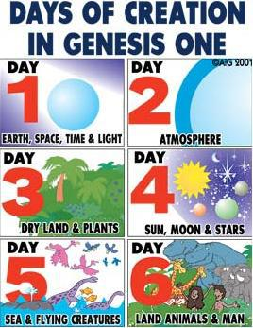
3. What Bible verse proves that Jesus believed that God is the Creator of all things?
____________________________________________________

4. What does the theory of evolution say about the beginning of life?

____________________________________________________

_____________________________________________________

5. How can we thank God for all that He has done for us?

____________________________________________________

____________________________________________________

Fill in the Blank

6. David said: “I am_______________________ and _________________________ made.”

7. God spoke and the _______________________ did the creating.

8. Genesis means ___________________________________________________________.

9. Woman means ____________________________________________________________.

10. Evolved means ____________________________________________________________.

Long Answer (on additional paper please)

11. Why have men developed another theory about how life began?
- How are men and women different from the animals and why did God make them like this?

