CSSA STAGE 1 JUNIOR #2 NAME ___________________________________

Creation

Multiple Choice: Circle ALL the Correct Answers!

1. Six thousand years ago is the same as:
a) 1,000 BC b) 2,000 BC
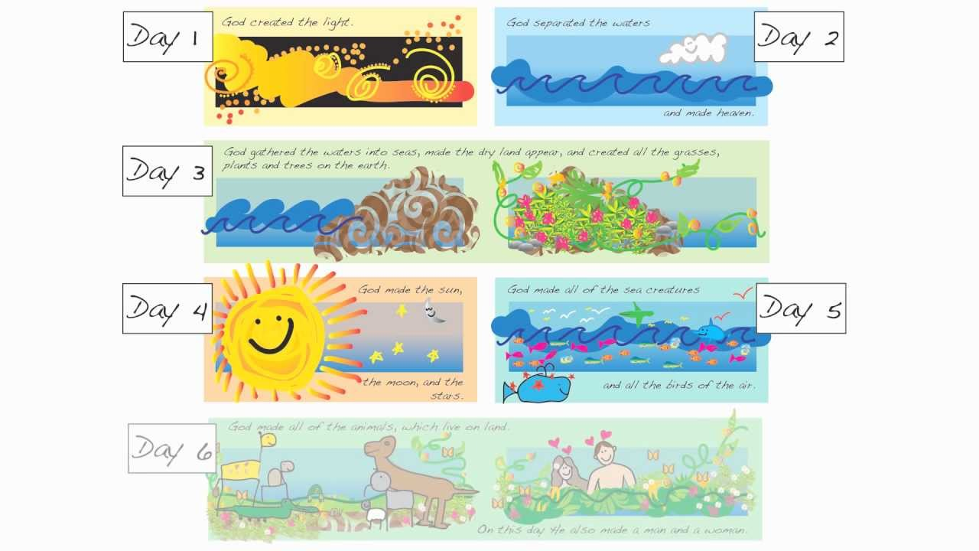
c) 3,000 BC d) 4,000 BC

2. The earth was “without form and void” means it was:
a) black
b) empty
c) waste
d) dark

3. God rested on the 7th day because he was:
a) tired
b) out of ideas
c) finished
d) waiting for help

4. Eve was created because Adam:
a) had too many ribs b) was lonely
c) couldn’t cook his meals d) hated animals

Short Answer

5. What Bible verse says God finished the creation in six literal days? ______________________

6. What does God mean when He says He will fill the earth with his glory? __________________

____________________________________________________
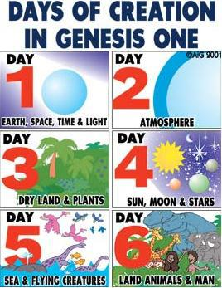
7. What Bible verse proves that Jesus believed that God is the Creator of all things?
____________________________________________________

8. What does the theory of evolution say about the beginning of life?

____________________________________________________

____________________________________________________

9. How can we thank God for all that He has done for us?

____________________________________________________

____________________________________________________
Matching
- Dry Land and Plants

- Sea Creatures and Birds

- Light and Day

- Rested or Finished

- Land Creatures and Man

- Air or Atmosphere

- Sun, Moon and Stars positioned in sky
10. Day 1 _____

11. Day 2 _____

12. Day 3 _____

13. Day 4 _____

14. Day 5 _____

15. Day 6 _____

16. Day 7 _____

Fill in the Blank

12. David said: “I am_______________________ and _________________________ made.”

13. God spoke and the _______________________ did the creating.

14. Genesis means ___________________________________________________________.

15. Woman means ____________________________________________________________.

16. Evolved means ____________________________________________________________.

Read Genesis Chapter 1

5. How many verses are in Genesis 1?______________________

6. How many times does it say, “God saw that it was good”? __________

7. What phrase indicates that each day was a 24-hour period? ____________________________

____________________________________________________________________________
