CSSA STAGE 1 JUNIOR #3 NAME ___________________________________

Disobedience in the Garden of Eden

Fill in the Blank

- The two special trees planted in the midst of the garden of Eden were the tree of __________

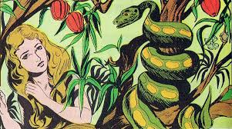
and the tree of the ________________________

of ____________ and ____________.

- Because Adam and Eve sinned, man became a

____________ _________________ creature.

- When a person is baptized, the Bible speaks of

that person ____________________ on Christ.
(Galatians 3v27)

- God drove Adam and Eve from the garden and placed cherubim there to _________________
the way to the tree of life.

- The serpents’ seed will _______________ his (Jesus’) __________________.

- The woman’s seed (Jesus) will _______________ the __________________ of the serpent.

True or False

_____ 7. Adam and Eve were not allowed to eat of the tree of the knowledge of good and evil, but they could touch it.

_____ 8. Disobedience of God’s law is sin, and the wages of sin is death.

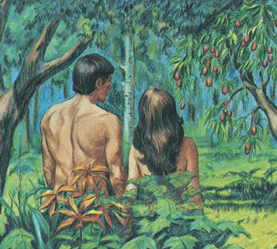
_____ 9. The serpent had no understanding of right and wrong.

_____ 10. Because Adam sinned, he would be ruled over by his wife.

_____ 11. Eve saw the fruit was good for food and it had magical powers.

_____ 12. Jesus bruised the head of the serpent, killing it.

_____ 13. The seed of the serpent are all those who do not know or follow God’s ways.

_____ 14. Adam and Eve died the day they ate the fruit.

Short Answer

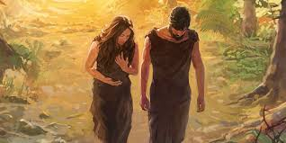
15. Was Adam deceived by Eve the same way Eve was deceived by the serpent? Explain your answer!
____________________________________________

____________________________________________

____________________________________________

16. If the serpent had no understanding or right and wrong, why was he punished?

____________________________________________

____________________________________________

____________________________________________

17. What lesson did Adam and Eve learn from the animal skin coats God gave them? __________

___________________________________________________________________________

____________________________________________________________________________

18. What does the Bible mean when it speaks of people “putting on Christ”? __________________

___________________________________________________________________________

___________________________________________________________________________

19. How could Eve have kept herself from sinning?
___________________________________________________________________________

___________________________________________________________________________

Bible Marking

20. Color Places Orange (2:8; 2:9; 2:10; 2:15; 3:8; 3:23; 3:24)

21. Color Time Green (3:8)

Project Book

22. Complete Page 1 of your Project Book.

