CSSA STAGE 1 JUNIOR #3 NAME ___________________________________

Disobedience in the Garden of Eden

Fill in the Blank

- The two special trees planted in the midst of the garden of Eden were the tree of __________

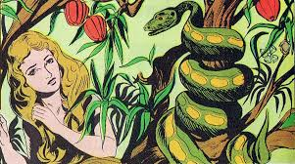
and the tree of the ________________________

of ____________ and ____________.

- Because Adam and Eve sinned, man became a

____________ _________________ creature.

- When a person is baptized, the Bible speaks of

that person ____________________ on Christ.
(Galatians 3v27)

- God drove Adam and Eve from the garden and placed cherubim there to _________________
the way to the tree of life.

- The serpents’ seed will _______________ his (Jesus’) __________________.

- The woman’s seed (Jesus) will _______________ the __________________ of the serpent.

True or False

_____ 7. Adam and Eve were not allowed to eat of the tree of the knowledge of good and evil, but they could touch it.

_____ 8. Disobedience of God’s law is sin, and the wages of sin is death.

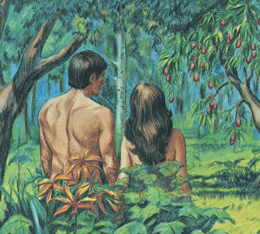
_____ 9. The serpent had no understanding of right and wrong.

_____ 10. Because Adam sinned, he would be ruled over by his wife.

_____ 11. Eve saw the fruit was good for food and it had magical powers.

_____ 12. Jesus bruised the head of the serpent, killing it.

_____ 13. The seed of the serpent are all those who do not know or follow God’s ways.

_____ 14. Adam and Eve died the day they ate the fruit.

Short Answer

15. Why did God allow the serpent to tempt Adam and Eve?

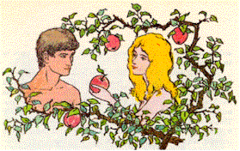
____________________________________________

____________________________________________

____________________________________________

16. Was Adam deceived by Eve the same way Eve was deceived by the serpent? Explain your answer!

____________________________________________

____________________________________________

____________________________________________

17. If the serpent had no understanding or right and wrong, why was he punished? ____________

___________________________________________________________________________

18. What lesson did Adam and Eve learn from the animal skin coats God gave them? __________
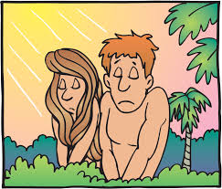
____________________________________________

____________________________________________

19. What does the Bible mean when it speaks of people “putting on Christ”?
____________________________________________

____________________________________________

20. How could Eve have kept herself from sinning?

____________________________________________

____________________________________________

21. How did Jesus bruise the head (kill) the serpent? ___________________________________

___________________________________________________________________________

___________________________________________________________________________

