CSSA STAGE 1 JUNIOR #4 NAME ___________________________________

Cain and Abel

Bible Search

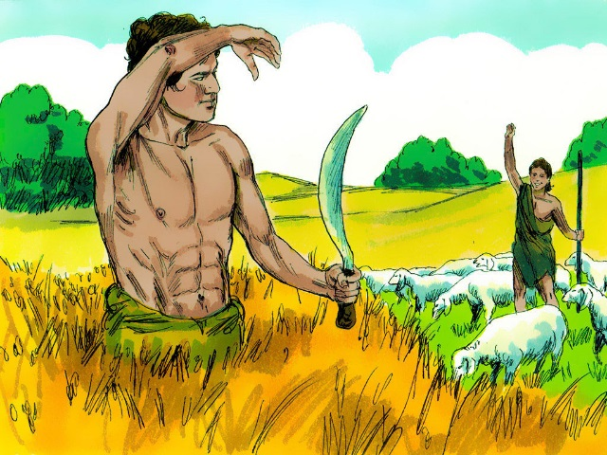
1. What does the name Cain mean?

___________________________________________

___________________________________________

2. Read Genesis 3v15. Why do you think Eve named her first child Cain? (hint: Who did she think he might be?)

___________________________________________

___________________________________________

___________________________________________

3. Where does the Bible say, “by faith Abel offered to God a more excellent sacrifice than Cain”?

___________________________________________________________________________

4. What verse in the New Testament tells us why Cain murdered his brother? (hint: Look up Cain in a concordance or use a computer bible?)

___________________________________________________________________________

Thought Questions

5. What makes worship acceptable to God?

_______________________________________________________________________________

_______________________________________________________________________________

_______________________________________________________________________________

6. Why did God accept Abel’s sacrifice and reject the offering of Cain?

_______________________________________________________________________________

_______________________________________________________________________________

_______________________________________________________________________________

_______________________________________________________________________________

7. Describe what kind of attitude we should show when we know we have sinned.
_________________________________________________________________________________________

_________________________________________________________________________________________

_________________________________________________________________________________________

8. The attitude of Cain was, at a later time, repeated in the attitude of the Jews during the time of the Lord Jesus Christ. Use the chart and verses below to identify some ways.

Cain & Abel | The Jews in the time of the Lord Jesus Christ
- Jealousy and hatred Cain showed Abel  - Cain’s hatred turned to thoughts of murder  - Cain’s punishment was to be a vagabond and a wanderer in the earth.  - God set a protective mark on Cain that no man should kill him. | - Psalm 69:4, John 5:16-18  ___________________________________________________  ___________________________________________________  ___________________________________________________  ___________________________________________________  - John 7:1; John 8:39-45; John 10:31; John 11:8, 53  ___________________________________________________  ___________________________________________________  ___________________________________________________  ___________________________________________________  - Ezekiel 36:17-20, Deut. 28: 45-50, 64-66  ___________________________________________________  ___________________________________________________  ___________________________________________________  ___________________________________________________  - Genesis 12:3____________________________________  ___________________________________________________  ___________________________________________________

