CSSA STAGE 1 JUNIOR #4 NAME ___________________________________

Cain and Abel

Multiple Choice: Circle ALL the Correct Answers!

1. Cain was:
a) humble b) a farmer
c) righteous d) ungodly

2. Abel was:
a) killed
b) righteous
c) a shepherd
d) Godly

3. Cain was punished and:
a) sent away to the land of Oz
b) sent away from his home and God
c) became a lawyer
d) later forgiven

4. Cain had:
a) a son named Seth b) a mark by God
c) wicked children d) righteous children

5. Seth’s descendants were:
a) known as the sons of men b) followers of God
c) known as the sons of God d) not followers of God

True or False

_____ 6. Cain’s jealousy turned to hatred and ended with the murder of his brother.

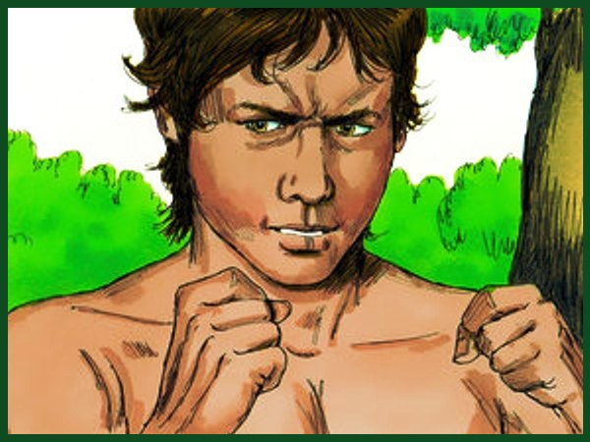
_____ 7. God would not forgive Cain for offering what he had grown.

_____ 8. Cain was sorry when he said his punishment was greater than he could bear.

_____ 9. Cain lied to God.

_____ 10. God appointed Seth to take Cain’s place.

_____ 11. As long as we have the desire to worship God, we can worship Him any way we want to.

Bible Search

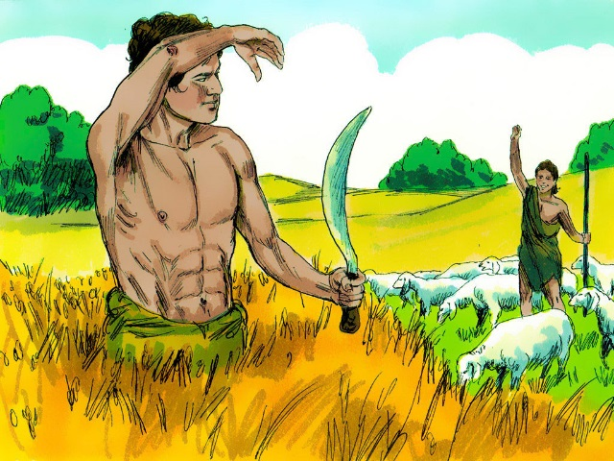
12. What does the name Cain mean?

___________________________________________

___________________________________________

13. Read Genesis 3v15. Why do you think Eve named her first child Cain? (hint: Who did she think he might be?)

___________________________________________

___________________________________________

___________________________________________

14. Where does the Bible say, “by faith Abel offered to God a more excellent sacrifice than Cain”?

___________________________________________________________________________

15. What verse in the New Testament tells us why Cain murdered his brother? (hint: Look up Cain in a concordance or use a computer bible?)

___________________________________________________________________________

Thought Questions

16. What makes worship acceptable to God? (hint: remember Cain did it his own way!)

_________________________________________________

_________________________________________________

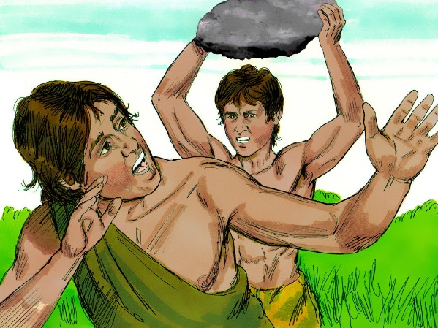
17. Why did God accept Abel’s sacrifice and reject the offering of Cain? (hint: Adam would have told Cain and Abel how God killed an animal to provide Adam and Eve with animal skin coverings and the forgiveness of their sins.)

____________________________________________

____________________________________________

18. Compare the descendants of Seth with the descendants of Cain.
___________________________________________________________________________

___________________________________________________________________________

19. Can you think of three ways Abel was like Jesus?

- ________________________________________________________________________

- ________________________________________________________________________

- ________________________________________________________________________

