CSSA STAGE 1 JUNIOR #5 NAME ___________________________________

The Story of the Flood

Matching

1. _____ Seth’s descendants
- 1,656 years

- 120 years

- Sons of men

- Our ark of safety

- Were saved

- A symbol of baptism

- Sons of God

2. _____ Eight people

3. _____ Adam to Noah was

4. _____ Jesus is

5. _____ Cain’s descendants

6. _____ Noah preached

7. _____ The flood is

Short Answer

8. What is the first thing Noah did when he came out of the ark? ___________________________

____________________________________________________________________________

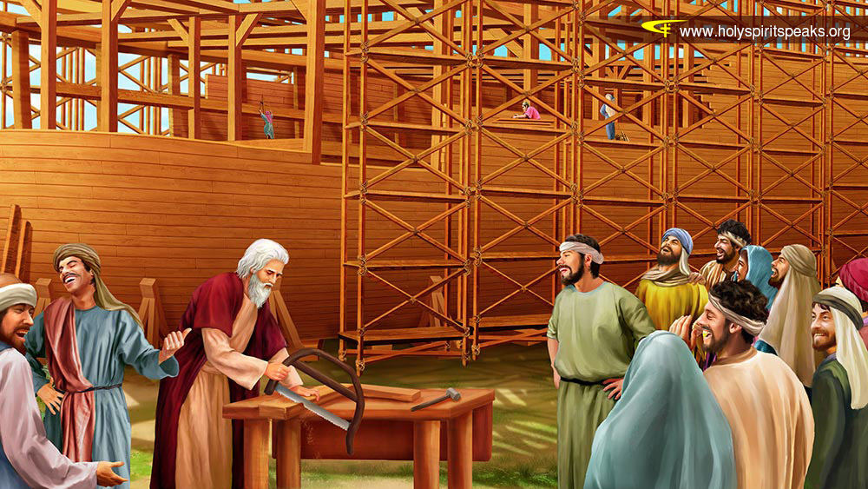
9. What is a covenant?

____________________________

____________________________

____________________________

10. When will the earth be filled with wickedness like it was in the days of Noah?
____________________________

____________________________

____________________________

11. How is the flood a symbol of baptism?

____________________________________________________________________________

____________________________________________________________________________

12. What does the flood teach us about God’s justice and mercy?

____________________________________________________________________________

____________________________________________________________________________
True or False
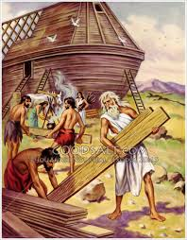
_____ 13. God gave the people an opportunity to repent while Noah built the ark.

_____ 14. Noah and his family were in the ark for 7 days before it rained for 50 days and nights.

_____ 15. Adam and Eve were in the ark just over 1 year.

_____ 16. The ark had 3 stories, 1 window and 1 door.

_____ 17. The people laughed at Noah while he built the ark.

_____ 18. God was sorry he had made man.

Bible Search

19. In what book of the New Testament is Noah called a “Preacher of Righteousness”?
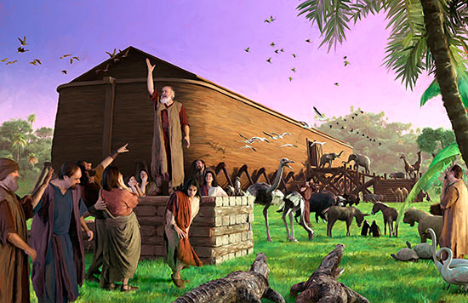
______________________________________

20. Noah took how many pairs of clean and unclean animals into the ark? (hint: Genesis 7)

______________________________________

______________________________________

21. Who shut the door of the ark”? _____________

22. What is the Hebrew word for “covenant”

______________________________________

What does this word mean? _____________________________________________________
