CSSA STAGE 1 JUNIOR #6 NAME ___________________________________

The Call of Abram

Multiple Choice: Circle ALL the Correct Answers!

1. Ur was:
a) full of moon worshippers b) a poor city
c) near Babylon d) a great place to serve God

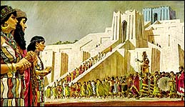
2. Abram built an altar in:
a) Ur
b) Shechem
c) Bethel
d) Haran

3. When Abram reached Canaan it was:
a) green and fertile
b) in a state of famine
c) the rainy season
d) very crowded

4. Abram left the comforts of Ur to:
a) live in a comfortable house b) live in tents
c) separate himself from idolatry and wickedness d) obey God

Fill in the Blank

5. A ziggurat is a ______________________ where people worship false gods.

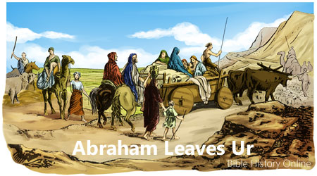
6. Abram the Hebrew means
___________________________

because he crossed over

the River ___________________

7. Abram crossed over the waters of the Euphrates and left the wickedness and idolatry of Ur behind. We do the same

thing when we are _______________.

8. Abram lived _____________________ the tower of Babel.

9. Abram had to go to ___________ because there was a severe famine in Canaan.

True or False

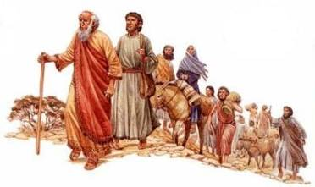
_____ 10. Abram’s parents taught him about the one true God.

_____ 11. God called Abram first out of Ur, then God called him out of Haran.

_____ 12. Abram took Sarah, Lot, Terah and his servants into Canaan.

_____ 13. Abram knew exactly where he was going.

_____ 14. Abram received the land God promised him.

Bible Search

15. What scripture states that Abram’s father, Terah, served other gods? ____________________

16. Name 4 things God promised Abraham in Genesis 12v2-4

- _________________________________________________________________________

- _________________________________________________________________________

- _________________________________________________________________________

- _________________________________________________________________________

Thought Questions

17. Name two ways we can be like Abram?

- _________________________________________________________________________

- _________________________________________________________________________

18. How can we become Abram’s descendants and share in the promises made to him?

___________________________________________________________________________

___________________________________________________________________________
