CSSA STAGE 1 JUNIOR #7 NAME ___________________________________

The Separation of Abram and Lot

Multiple Choice: Circle ALL the Correct Answers!

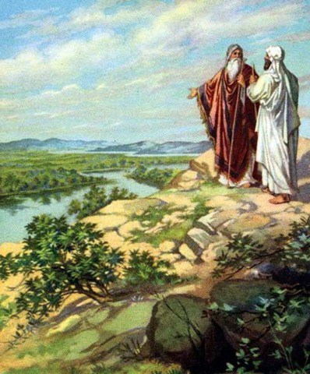
1. Abram and Lot separated because:
a) Lot was stealing Abram’s flocks
b) Abram & Lot didn’t like each other
c) they had too many animals to share the land
d) their herdsmen argued

2. Sarah gave Hagar to Abram as a wife because:
a) Hagar was very beautiful
b) Abram wanted Hagar
c) Sarah couldn’t have children
d) Abram didn’t love Sarah anymore

3. The promise to Abram:
a) meant he had to have a son
b) will be fulfilled when Jesus returns
c) can include us through baptism
d) was accomplished through Ishmael

Short Answer

4. Why was God please with Abram’s attitude and not with Lot’s? ________________________

___________________________________________________________________________

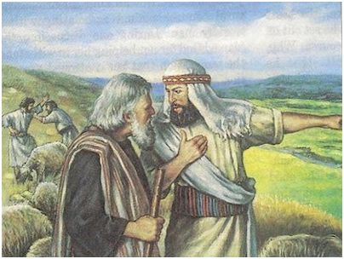
5. Why did Lot’s wife look back at Sodom as they ran from the city?

_______________________________________

_______________________________________

_______________________________________

6. Why must we keep separate from the pleasure and comfort of wicked surroundings?

_______________________________________

_______________________________________

_______________________________________

7. What does the name Abraham mean? ____________________________________________

True or False
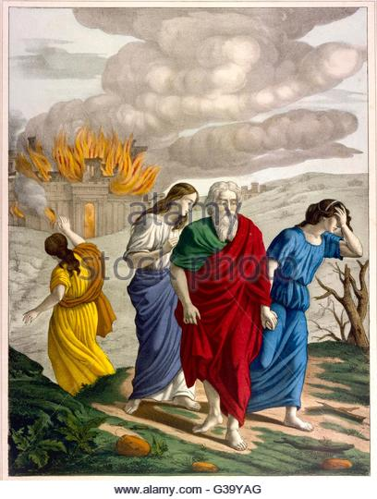
_____ 8. Abram was jealous of Lot’s increased herds and flocks.

_____ 9. Abram gave Lot first choice of the land.

_____ 10. Evil friends can turn us away from God.

_____ 11. Sodom was destroyed by a tornado.

Bible Search

12. How many people left Sodom with Lot and

lived? (Gen 19) ___________________________

13. How many people left Sodom that will be immortal at the

resurrection? (Gen 19, 2 Pet 2v7) __________

14. What does Luke 17v28-32 tell us about Lot’s day and our day? _________________________

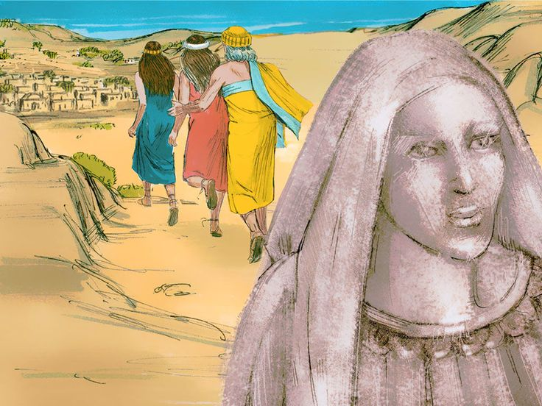
______________________________________

______________________________________

______________________________________

Thought Questions

15. Abram had been promised the land by God, yet Abram gave Lot the opportunity to live in whatever part of the land he wanted. Abram trusted God and was unselfish with his possessions. Give an example of how we could demonstrate trust in God and be unselfish with our possessions?

___________________________________________________________________________

___________________________________________________________________________

16. Lot chose the green pastures near Jordan because it looked good and easy. It cost him his family, servants, possessions and almost his life? What was his mistake? Give an example of how we could repeat Lot’s mistake if we are not careful.

___________________________________________________________________________

___________________________________________________________________________

17. Lot took his family to wicked Sodom. He continued to hate their evil ways but his family and servants became friendly with the people of Sodom and lost their lives. What was Lot’s mistake? Give an example of how we could repeat Lot’s mistake in our lives.

___________________________________________________________________________

__________________________________________________________________________

