CSSA STAGE 1 JUNIOR #10 NAME ___________________________________
Jacob and Esau
The Birthright & Blessing

Multiple Choice: Circle ALL the Correct Answers!

1. Before the twins were born, Rebekah was told:
a) they would be two nations b) one would be fat and the other skinny
c) the oldest would serve the youngest d) they would always get along

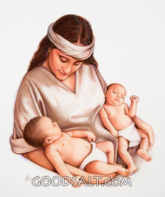
2. Esau was:
a) older than Jacob
b) a hunter
c) quick tempered
d) his dad’s favorite

3. Jacob was:
a) quiet and peaceful
b) upright
c) hairy
d) his mom’s favorite

4. Jacob deceived Isaac by:
a) covering his hairy skin b) lying
c) wearing Easu’s clothes d) playing tricks on him

5. Isaac blessed Esau by:
a) giving him back his birthright b) giving him the sword to live by
c) taking away Jacob’s blessing d) giving him a different blessing

True or False

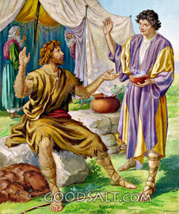
_____ 6. Esau was too busy enjoying life to be bothered with God.

_____ 7. The birthright meant the birth of the child went right.

_____ 8. Jacob received the birthright and the blessing.

_____ 9. Esau was sorry, repented and turned to God.

_____ 10. God was teaching Jacob that lying was wrong when he allowed Laban to deceive him.

_____ 11. Later, Jacob’s ten sons became the nation of Israel.

Fill in the Blank

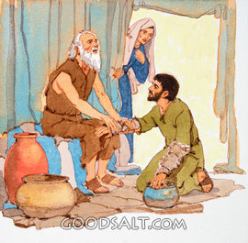
12. The birthright meant the firstborn received ___________
as many goods as his brothers.

13. Isaac wanted to bless Esau but ___________________ made sure Jacob received the blessing.

14. The name Jacob means _________________________

15. Esau ___________________ the women of Canaan.

16. Esau planned to __________ Jacob when his father Isaac died.

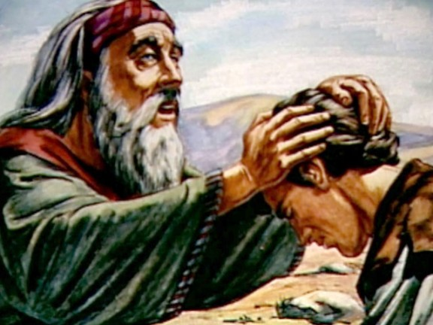
Bible Search

17. Which chapter in Genesis did God repeat the promises He made to Abraham to his son Isaac? _______

18. Which chapter in Genesis did Isaac pray that God would give Jacob the blessing?
________________________________________________

19. Which chapter in Hebrews is Esau described as a profane person?
________________________________________________

Short Answer

20. What does profane mean? ______________________________________________________

21. Why was Esau, Jacob’s favorite son?______________________________________________

___________________________________________________________________________

22. Why did Esau sell his birthright? _________________________________________________

23. Give two reasons why Jacob went to Haran?

- ________________________________________________________________________

- ________________________________________________________________________

Thought Questions

24. It was God’s will that Jacob should receive the promises. Do you think Isaac knew he was wrong to try to bless Esau? Why?

___________________________________________________________________________

25. Do you think Jacob and Rebekah were wrong to deceive Isaac? Why?

___________________________________________________________________________

