CSSA STAGE 1 JUNIOR #11 NAME ___________________________________

Jacob’s Journeys

Fill in the Blank

- At Bethel God repeated to Jacob the _____________________ given to Abraham and Isaac.

- Laban deceived Jacob and gave him _________ for his wife instead of ___________________.

- The name of Jacob’s sons were R_______________, S________________, L________,

J____________, D_____, N__________________, G______, I________________,

Z___________________, J________________ and B____________________ .

- Jacob was afraid of Esau and he knew he needed __________________ help.

- The ladder Jacob saw in his vision was a ladder of _______________________.

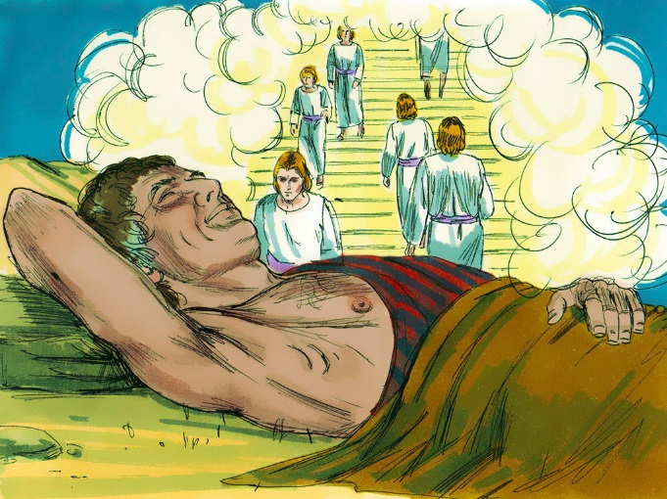
Matching
- Parched

- House of God

- Snorer

- Prince of God

- Heel-tripper

6. _____ Jacob

7. _____ Israel

8. _____ Bethel

9. _____ Haran

10. _____ Nahor

True or False

_____ 11. Eliezer took the same journey to Haran that Jacob was going to take.

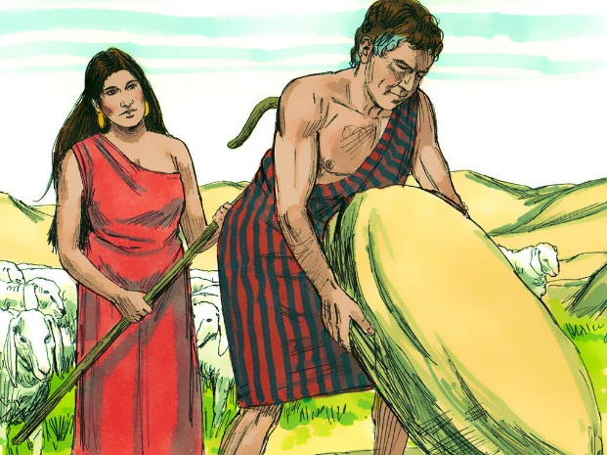
_____ 12. In Jacob’s dream, pigeons were on the ladder.

_____ 13. Jacob promised God a fifth of all his possessions.

_____ 14. Jacob met Rachel at a well.

_____ 15. Jacob ended up with 4 wives.

_____ 16. Jacob loved Rachel, Leah’s older sister, the best.

_____ 17. When Jacob met up again, Esau tried to kill him.
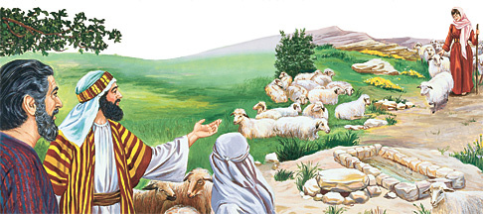
Short Answer

18. What direction did Jacob travel?__________

19. Give two reasons why Jacob left his home in Beersheba?
- _________________________________

_________________________________

- ________________________________________________________________________

20. Describe Jacob’s dream at Bethel. _______________________________________________

___________________________________________________________________________

21. What did the dream mean? _____________________________________________________

____________________________________________

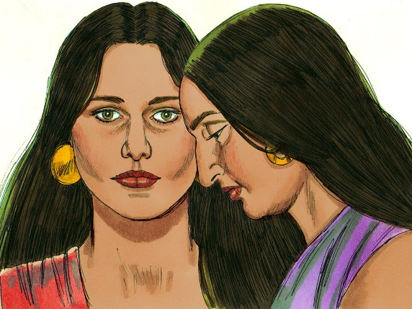
____________________________________________

22. What did Jacob promise to do at Bethel? ___________

____________________________________________

____________________________________________

23. Why did Jacob leave Haran? ____________________

____________________________________________

____________________________________________

24. Who are the ministers in Hebrews 1v14? __________________________________________

Thought Questions

25. Why did Jacob pour oil on the stone he slept on? ___________________________________

___________________________________________________________________________

26. What was God teaching Jacob when He allowed Laban to deceive him by giving him Leah?

___________________________________________________________________________

___________________________________________________________________________

27. Why would Laban want to harm Jacob? ___________________________________________

___________________________________________________________________________

28. Why did Jacob wrestle with the angel? ____________________________________________

___________________________________________________________________________

29. Why did the angel put Jacob’s hip out of joint so that he was lame? _____________________

___________________________________________________________________________

