CSSA STAGE 1 JUNIOR #8 NAME ___________________________________

Abraham Offers Isaac

Multiple Choice: Circle ALL the Correct Answers!

1. Abraham and Isaac climbed the mountain:
a) alone
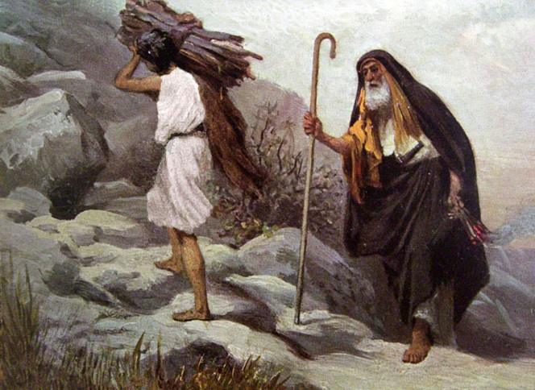
b) with Abraham’s two servants
c) with Isaac resisting
d) with Isaac carrying the wood

2. Abraham:
a) built an altar b) tied Isaac up
c) laid Isaac on the altar d) took out his knife

3. Abraham was stopped from killing Isaac by:
a) Isaac b) his servant
c) an angel d) none of these

4. Because Abraham was faithful, God promised to:
a) give him 4 more sons b) bless him
c) bring peace to the world d) multiply his descendants

Short Answer

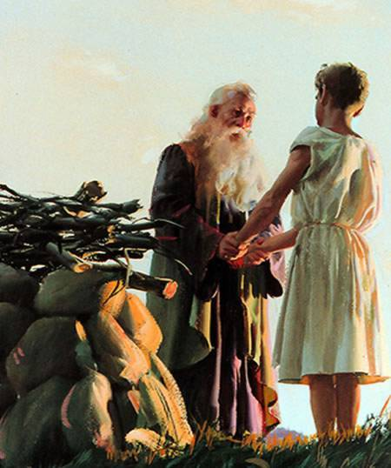
4. It took Abraham 3 days to get to the place he was supposed to offer Isaac. What are some of the other times in the Bible where the #3 is used about people? In what way are all these references related?
______________________________________________

______________________________________________

______________________________________________

5. What similarities can you find with Abraham offering Isaac and God offering Jesus? (hint: Isaac carried the wood, etc)

______________________________________________

______________________________________________

______________________________________________

6. Look up Hebrews 11v17-19. What does Paul say Abraham believed God would do if Abraham had actually killed Isaac?

__________________________________________________________________________

True or False

_____ 8. Abraham’s love for Isaac was greater than his love for God.
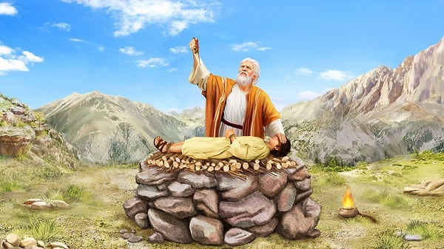
_____ 9. Isaac knew from the start that he was the offering.

_____ 10. Because Abraham was faithful God promised to give his seed power to conquer and rule his enemies.

_____ 11. What Abraham did in offering Isaac pointed forward to what God would do in offering His Son.

Bible Search

12. What verse tells us how old Abraham was when Isaac was born? (hint: Gen 17) ____________

13. What verse concerning the promises assured Abraham that God would raise Isaac to life again if he killed him? (hint: Gen 21) __________

14. What verse clearly indicates that Abraham expected Isaac to return with him? (hint: Gen 22)

_________________________

15. What verse tells us the name Abraham gave to the place where God provided the ram instead of Isaac? (hint: Gen 22) ____________

Thought Questions

15. How did Abraham demonstrate the principle: the love for man must never take the place of the love of God?

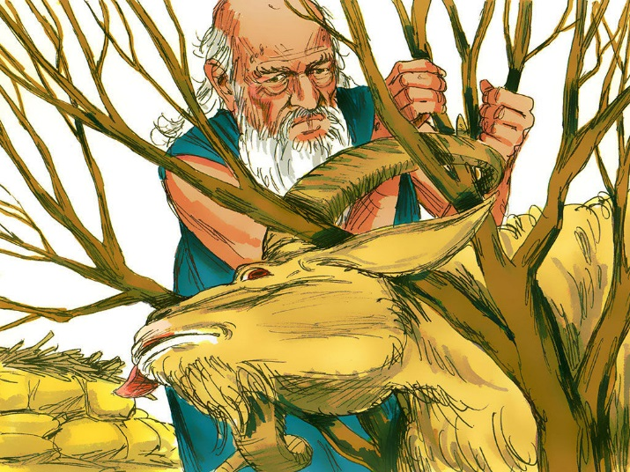
________________________________________

________________________________________

________________________________________

16. How can we demonstrate this in our lives?

________________________________________

________________________________________

________________________________________

17. How did Abraham demonstrate his faith in God’s promise when he was willing to kill Isaac?

__________________________________________________________________________

__________________________________________________________________________

