CSSA STAGE 1 JUNIOR #9 NAME ___________________________________

Choosing a Wife for Isaac

Multiple Choice: Circle ALL the Correct Answers!

1. Eliezer was:
a) Abraham’s servant b) told to find a wife for Isaac
c) stealing from Abraham d) faithful
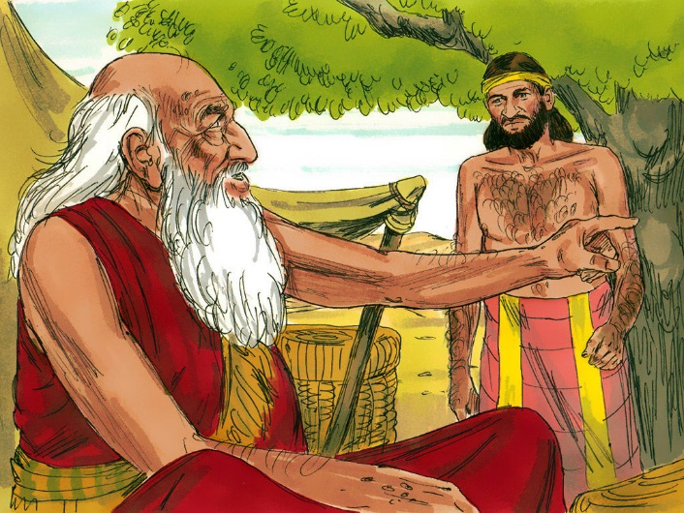
2. Eliezer was told to find a wife for Isaac from:
a) Shechem
b) Bethel
c) Haran
d) None of the above

3. On his journey Eliezer took:
a) 10 camels
b) jewels
c) clothing
d) his faith

4. Rebekah showed her faith by:
a) leaving Deborah b) leaving her parents
c) going to an unknown land d) agreeing to marry someone she had never met

5. Rebekah was:
a) related to Abraham b) divorced
c) humble d) angry

True or False

_____ 6. Eliezer was told he could take Isaac to Haran.
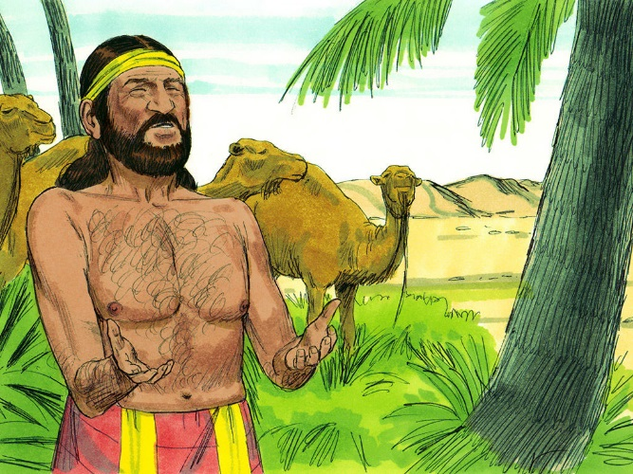
_____ 7. God answered Eliezer’s pray before he even finished praying.

_____ 8. Laban was Rebekah’s father.

_____ 9. Deborah was Rebekah’s mother.

_____ 10. Rebekah covered her face with a veil because she was cold.

_____ 11. Abraham trusted God to choose a good wife for Isaac because God knows the heart.

_____ 12. Choosing a partner in the Lord must be done prayerfully.

Bible Search
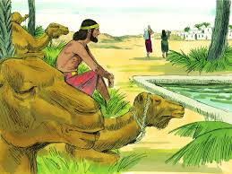
13. According to a Bible Atlas, how far is it from Hebron to Haran?
____________________________________________

14. Using a concordance, find the verse that states, “Be not unequally yoked with unbelievers.”
____________________________________________

15. How was Rebekah related to Abraham?
____________________________________________

Fill in the Blank

16. Eliezer offered a ____________________ to God that he might find the right woman for Isaac.

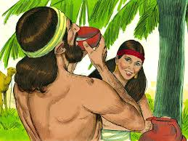
17. Rebekah covered her face with a _____________ because she was modest.

18. It is important to choose friends who __________________ God.

19. Marriage is a ___________________ long contract.

Short Answer

20. Why didn’t Abraham want Isaac to marry a Canaanite woman? _________________________

___________________________________________________________________________

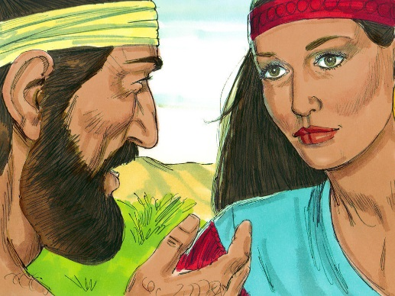
21. Why did Abraham send Eliezer to Haran to find a wife for Isaac?
__________________________________________________

__________________________________________________

22. Why didn’t Abraham let Isaac go back to Haran to find himself a wife?
__________________________________________________

__________________________________________________

23. What sign was Eliezer given so that he would know which was the right woman for Isaac?

___________________________________________________________________________

24. Why did it take a lot of faith for Rebekah to go with Eliezer? ___________________________

___________________________________________________________________________

25. Why is it important to marry someone with the same beliefs? __________________________

___________________________________________________________________________

