BIBLE QUIZ AND SKIT NIGHT

Round 1 10 Biblical Questions Part 1 (blank sheet of paper) – 10 mins

Round 2 Match the Person to the Event – 10 mins

Round 3 Chinese Whisper Skit 1 – 5 mins

Round 4 Bible Oddities (blank sheet of paper) – 10 mins

Round 5 10 Biblical Questions Part 2 (blank sheet of paper) – 10 mins

Round 6 Chinese Whisper Skit 2 – 5 mins

Round 7 Mark the places on a map – 10 mins

Biblical Questions Part 1 (ROUND 1)

- What were the Hebrew names for Shadrach, Meshach and Abednego?
Answer: Hananiah, Mishael, Azariah (Daniel 1v7)

- What was the name of the angel who told Zacharias that Elisabeth would have a baby?
Answer: Gabriel (Luke 1v13-19)

- Who is the first person to be called a prophet in the Bible?
Answer: Abraham (Genesis 20v7)

- Who had a donkey that spoke to him?
Answer: Balaam (Numbers 22v28)

- Who was the first person to raise someone from the dead?
Answer: Elijah – raised the widow of Zarephath’s son (1 Kings 17v17-24)

- What happened on the 4th day of creation?
Answer: God appointed the sun, moon and stars (Genesis 1v14-19)

- What was the second plague?
Answer: Frogs (Exodus 8v2)

- How many days did it take to rebuild the walls of Jerusalem in Nehemiah’s day?
Answer: 52 days (Nehemiah 6v15)

- What did John the Baptist wear clothing made out of?
Answer: Camel’s hair (Matthew 3v4)

- How old was Methuselah when he died?
Answer: 969 years (Genesis 5v27)

2 points for each question
Match the Person to the Event (ROUND 2)
Write the name in the square provided

Shaved his head and beard
This man was commander of Solomon’s army
Who said “give me children, or else I die”
I anointed Solomon as king
Even though I was a leper, I was commander of the Syrian Army
I was Paul’s famous Rabbi teacher
I had a hair cut whilst I was asleep
It took me 13 years to build my palace
Whose acts are recorded in the book of Gad the Seer
The apostle that was exiled to Patmos
I was a seller of purple
Who was told in a vision to measure the temple in Jerusalem?
I am the oldest son of Joseph
Who said “Art thou he that troubleth Israel?”
I was rescued out of the mire
I lead 300 men against the Midianite armies
I performed a miracle where an axe head floated
My daughter was raised from the dead
I was Timothy’s Grandmother
I had a twin brother who was a hunter

Gamaliel  Benaiah  John  Jairus  Jeremiah | Ezekiel  John  Ahab  Rachel  Samson | Gideon  Zadok  Jacob  Manasseh  Solomon | Naaman  Lois  Elisha  David  Lydia

1 point for each question
MATCH THE PERSON TO THE EVENT
(Answers)

Ezekiel | Shaved his head and beard (Ezekiel 5v1)
Benaiah | This man was commander of Solomon’s army (1 Kings 2v35, 4v4)
Rachel | Who said “give me children, or else I die” (Genesis 1v30)
Zadok | I anointed Solomon as king (1 Kings 1v39)
Naaman | Even though I was a leper, I was commander of the Syrian Army  (2 Kings 5v1)
Gamaliel | I was Paul’s famous Rabbi teacher (Acts 22v3)
Samson | I had a hair cut whilst I was asleep (Judges 16v19)
Solomon | It took me 13 years to build my palace (1 Kings 7v1)
David | Whose acts are recorded in the book of Gad the Seer (1 Chron 29v29)
John | The apostle that was exiled to Patmos (Revelation 1v9)
Lydia | I was a seller of purple (Acts 16v14)
John | Who was told in a vision to measure the temple in Jerusalem? (Revelation 11v1-2)
Manasseh | I am the oldest son of Joseph (Genesis 41v51)
Ahab | Who said “Art thou he that troubleth Israel?” (1 Kings 18v17)
Jeremiah | I was rescued out of the mire (Jeremiah 38v6)
Gideon | I lead 300 men against the Midianite armies (Judges 7v6-7)
Elisha | I performed a miracle where an axe head floated (2 Kings 6v1-7)
Jairus | My daughter was raised from the dead (Luke 8v41-56)
Lois | I was Timothy’s Grandmother (2 Timothy 1v5)
Jacob | I had a twin brother who was a hunter (Genesis 25v24-27)

Chinese Whisper Skits

ROUND 3

- Jael calling Sisera inside her tent, offering him milk and then killing him with a tent peg.

ROUND 6

- Samson killing a lion on the way to Timnath, then taking honey from the lion’s mouth on his way back home, eating it and offering the honey to his father and mother.

10 Bible Oddities (ROUND 4)

- Who was the world’s first murder victim?
Answer: Abel (Genesis 4v8)

- What is the longest name in the Bible?
Answer: Mahershalalhashbaz (Isaiah 8v1)

- Who was the first man recorded of shaving in the Bible?
Answer: Joseph – when he was brought before Pharaoh (Genesis 41v14)

- What is the only book of the Bible to mention a “pair of shoes”?
Answer: Amos (Amos 2v6, 8v6)

- Who had an iron bed that was about 13 feet long and 6 feet wide?
Answer: Og, King of Bashan (Deuteronomy 3v11)

- How many books in the Bible are named after women and what are they?
Answer: Two – Ruth and Esther

- What is the chapter that talks about dead, dry bones being brought to life?
Answer: Ezekiel 37

- Whose hair weighted 200 shekels when he had it cut each year?
Answer: Absalom (2 Samuel 14v26)

- Who used a stone for a pillow?
Answer: Jacob (Genesis 28v11)

- Who died by having a wet thick cloth put on his face?
Answer: Benhadad (2 Kings 8v7, 15)

2 points for each question
Biblical Questions Part 2 (ROUND 5)

- Which king of Moab was so fat that when he was stabbed, the handle of the dagger sank into his belly?
Answer: Eglon (Judges 3v21-22)

- How many days was Jesus on the earth for after his resurrection?
Answer: 40 days (Acts 1v3)

- What was the name of the man that fell out of a window while Paul was preaching?
Answer: Eutychus (Acts 20v9)

- How many years were added to Hezekiah’s life?
Answer: 15 years (2 Kings 20v6)

- What is the first recorded miracle of Jesus?
Answer: Turning water into wine at the wedding in Cana (John 2v1-11)

- Where were the disciples first called Christians?
Answer: Antioch (Acts 11v26)

- Who was the youngest king to reign in the Bible?
Answer: Joash – only 7 years old (2 Chronicles 24v1)

- What did Hannah make for Samuel each year while he was living with Eli?
Answer: A little coat (1 Samuel 2v19)

- Who tried to pay Peter and John for the power to give people the Holy Spirit?
Answer: Simon the sorcerer (Acts 8v18-19)

- What was Esther’s Hebrew name?
Answer: Hadassah (Esther 2v7)

2 points for each question
Mark the places on the Map (ROUND 7)
Write the number which corresponds with each of the places

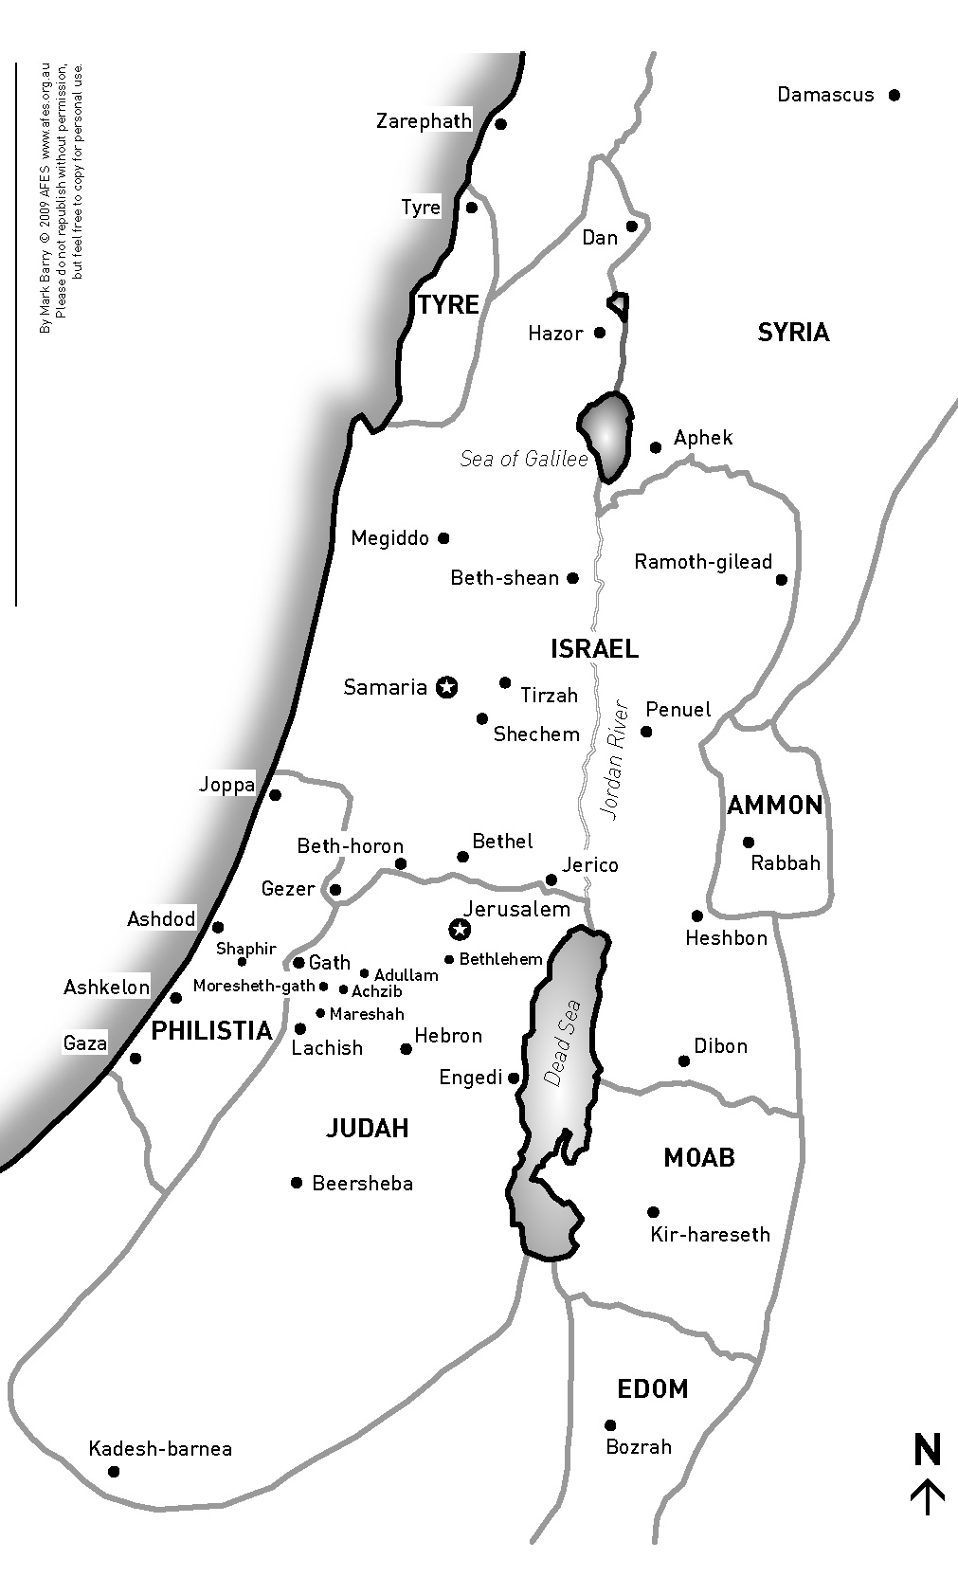
10

Beersheba
Bethel
Hebron
Shechem
Jerusalem
Bethlehem
Damascus
Kadesh-barnea
Jericho
Joppa

8
3
7
5
2
4
9
6
1
Mark the places on the Map (ROUND 7)
ANSWERS

10

Beersheba | 7
Bethel | 4
Hebron | 9
Shechem | 5
Jerusalem | 1
Bethlehem | 6
Damascus | 10
Kadesh-barnea | 3
Jericho | 8
Joppa | 2

2 points for each place
8
3
7
5
2
4
9
6
1

