FAMILY DAY

Program for the Day

Rough Timing

3.30pm Daily Readings
4.15 to 5.15pm Quiz and Activities
5.30ish Dinner

Guidelines

- Create a Biblical name for your team and write it on your score sheet.
- No technology / devices to be used during the afternoon … just your Bible!
- Some questions are easier. Please encourage the younger ones in your group to answer these.
- Work together and have fun!

Quiz and Activities

Round 1 Finish the Proverb (5 proverbs)

Round 2 Pictionary x 4

Activity: Balloon burst (activity for children)

Round 3 Who Am I? (10 people)

Round 4 Label the parts of the Spiritual Warrior (Ephesians 6)

Activity: Move the marshmallows (activity for young children)

Round 5 Bible math (4 questions)

Round 6 Guess the hymn (5 hymns)

Activity: Paper airplanes

Round 7 Geography of Israel (8 places)

Round 8 Bible oddities (10 questions)

Activity: The most push ups
ROUND 1 - FINISH THE PROVERB

- Proverbs 17v9 “He that covereth a transgression seeketh love; but he that repeateth a matter…”
Answer: “…separateth very friends”

- Proverbs 17v10 - “A reproof entereth more into a wise man than an…”
Answer: “... hundred stripes into a fool”

- Proverbs 17v17 “A friend loveth at all times, and a…”
Answer: “…brother is born for adversity”

- Proverbs 17v22 “A merry heart doeth good…”
Answer: “…like a medicine”

- Proverbs 17v28 “Even a fool, when he holdeth his peace…”
Answer: “…is counted wise”
(Bonus: “and he that shutteth his lips is esteemed a man of understanding”)

ROUND 2 - PICTIONARY

- Moses holding two tables of stones with the 10 commandments on them.
Hint (if needed): Mt Sinai

- Paul sewing tents with Aquila and Priscilla.
Hint (if needed): Needle and thread.

- Nebuchadnezzar turns into a beast and lives like an animal.
Hint (if needed): A huge change in life!

- The walls of Jericho falling down.
Hint (if needed): Into the Promised Land.

ACTIVITY - BALLOON BURST .

Each child bops a balloon in the air while the music is playing. When the music stops, the last person to touch their balloon is to pop the balloon and complete the challenge that is on the paper.

Example Challenges
- Get on the floor and act and sound like a dog
- Tell a funny joke
- Hop around the hall once
- Clap a verse of your favourite hymn and see if anyone can guess it

ROUND 3 - WHO AM I?

- I was the first man on earth.
Answer: Adam

- I was a seller of purple
Answer: Lydia (Acts 16v14)

- I was the commander of the Syrian Army and I had leprosy.
Answer: Naaman (2 Kings 5v1)

- I was an apostle who was exiled to Patmos.
Answer: John (Revelation 1v9)

- I stirred up the people to rebuild the walls of Jerusalem.
Answer: Nehemiah (Nehemiah 2v18)

- I performed a miracle where an axe head floated.
Answer: Elisha (2 Kings 6v1-7)

- It took me 13 years to build my palace.
Answer: Solomon (1 Kings 7v1)

- I fell out of a window while I was listening to Paul preach.
Answer: Eutychus (Acts 20v9)

- I lead 300 men against the Midianite armies.
Answer: Gideon (Judges 7v6-7)

- I anointed Solomon as king.
Answer: Zadok (1 Kings 1v39)

ROUND 4 - LABEL THE PARTS OF THE SPIRITUAL WARRIOR

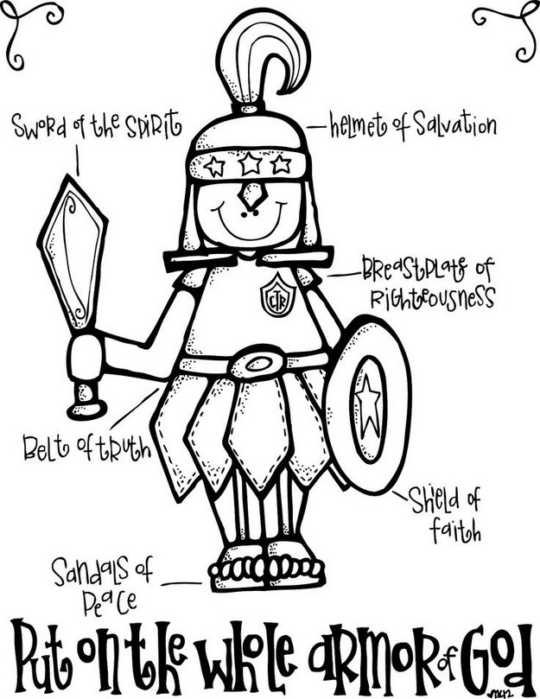
ROUND 4 - LABEL THE PARTS OF THE SPIRITUAL WARRIOR

Source: www.coloringpagess.bid
ACTIVITY - MOVE THE MARSHMALLOWS .

Each child has a bowl of marshmallows, a spoon and a plate. They have to move the marshmallows from the bowl to the plate, with the spoon. The winner is the person to empty their bowl first!

ROUND 5 - BIBLE MATH

Question 1 (for the kids only)

- Take the number of disciples Jesus had (12 – Matt 10v1)
- Add the number of wise virgins (5 – Matt 25v2)
- Subtract the day that God made dry land appear (3 – Gen 1v9)
- Add the number of years Jacob agreed to serve Laban for so he could marry Rachel (7 – Gen 29v18)
- Add the number of plagues God sent on Egypt (10)

12 + 5 – 3 + 7 + 10 = 31

Question 2

- Take the number of tribes in Israel (12 – Gen 49v28)
- Add the number of days Jesus fasted in the wilderness (40 – Matt 4v2)
- Subtract the number of days it took to rebuild the walls of Jerusalem in Nehemiah’s day (52 – Neh 6v15)
- Add the number of days Jesus spent with his disciples after he was resurrected (40 – Acts 1v3)
- Divide by the number of wagons given to the sons of Merari in Numbers 7v8 (4)

12 + 40 - 52 + 40 / 4 = 10

Question 3

- Take the number of chapters in Ezra (10)
- Multiply by the number of months Moses was hidden by his parents when he was born (3 – Heb 11v3)
- Add the number of fish Peter caught in John 21 (153 – John 21v11)
- Subtract the number of books in the Bible (66)
- Add the age Josiah was when he became king (8 – 2 Kings 22v1)

10 x 3 + 153 - 66 + 8 = 125

Question 4

- Take the number of pieces of silver Joseph was sold for (20 – Gen 37v28)
- Multiply by the number of times Naaman dipped himself in the river Jordan (7 – 2 Kings 5v14)
- Add the number of years that David reigned for (40 – 1 Kings 2v11)
- Divide by the number of things mentioned in Proverbs that are little upon earth, but exceeding wise (4 – Prov 30v25)
- Subtract the number of maidens that Hegai gave to Esther (7 – Esther 2v9)

20 x 7 + 40 / 4 – 7 = 38

ROUND 6 - GUESS THE HYMN

The first two chords will be played for each hymn – teams to guess what hymn it is:

- Hymn 379 – Most glorious things are spoken

- Hymn 14 – God is my strong salvation

- Hymn 135 – Dear Lord and Maker of mankind

- Hymn 410 – Lord, keep us safe this night

- Hymn 77 – All-pow’rful, self-existent God

ACTIVITY - PAPER AIRPLANES .

Each player to get help from their team to make a paper airplane. The player then flies the plane and the winner is the one that flies that furtherest.

ROUND 7 - GEOGRAPHY OF ISRAEL

Write the number which corresponds with each of the places.

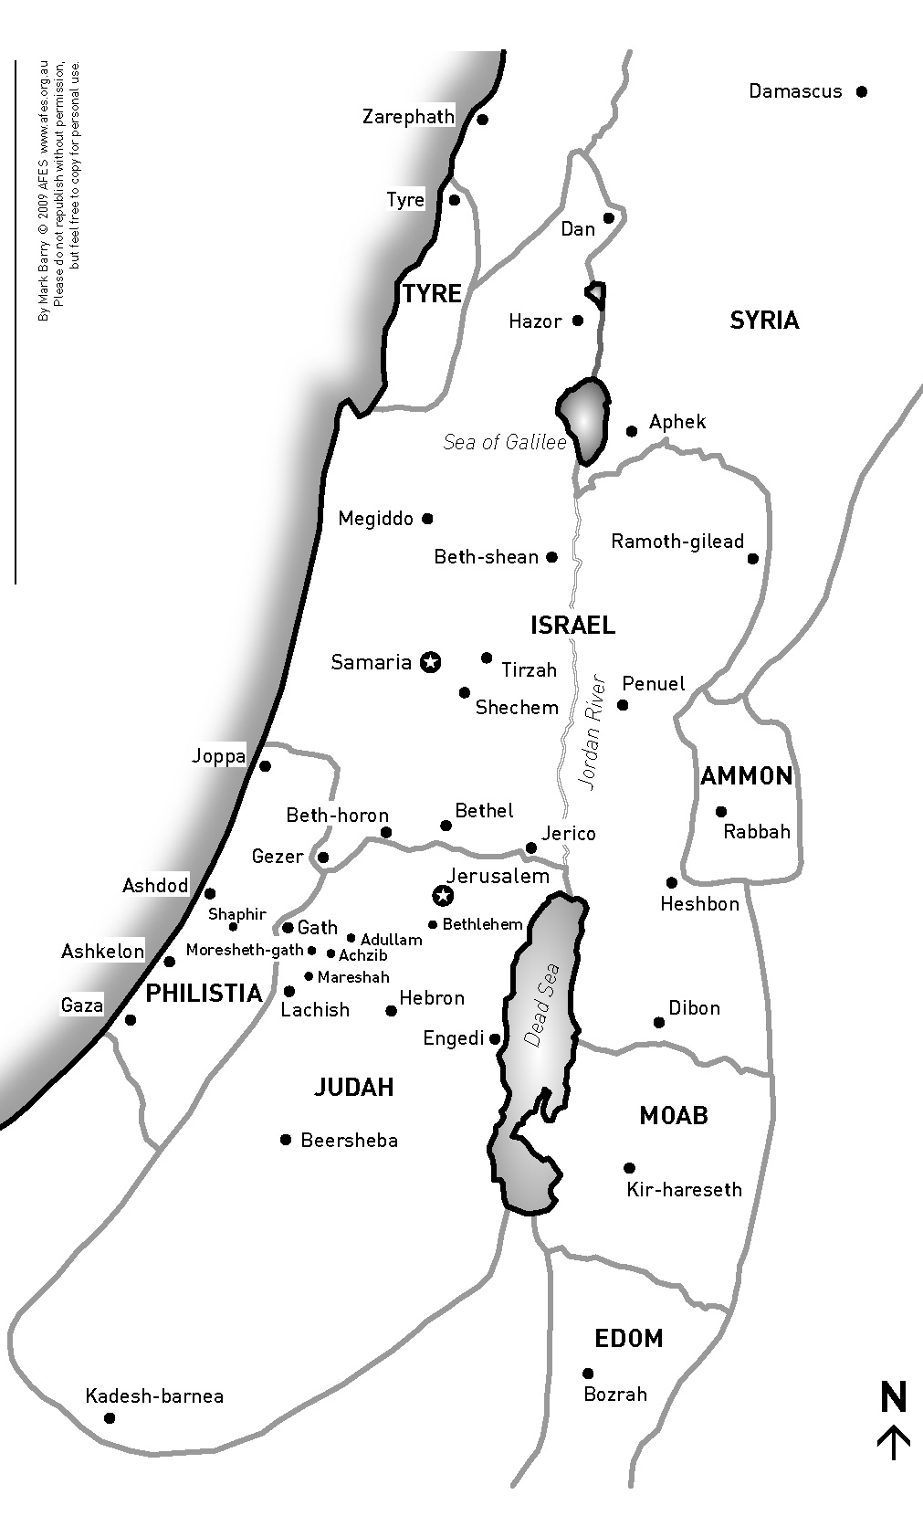
6

Jerusalem
Bethlehem
Shechem
Damascus
Kadesh-barnea
Jericho
Joppa
Beersheba

8
7
5
3
2
4
1
ROUND 7 - GEOGRAPHY OF ISRAEL (ANSWERS)

Write the number which corresponds with each of the places.

6

Jerusalem | 1
Bethlehem | 4
Shechem | 8
Damascus | 6
Kadesh-barnea | 3
Jericho | 5
Joppa | 2
Beersheba | 7

8
7
5
3
2
4
1
ROUND 8 - BIBLE ODDITIES

- Who wore camel’s hair for his clothes?
Answer: John the Baptist (Mark 1v6)

- How many books in the Bible are named after women?
Answer: Two – Ruth and Esther

- What is the only book of the Bible to mention a “pair of shoes”?
Answer: Amos (Amos 2v6, 8v6)

- What is the chapter that talks about dead, dry bones being brought to life?
Answer: Ezekiel 37

- What is the longest name in the Bible?
Answer: Mahershalalhashbaz (Isaiah 8v1)

- Who was the first man recorded of shaving?
Answer: Joseph – when he was brought before Pharaoh (Genesis 41v14)

- Who used a stone for a pillow?
Answer: Jacob (Genesis 28v11)

- Who died by having a wet thick cloth put on his face?
Answer: Benhadad (2 Kings 8v7, 15)

- What did Shamgar slay 600 Philistines with?
Answer: An ox goad (Judges 3v31)

- Who cut Samson’s hair?
Answer: “A man” – Judges 16v19

ACTIVITY - PUSH UPS .

See who can do the most push ups

