The Life of Christ – A Meditation Through Song

~ Meditation: Hymn 328 God so loved the world
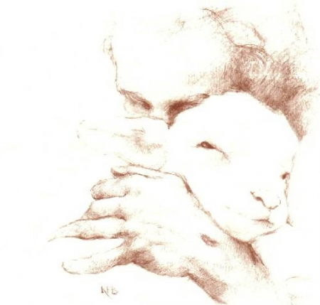

Christ is born, the great Anointed!

Hymn 192 * Hark! what mean those holy voices

Hymn 190 * Bethlehem, thou little city

“To do Thy will I take delight”

Hymn 22 * O blessed is the man whose trust

Hymn 201 Forty days and forty nights

~ Meditation: Hymn 161 Our Father which art in heav’n

Hymn 325 Come to me all you who are weary and burdened

Hymn 202 Fierce was the billow wild, dark was the night

He bows beneath the sins of men

Hymn 220 Ride on! ride on in majesty!

Hymn 242 * “This is my body”, Jesus the Saviour said

Hymn 216 Beyond where Kedron’s waters flow

~ Meditation: Hymn 219 * O Saviour, where shall guilty man

Hymn 247 Jesus Christ from death is raised, Hallelujah!

Saints and angels throng around him!

Hymn 265 How long, O Lord our Saviour

~Meditation: Hymn 270 * We would see Jesus!

---(Please stand for the concluding hymns and prayer)---

Hymn 279 Look, ye saints, the sight is glorious

Hymn 295 Hallelujah, sing of Jesus

(* Hymn may be unfamiliar; pianist will play 1 verse through.)

The Life of Christ – A Meditation Through Song

~ Meditation: Hymn 328 God so loved the world

Christ is born, the great Anointed!

Hymn 192 * Hark! what mean those holy voices

Hymn 190 * Bethlehem, thou little city

“To do Thy will I take delight”

Hymn 22 * O blessed is the man whose trust

Hymn 201 Forty days and forty nights

~ Meditation: Hymn 161 Our Father which art in heav’n

Hymn 325 Come to me all you who are weary and burdened

Hymn 202 Fierce was the billow wild, dark was the night

He bows beneath the sins of men

Hymn 220 Ride on! ride on in majesty!

Hymn 242 * “This is my body”, Jesus the Saviour said

Hymn 216 Beyond where Kedron’s waters flow

~ Meditation: Hymn 219 * O Saviour, where shall guilty man

Hymn 247 Jesus Christ from death is raised, Hallelujah!

Saints and angels throng around him!

Hymn 265 How long, O Lord our Saviour

~Meditation: Hymn 270 * We would see Jesus!

---(Please stand for the concluding hymns and prayer)---

Hymn 279 Look, ye saints, the sight is glorious

Hymn 295 Hallelujah, sing of Jesus

(* Hymn may be unfamiliar; pianist will play 1 verse through.)

