Hot Chocolate Hymn Sing

What: Ecclesial hymn sing with refreshments!

When: 7:30pm on Friday, November 15

Where: Milford Road Ecclesial Hall
(insert address)
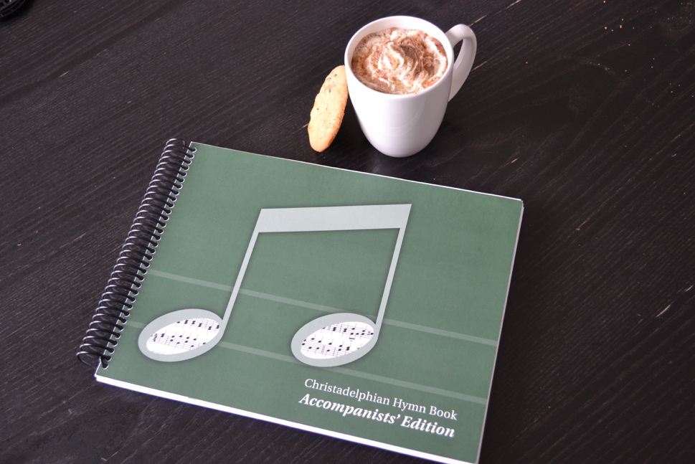

Potluck snack. Hot chocolate provided!
Contact (insert email address) if you have any questions.

