Opening Prayer
Reading: Psalm 1
Hymn 1
Reading: Psalm 27:1-6
Hymn 14
Reading: Psalm 122:6-9
Hymn 61
Reading: Rev. 19:5-8
Hymn 89
Reading: Psa. 27:11-14
Hymn 165
Reading: Heb. 4:14-16, 5:4-6
Hymn 262

Reading: Isa. 35
Hymn 289
Reading: Isa. 11:1-4, 9-10
Hymn 290
Reading: Eph. 6:11-18
Hymn 355
Reading: Psa. 24:1-6
Hymn 379
Reading: Rev. 5
Hymn 405
Hymn 406
Closing Prayer

Hot Chocolate Hymn Sing

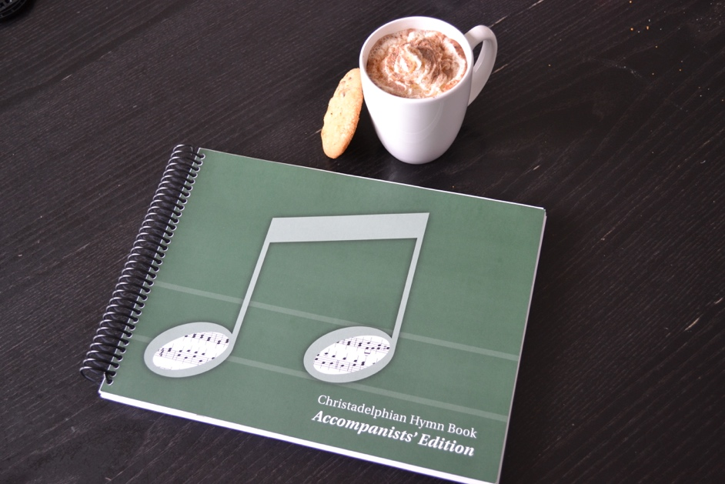
Milford Road Ecclesia
November 15, 2019
“Make a joyful noise unto the LORD, all ye lands. Serve the LORD with gladness: come before his presence with singing.”
Psalm 100:1-2

