CSSA STAGE 1 JUNIOR Handout #2 NAME ___________________________________

Evolution: The Big Lie

Fill in the Blanks
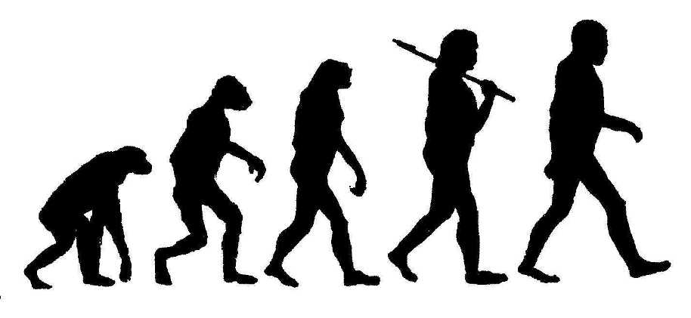
- Scientists that don’t believe in God explain the origin of life by ____________________________________.

- Scientists say Evolution occurred by

____________________________________.

- Nothing is by chance with God. He has a

__________________ year plan.

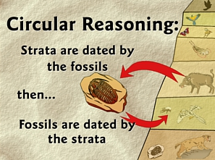
- In Romans 5v12, the apostle _______________ proved that you can’t believe in evolution and God at the same time.

Multiple Choice: Circle ALL the Correct Answers!

5. Supposedly, evolution occurred over a period of:
a) 100 years
b) 1,000 years
c) 100,000 years
d) over 1,000,000 years

6. People who believe in evolution will tell you your ancestors were once a:
a) simple creature
b) monkey
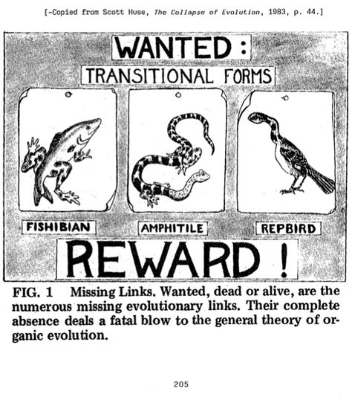
c) fish
d) reptile

7. Many people who believe in evolution think they:
a) are basically good
b) are healthier
c) don’t need forgiveness
d) none of the above

8. People die because they:
a) drink b) exercise
c) sin d) eat fruit

9. The best way we can learn about God is to:
a) read the bible b) talk to our friends
c) read science books d) both a and c

True or False

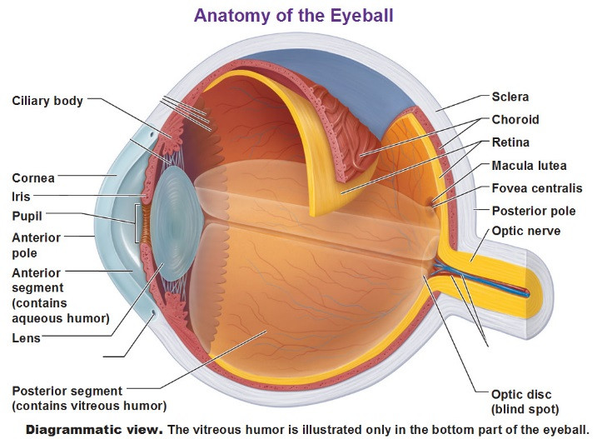
_____ 10. God has a particular time period in which he plans to complete His purpose.

_____ 11. If the pieces of a watch don’t come together by chance, neither would the intricate parts of the human body.

_____ 12. God wants to fill the earth with people who learn to live like Him.

_____ 13. Death is something that just developed by chance.

_____ 14. Everyone who believes in evolution doesn’t believe in God.

_____ 15. Just because we know God created us doesn’t mean we should serve Him.

Short Answer

16. Our bodies are more complicated than the best computers. How does that help to disprove evolution?
___________________________________________________________________________

___________________________________________________________________________

17. What is one reason why people like to believe in evolution? ___________________________

___________________________________________________________________________

18. How can we be different from the children in our school or neighborhood? ________________

___________________________________________________________________________

19. Why can’t you believe that God slowly created our world over millions of years through evolution?

___________________________________________________________________________

___________________________________________________________________________

