CSSA STAGE 1 JUNIOR #12 NAME ___________________________________

Joseph – Prisoner in a Foreign Land

Short Answer

- Give two reasons why Joseph’s brothers were jealous of him?

- _________________________________________________________________________

- _________________________________________________________________________

2. Describe Joseph’s first dream. __________________________________________________

___________________________________________________________________________

___________________________________________________________________________

3. Describe Joseph’s second dream. _______________________________________________

___________________________________________________________________________

___________________________________________________________________________

4. What was God teaching Jacob’s family from Joseph’s dreams? ________________________

___________________________________________________________________________

___________________________________________________________________________

5. Why did Joseph’s brothers dip his coat into the blood of a goat? ________________________

___________________________________________________________________________

___________________________________________________________________________

6. Why did Potiphar put Joseph in charge of his house? ________________________________

___________________________________________________________________________

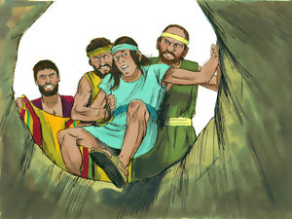
Matching
- Captain of Egyptian Guard

- King of Egypt

- The Increaser

7. _____ Joseph

8. _____ Potiphar

9. _____ Pharoah

True or False

_____ 10. Joseph found his brothers at Shechem, feeding the sheep.
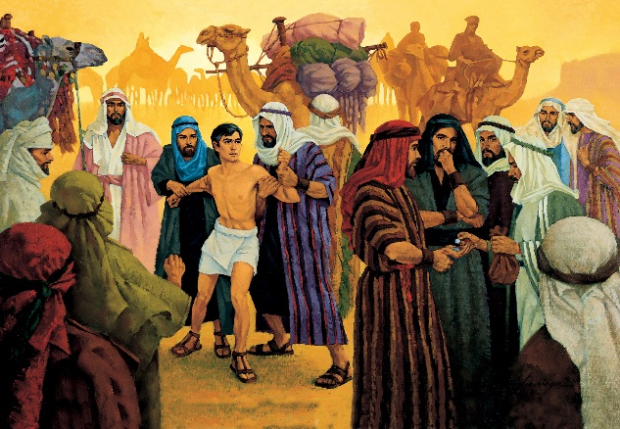
_____ 11. Judah suggested his brothers put Joseph in a pit instead of killing him.

_____ 12. Reuben wanted to sell Joseph to the Ishmaelites.

_____ 13. Joseph hated his brothers.

_____ 14. The butler forgot to help Joseph when he was freed.

Fill in the Blank

15. Joseph was about _________ years old when he was sold into slavery.

16. Joseph was falsely accused by _________________ and put into prison.

17. In the butler’s dream, the three branches represented _________ __________________.

18. The chief baker was ____________________.

19. List three ways that show Joseph was a type of the Lord Jesus Christ.

- _______________________________________________________________________

- _______________________________________________________________________

- _______________________________________________________________________

Thought Questions

20. List three ways Joseph was a good example for us.

- _______________________________________________________________________

_______________________________________________________________________

 





 





