CSSA STAGE 1 JUNIOR #13 NAME ___________________________________

Joseph Ruler in Egypt

Multiple Choice: Circle ALL the Correct Answers!

1. After Joseph interpreted the butler’s dream, he remained in prison for:
a) 2 years b) 4 years c) 6 years d) 8 years

2. Joseph was chosen as ruler of Egypt and given:
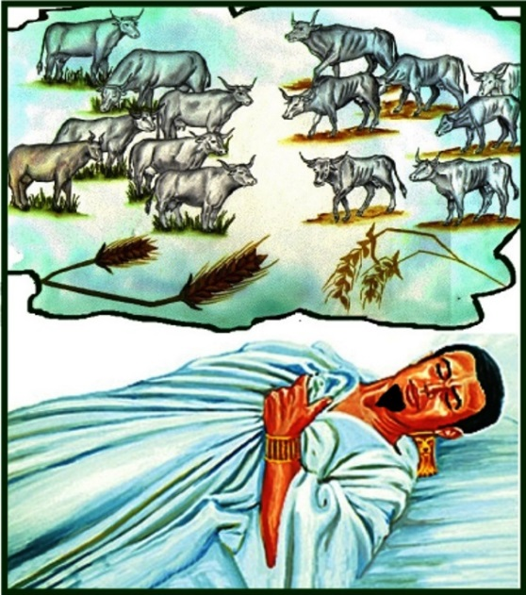
a) fine clothes
b) the king’s ring
c) ten donkeys
d) the best food

3. Joseph accused his brothers of:
a) trying to kill him
b) being spies
c) stealing
d) lying

4. Joseph kept the following brother in prison after he released the others:
a) Judah
b) Reuben
c) Simeon
d) Benjamin

5. Joseph commanded his brothers to:
a) bring him a wife b) serve him 10 years
c) bring Benjamin back d) bring their father

True or False

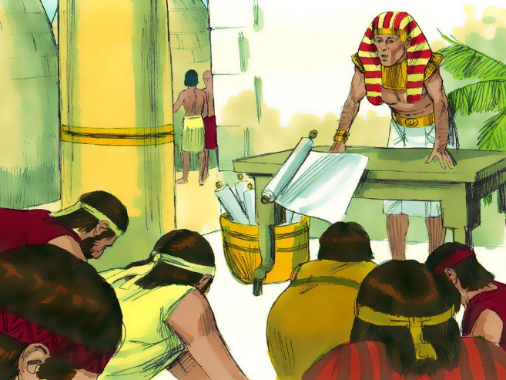
_____ 6. In Pharaoh’s dream the fat cows got fatter.

_____ 7. In Pharaoh’s dream the thin ears of corn ate the fat ears of corn.

_____ 8. The seven fat cows and the seven fat ears of corn meant there would be seven years of famine.

_____ 9. The seven thin cows and the seven thin ears of corn meant there would be 14 years of famine.

_____10. Pharaoh recognized that God was with Joseph.

Short Answer

11. What made the butler think about Joseph again? ___________________________________

__________________________________________________________________________

12. What did Pharaoh’s dreams of cows and corn mean? _______________________________

__________________________________________________________________________

13. Why did Jacob keep Benjamin home when he sent his other sons to Egypt? _____________

__________________________________________________________________________

14. Which dreams of Joseph were fulfilled when his brothers bowed down to him? ___________

__________________________________________________________________________

15. Why didn’t Joseph’s brothers recognize him? ______________________________________

__________________________________________________________________________

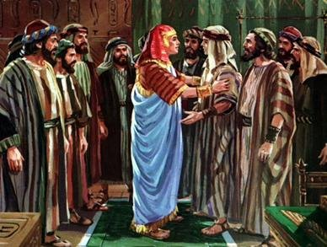
16. Why did Joseph speak roughly to his brothers?

___________________________________________

___________________________________________

___________________________________________

17. Was Joseph interested in revenge or was he acting out of love and concern for his brother’s eternal salvation?

___________________________________________

Who Said It

18. “It is not in me. God shall give Pharaoh an answer of peace.” __________________________

19. “Can we find such a one as this is, a man in whom the Spirit of God is?”__________________

20. “Get you down thither and buy for us from thence, that we may live and not die.” ___________

Thought Questions

21. Why do you think Joseph put his brother’s money back in their sack of food? ______________

___________________________________________________________________________

22. Why do you think God allowed Joseph to be sold and taken into Egypt? __________________

___________________________________________________________________________

23. What do you think Joseph learned from all the years he spent in prison? _________________

___________________________________________________________________________

