CSSA STAGE 1 JUNIOR #15 NAME ___________________________________

Moses Born to Deliver Israel

Multiple Choice: Circle ALL the Correct Answers!

1. Pharoah made the Hebrew people slaves because:
a) they had a lot of muscles b) there were so many of them
c) he was afraid they would fight against him d) he thought he was better than them

2. Pharoah commanded that:
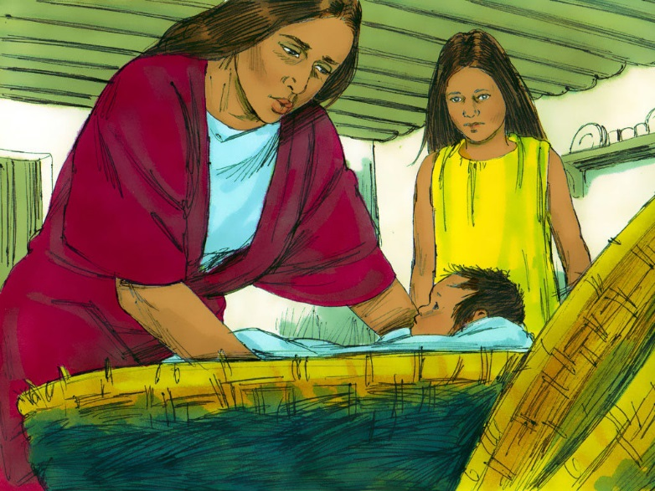
a) all Israelites must die
b) no Israelites could get married
c) all baby boys were to be destroyed
d) no Israelites could have babies

3. Amram and Jochebed hid Moses for:
a) 3 months
b) 6 months
c) 9 months
d) 12 months

4. Moses fled into the land of:
a) Moab b) Edom
c) Ethiopia d) Midian

5. Moses married:
a) a daughter of the priest of Midian b) Zipporah
c) Sapphira d) an Ethiopian

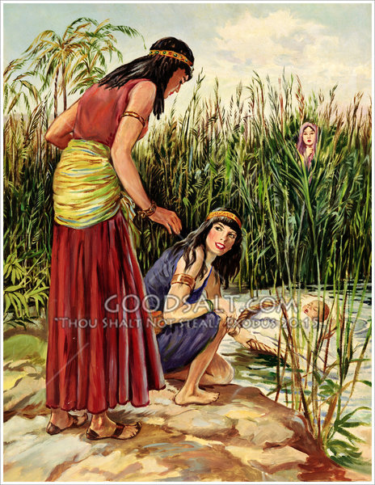
True or False

_____ 6. Jochebed put Moses in an ark of bulrushes by the water’s edge.

_____ 7. Aaron watched his little brother in the bulrushes.

_____ 8. Pharaoh’s daughter found the ark.

_____ 9. Jochebed was paid to feed her own baby.

_____ 10. Jochebed and Amram are mentioned with the faithful in Philippians.

_____ 11. Moses was taught as an Egyptian prince.

_____ 12. Moses forgot about God.

Short Answer

13. What happened that caused the Israelites to no longer be treated as friends of Egypt?

___________________________________________________________________________

14. Who nursed baby Moses? ______________________________________________________

15. What was the first thing Jochebed taught Moses when he was old enough to learn? ________

___________________________________________________________________________

16. What did Moses do when he saw an Egyptian mistreating a Hebrew? ____________________

___________________________________________________________________________

17. What did the hard and lonely life of a shepherd teach Moses regarding God? ______________

___________________________________________________________________________

18. How did the 40 years in Midian help Moses to lead the nation of Israel out of Egypt? ________

___________________________________________________________________________

Who Said It

19. “God will surely visit you and bring you out of this land.” _______________________________

Fill in the Blank
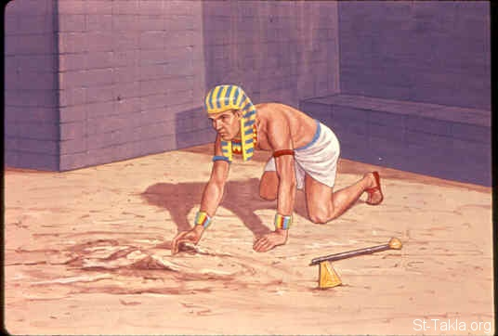
20. Moses had a brother named _______________ and

a sister named ____________________.

21. Moses was __________ years old when he left Egypt.

22. Moses ______________ an Egyptian and buried him

in the _______________.

23. Pharaoh wanted to __________ Moses after he killed the Egyptian.

Research/Thought Questions

24. Amram and Jochebed were of the tribe of Levi. What do you know about the tribe of Levi?

___________________________________________________________________________

___________________________________________________________________________

25. Compare the purpose of Noah’s ark with the purpose of Moses’ ark. What did they have in common and what made them different?
___________________________________________________________________________

___________________________________________________________________________

