CSSA STAGE 1 JUNIOR #16 NAME ___________________________________

Moses at the Burning Bush

Multiple Choice: Circle ALL the Correct Answers!

1. Who spoke to Moses at the burning bush?
a) God himself b) an angel
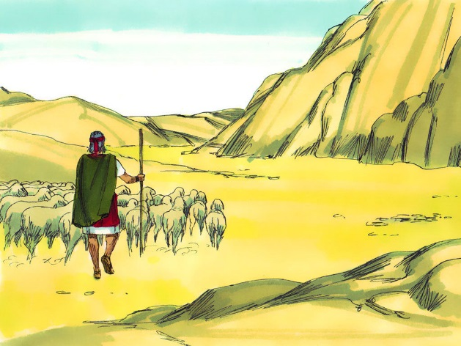
c) Aaron d) no one

2. The reason Moses hesitated to go back to Egypt was:
a) he was humble and wiser now
b) he was afraid
c) he thought someone else could do a better job
d) he really didn’t want to

3. Bible names often describe the:
a) work of a person
b) character of a person
c) purpose of a person
d) stature of a person

4. Some of the signs Moses received to show Israel that God was with him were:
a) the water turned to blood b) the rod became a serpent
c) his foot became leprous d) the sun stood still

Short Answer

5. Approximately how many years were there between Joseph’s death and Moses’ birth? _______

6. What strange sight did Moses see on Mount Horeb? __________________________________

____________________________________________________

7. What did the angel tell Moses he must do for God’s people?

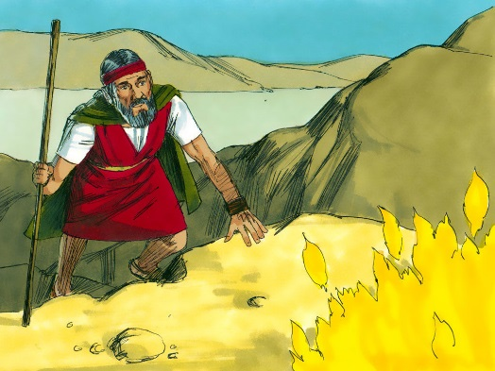
____________________________________________________

____________________________________________________

8. What does the name Yahweh mean? ______________________

____________________________________________________

9. Give two reasons why Moses didn’t think he was the person to lead Israel out of Egypt?

- _________________________________________________

- _________________________________________________
True or False

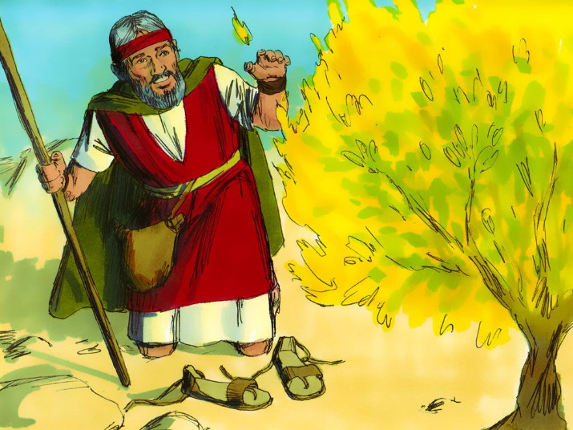
_____ 10. No man hath seen God at any time.

_____ 11. Moses was eager to go back to Egypt.

_____ 12. Bible names are just a label.

_____ 13. Moses spent 40 years in Midian before returning to Egypt.

_____ 14. Moses had to convince the elders of Israel that God would deliver them.

_____ 15. God told Moses right at the start that Pharaoh would not let the Israelites go right away.

Matching
- He who will be

- Father of a great multitude

- Heel catcher

- Prince with God

- Lofty Father
16. _____ Abram

17. _____ Yahweh

18. _____ Israel

19. _____ Abraham

20. _____ Jacob

Fill in the Blank

21. John 1v18 states, “no ________ hath seen ________ at any time.”

22. Moses was _______ years old when God told him to go back to Egypt.

23. The burning bush and the words of the angel were a __________ to Moses that God would be with him.

24. He who will be means _________________________________________________________.

Thought Questions

25. What did Jesus mean when he said, “he who has seen me has seen the Father”? __________

___________________________________________________________________________

26. What do you think the burning bush symbolizes? ____________________________________

___________________________________________________________________________

