CSSA STAGE 1 JUNIOR #17 NAME ___________________________________
God Sends Plagues on Egypt

Multiple Choice: Circle ALL the Correct Answers!

1. Both the Egyptians and the Israelites experienced the first
a) 2 plagues b) 3 plagues c) 4 plagues d) all the plagues

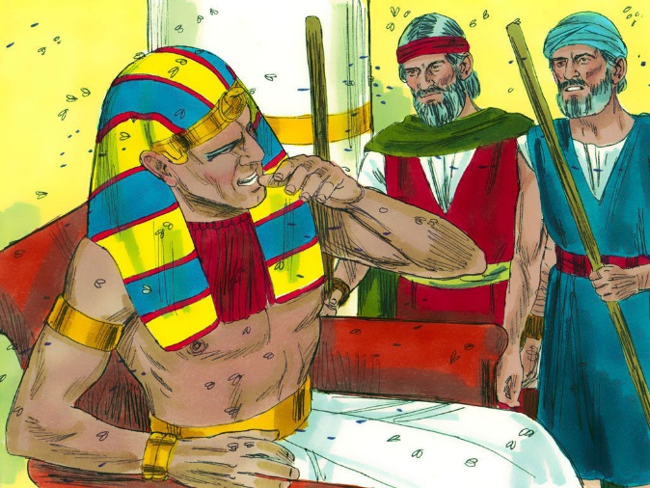
2. Murrain was:
a) an exotic food
b) a contagious disease
c) a city in Egypt
d) the 5th plague

3. The ashes became dust and turned into:
a) hail
b) chicken pox
c) boils
d) frogs

4. The locusts:
a) ate green crops b) came in on the east wind
c) were swept into the Red Sea d) destroyed the crops

Short Answer

5. When Moses and Aaron told Pharoah that Yahweh said, “Let Israel go”, what did Pharoah say about Yahweh?
____________________________________________________________________________

6. What punishment did Pharoah give the Israelites in response to Moses’ and Aaron’s request?

____________________________________________________________________________

7. How was Aaron’s rod shown to be more powerful than the rods of the magicians? _______________

____________________________________________________
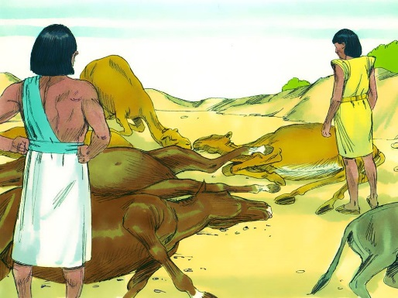
____________________________________________________

8. After which plague did the magicians admit they were no match for God? _________________

9. Why did God let the Israelites experience the first 3 plagues?

___________________________________________________

___________________________________________________

10. How did some of the Egyptians show their fear for Israel’s God during the plague of hail?

____________________________________________________________________________
True or False

_____ 11. When Moses turned the water into blood only the Nile was affected.

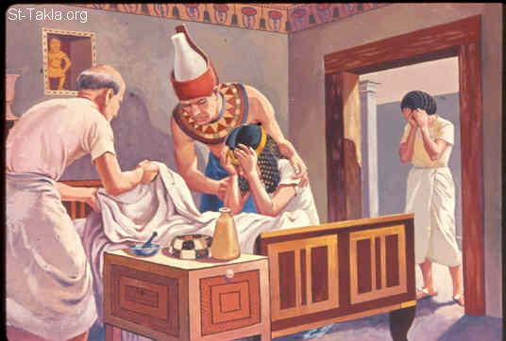
_____ 12. Locust was the 4th plague.

_____ 13. The Egyptians were able to make lice.

_____ 14. The magicians were able to make frogs appear as well as make them disappear.

_____ 15. After the frog plague, Pharoah said he would let the people go.

_____ 16. Both the Israelites and the Egyptians suffered from the plague of flies.

Fill in the Blank

17. The Israelites lived in the land of _________________ while in Egypt.

18. God brought the plagues upon Egypt to show his _____________ over the gods of Egypt.

19. Pharoah’s heart was _________________________.

20. Israel had to ____________________ themselves and _____________ in God to deliver them.

21. We must be _____________________ from the world.

22. God is ____________________ to those who separate themselves, but _________________ to those who hate him.

Learn the 10 Plagues (Below are two different sayings that might help)

Read the Sentences Downward Corresponding Plagues
Big
Frogs
Little
Flies
Moses
By
His
Lord
Did
Destroy
Black
Frogs
Gobbled
Flies
Pharoah
Became
Hardened
Leaving
Dead
Firstborn
Blood
Frogs
Lice or Gnats
Flies
Plague or Murrain
Boils
Hail
Locusts
Darkness
Firstborn

