CSSA STAGE 1 JUNIOR #18 NAME ___________________________________

Israel Keeps Passover & Crosses Red Sea

Multiple Choice: Circle ALL the Correct Answers!

1. The lamb was:
a) chosen on 10th day b) killed on the 14th day c) roasted d) strangled

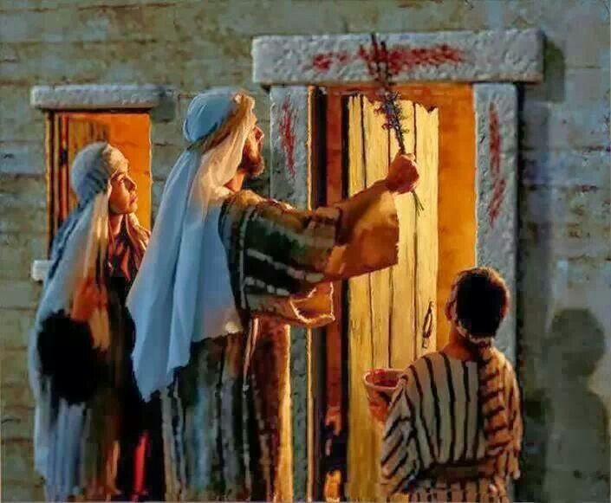
2. On the night of the Passover the Israelites had to:
a) stay in their homes
b) be dressed ready to leave
c) put blood on their floor
d) stay awake

3. Who’s bones did Moses command had to be taken out of Egypt:
a) Abraham
b) Isaac
c) Jacob
d) Joseph

4. The angel of the Lord went before the Israelites in a cloud to:
a) show them the way b) protect them from the heat of the sun
c) give them water d) keep Pharaoh from attacking them

Short Answer

5. Why did God allow the children of Israel to take the Egyptian’s belongings? ________________

____________________________________________________________________________

6. What was done with the blood of the Passover lamb? _________________________________

____________________________________________________________________________

7. What happened at midnight on the Passover night? ______________________________________________

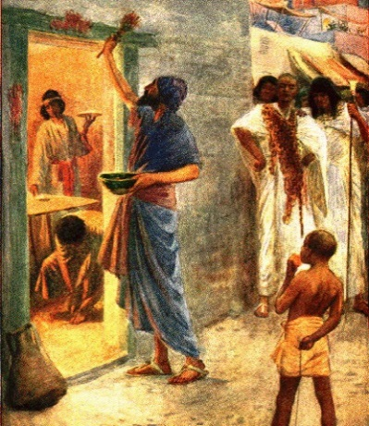
____________________________________________________

____________________________________________________

8. How were the Israelites trapped at Hahiroth? ________________

____________________________________________________

9. How did God rescue them? _____________________________

____________________________________________________

____________________________________________________
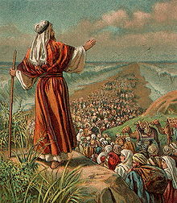
True or False

_____ 10. God calls Israel his firstborn.

_____ 11. God defeated the so-called Egyptian gods by directing the plagues against them.

_____ 12. The month of the Israel’s exodus from Egypt was to become the first month of their New Year.

_____ 13. The Israelites took the left-over lamb with them for food on their trip.

_____ 14. Some Egyptians went with the Israelites when they left Egypt.

Fill in the Blank

15. The word “borrow” really meant _________________ the jewels and clothing from the Egyptians.

16. The first month of Israel’s New Year was called _________________.

17. The Passover feast was to be kept every _________________ to remind Israel of their deliverance.

18. About _________________ men, besides women and children left Egypt.

19. The children of Israel were at _____________________ when they learned that Pharaoh and 600 chariots were just behind them.

Thought Questions

20. List three similarities between the Passover lamb and Jesus.

- _______________________________________________________________________

- _______________________________________________________________________

- _______________________________________________________________________

21. List three similarities between crossing the Red Sea and baptism.

- _______________________________________________________________________

- _______________________________________________________________________

- _______________________________________________________________________

