CSSA STAGE 1 JUNIOR #19 NAME ___________________________________

God Cares for His People in the Wilderness

Multiple Choice: Circle ALL the Correct Answers!

1. How many days did the Israelites travel without water after crossing the Red Sea?
a) 1 day b) 2 days c) 3 days d) 4 days

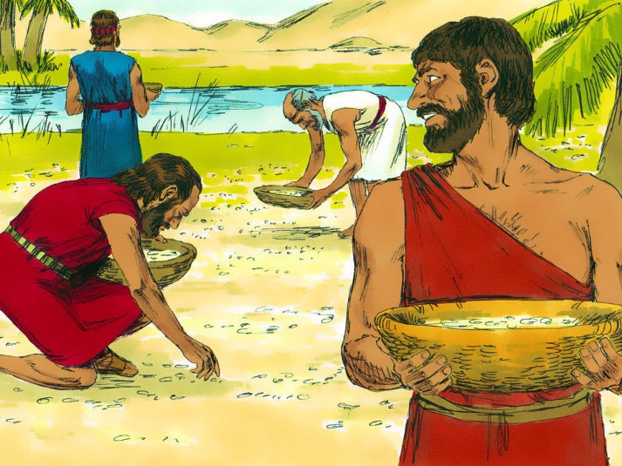
2. The water was bitter at:
a) Elim
b) Marah
c) Succoth
d) Ethan

3. When the Israelites were hungry and wanted to go back to Egypt they forgot that they:
a) were slaves
b) were treated cruelly
c) didn’t have enough food
d) wanted freedom

4. Manna was:
a) black b) like honey c) sour d) meat

5. Who was commander of the Israelites in the battle with the Amalekites?
a) Moses b) Hur c) Aaron d) Joshua

Short Answer

6. What was Moses told he must do to make the water at Marah fit to drink? _________________

____________________________________________________________________________

7. What lesson was God trying to teach the Israelites at Marah? ___________________________

____________________________________________________________________________

8. What special instructions were the Israelites given about gathering the manna? _________________

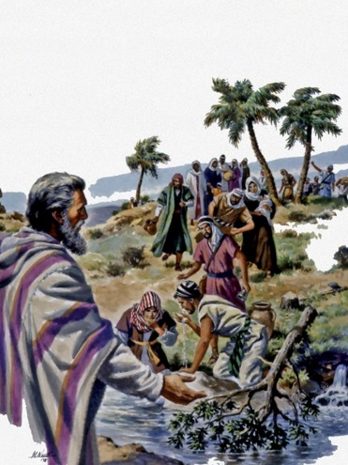
________________________________________________________

________________________________________________________

9. What was Moses told to do to provide water at Rephidim? _________

________________________________________________________

10. What did Moses have to do during the battle with the Amalekites at Rephidim?
________________________________________________________

True or False

_____ 11. There were 12 wells of water at Marah.
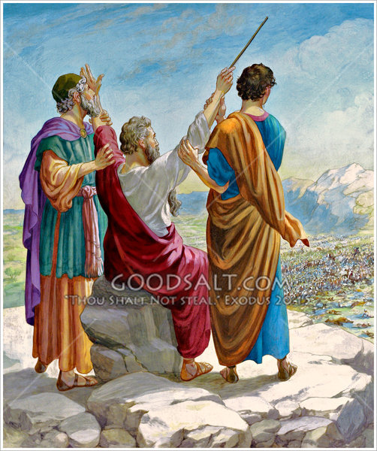
_____ 12. Many of the Israelites wanted to go back to Egypt.

_____ 13. On the sixth day the Israelites gathered enough manna for two days.

_____ 14. The Amalekites attacked the weak and feeble Israelites.

_____ 15. When Moses raised his hands in prayer the Israelites were successful.

_____ 16. God will give us everything we want.

_____ 17. Manna means God will provide.

_____ 18. Jesus is the bread of life.

Fill in the Blank

19. Quails are ___________________.

20. Manna is _________________.

21. God provided manna for _________________ years.

22. The _______________________ attacked the Israelites at Rephidim.

23. The Israelite’s shoes did not _______________ out and their feet did not _________________.

Thought Questions

20. Give two reasons why God kept the Israelites in the wilderness for 40 years and allowed them to be thirsty, hungry and attacked by their enemies.

- _______________________________________________________________________

- _______________________________________________________________________

21. Name two ways in which manna is like the word of God.

- ________________________________________________________________________

- ________________________________________________________________________

22. How is Jesus like the rock that Moses hit? _________________________________________

___________________________________________________________________________

___________________________________________________________________________

