CSSA STAGE 1 JUNIOR #20 NAME ___________________________________

Israel at Mt Sinai

Multiple Choice: Circle ALL the Correct Answers!

1. God told Moses that the Israelites would be a:
a) military people b) peculiar people c) kingdom of priests d) holy nation

2. Barriers were set up around Mt Sinai because:
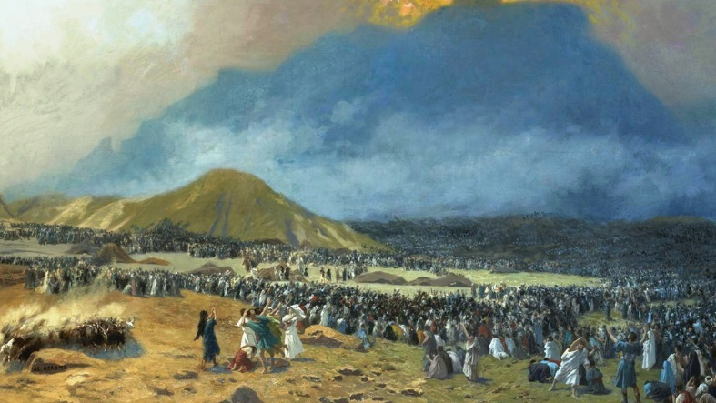
a) it was so steep
b) an avalanche could occur
c) it was holy
d) too many falling rocks

3. If anyone touched the mountain they would:
a) get sick
b) lose their dinner
c) be childless
d) be struck dead

4. The law of Moses brought God to mind:
a) at home b) at school c) in daily life d) while playing

Short Answer

5. How many months did it take the Israelites to get to Mt Sinai? ______________

6. Why was it necessary for God to give laws to the Israelites at Mt Sinai? ___________________

____________________________________________________________________________

7. Describe Mt Sinai when God gave the 10 commandments? ______________________________________

________________________________________________________

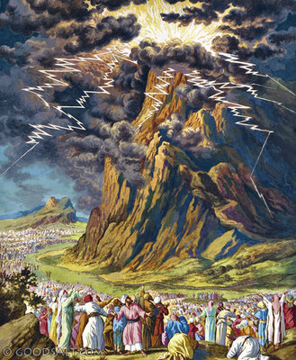
________________________________________________________

8. Who was God going to send to lead the Israelites to the Promised Land?

________________________________________________________

9. What did the Israelites make with God at Mt Sinai? _______________

________________________________________________________

10. What did Jesus say was the first and greatest commandment? ______

________________________________________________________

11. How many of the 10 commandments are repeated in the New Testament? ________________

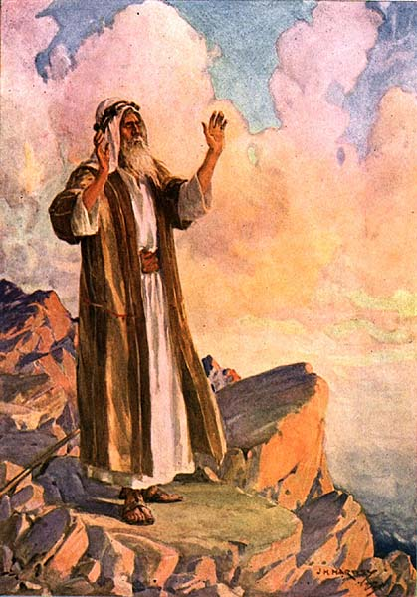
True or False

_____ 12. The Israelites were terrified when God gave them the 10 commandments.

_____ 13. The first commandment is, “Thou shalt have no other gods before me.”

_____ 14. The 10th commandment is, “Thou shalt not steal.”

_____ 15. The Israelites did not want God to speak to them directly.

_____ 16. The first four commandments relate to family life.

_____ 17. We no longer have to keep the 10 commandments.

Fill in the Blank

18. The first four commandments relate to the way Israel was to _____________________ God.

19. The fifth commandment concerns ___________________ life.

20. The remaining five commandments show how to treat _______________________.

21. Thou shalt have no other _____________ before me.

22. Thou shalt not make unto thee any _____________________ ____________________.

23. Thou shalt not take the _____________ of Yahweh thy God in _____________.

24. Remember the ____________________ day, to keep it __________.

25. _______________ thy father and thy mother.

26. Thou shalt not _____________.
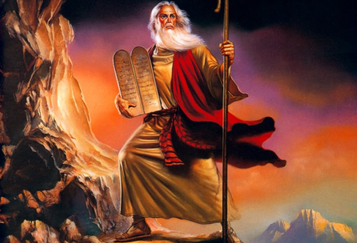
27. Thou shalt not commit _______________________.

28. Thou shalt not ____________________.

29. Thou shalt not bear _________________

_________________________ .

30. Thou shalt not __________________.

