CSSA STAGE 1 JUNIOR #21 NAME ___________________________________

The Golden Calf

Multiple Choice: Circle ALL the Correct Answers!

1. Altogether, Moses went up to Mt Sinai:
a) 2 times b) 5 times c) 7 times d) 10 times

2. When Moses received the 10 commandments, he was on the mountain for:
a) 10 days
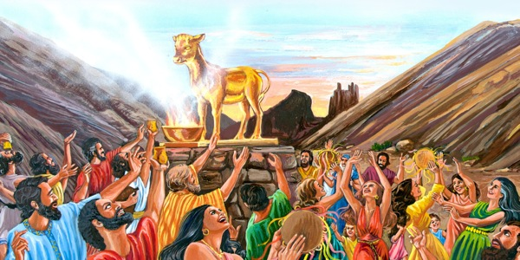
b) 20 days
c) 30 days
d) 40 days

3. The Israelites made a golden calf because:
a) they thought Moses would never return
b) they forgot their promise to love God
c) they wanted a god they could see
d) their heart wasn’t right with God

4. Aaron blamed the golden calf on:
a) Moses b) himself c) the people d) none of these

5. The golden calf was:
a) burned with fire b) ground into powder
c) thrown into the water d) drank by the people

Short Answer

6. Which chapter in Exodus records the incident of the golden calf? ________________________

7. Who did Moses leave in charge of the people when he went up Mt Sinai? ________________________

8. Who did Moses take part way up Mt Sinai when he received the 10 commandments?_________

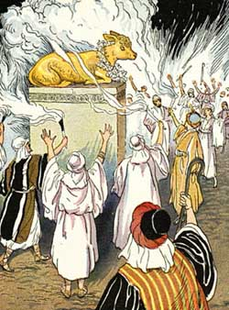
9. What two commandments did the Israelites break when they made the golden calf?

- _______________________________________________________

- _______________________________________________________

10. What did the Israelites do at the feast with the golden calf? _____________

____________________________________________________________

____________________________________________________________

11. Who answered Moses’ question, “Who is on the Yahweh’s side”? ________________________________
True or False
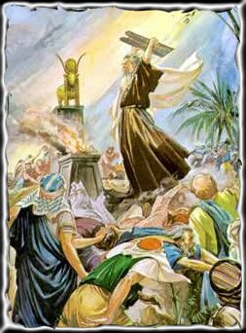
_____ 12. Moses was on Mt Sinai for 40 hours.

_____ 13. The 10 commandments were written with the finger of God.

_____ 14. The golden calf was made with jewelry from Egypt.

_____ 15. Moses would rather die than have God destroy His people.

_____ 16. Moses broke the tablet with the 10 commandments.

_____ 17. Three thousand of the tribe of Levi were killed.

_____ 18. God sent a plague to punish the people.

Fill in the Blank

19. Moses received the 10 commandments on the _______ time he went up Mt Sinai.

20. God was so angry with His people that he wanted to __________ them and make a new

___________________ out of Moses.

21. Joshua thought the noise of shouting meant Israel must have been ________________ by enemies.

22. Moses knew it was the noise of _____________________ and dancing.

23. We must keep our _________________________.

Thought Questions

24. Why do you think Aaron listened to the people and made a golden calf?__________________

___________________________________________________________________________

25. Why do you think Moses didn’t want God to destroy the people and start a new nation from him?
___________________________________________________________________________

___________________________________________________________________________

26. How is Moses going up into Mt Sinai like Jesus going to heaven?_______________________

___________________________________________________________________________

27. Name one lesson we can learn from this story.______________________________________

___________________________________________________________________________

