CSSA STAGE 1 JUNIOR #22 NAME ___________________________________

The Tabernacle - God’s Meeting Place with Israel

Multiple Choice: Circle ALL the Correct Answers!

1. The people of Israel were asked to bring the following materials for the Tabernacle:
a) gold b) badger’s skins c) wood d) linen

2. God chose these two special men to be in charge of building the Tabernacle:
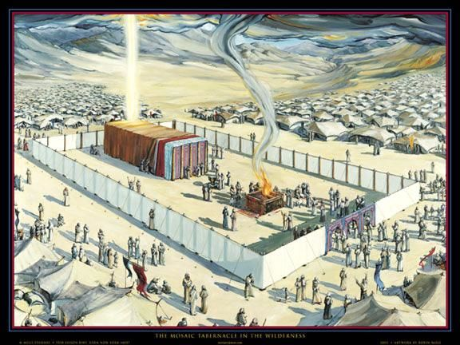
a) Rueben & Simeon
b) Joshua & Caleb
c) Aaron & Hur
d) Bezaleel & Aholiab

3. The women made:
a) curtains
b) the altar of incense
c) holy garments
d) food offerings

4. The walls of the Tabernacle were made of:
a) oak b) maple c) shittim d) pine

5. The Tabernacle was located:
a) north of the camp b) in the center of the camp
c) south of the camp d) east of the camp

6. God gave the workers on the Tabernacle:
a) a paycheck b) extra food c) wisdom d) more space

Short Answer
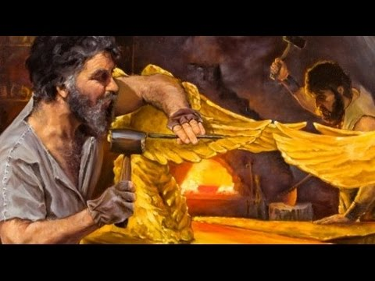
7. Who gave Moses the plans for the Tabernacle? ________________

8. Where did Moses receive the instructions for the Tabernacle?

__________________________________________________

9. What colors were used in the Tabernacle? ________________

__________________________________________________

10. Who pitched their tents at the front of the curtained entrance of the Tabernacle?

____________________________________________________________________________

11. How did the Israelites know when it was time to move the camp?

______________________________________________________________________________________________________

True or False

_____ 12. The people were forced to bring materials for the Tabernacle.

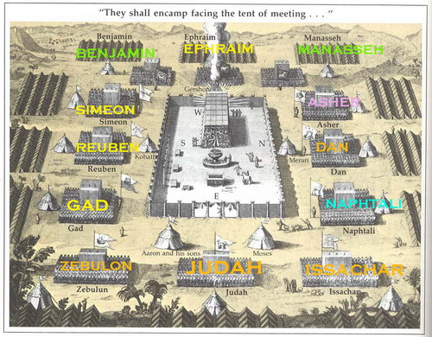
_____ 13. The people brought more than enough materials.

_____ 14. The top pf the Tabernacle was covered with animal’s skins.

_____ 15. The Holy Place and the Most Holy Place were divided by a wall.

_____ 16. The Most Holy place was in the form of a perfect cube.

_____ 17. The tribe of Levi always led the nation of Israel when they moved.

_____ 18. The curtain surrounding the Tabernacle was made of blue, purple and scarlet.

Fill in the Blank

19. Another name for the Tabernacle was ____________________________________________.

20. God told Moses that the Tabernacle must be made ____________________ as he was shown.

21. The Tabernacle measured about _____________ meters by _______________ meters.

22. The Tabernacle was divided into the _________ Place and the _________ _________ Place.

Thought Questions

24. Why do you think God wanted the Tabernacle in the middle of the camp of Israel?__________

___________________________________________________________________________

25. What can we learn from the people who willingly gave gifts for the Tabernacle?____________

___________________________________________________________________________

___________________________________________________________________________
