Tabernacle Overview

Layout of the Tabernacle
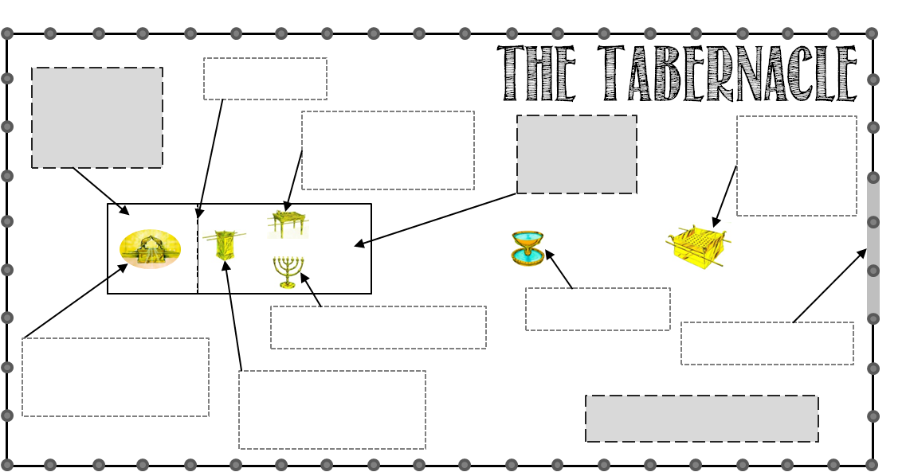

Items in the Tabernacle

Altar of Burnt Offering  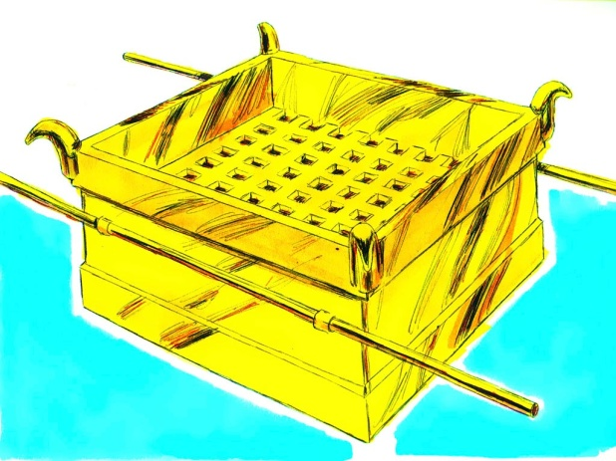 | Location:  Made of:  Purpose:  Lesson: |  | Laver  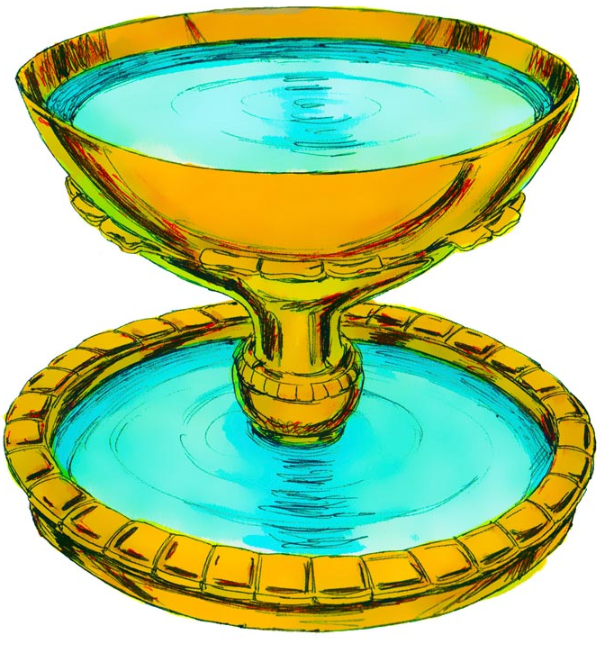 | Location:  Made of:  Purpose:  Lesson:
Table of Shewbread  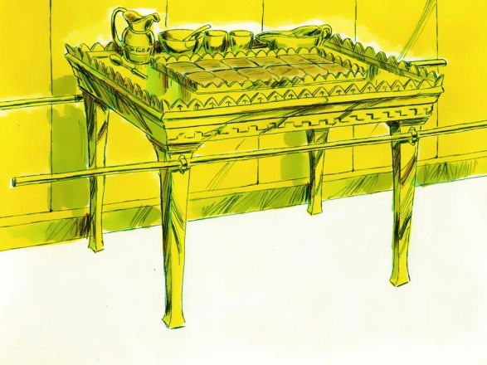 | Location:  Made of:  Purpose:  Lesson: |  | Lampstand  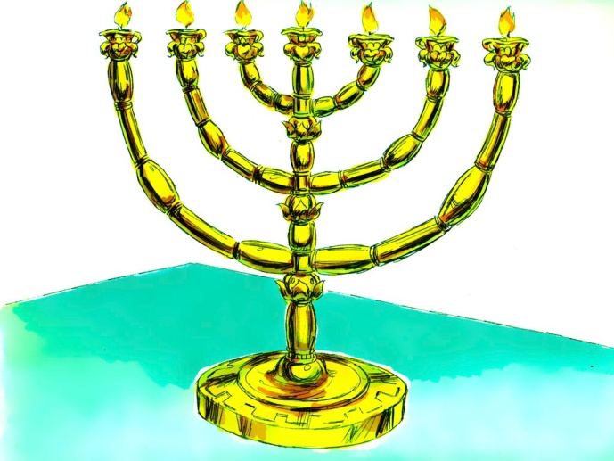 | Location:  Made of:  Purpose:  Lesson:
Altar of Incense  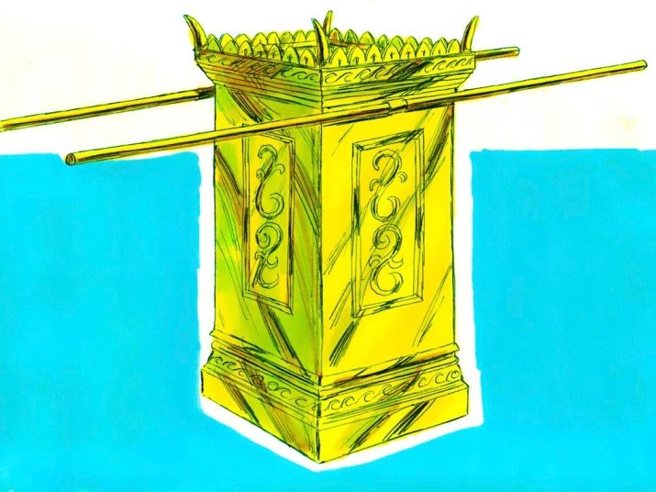 | Location:  Made of:  Purpose:  Lesson: |  | Ark of the Covenant  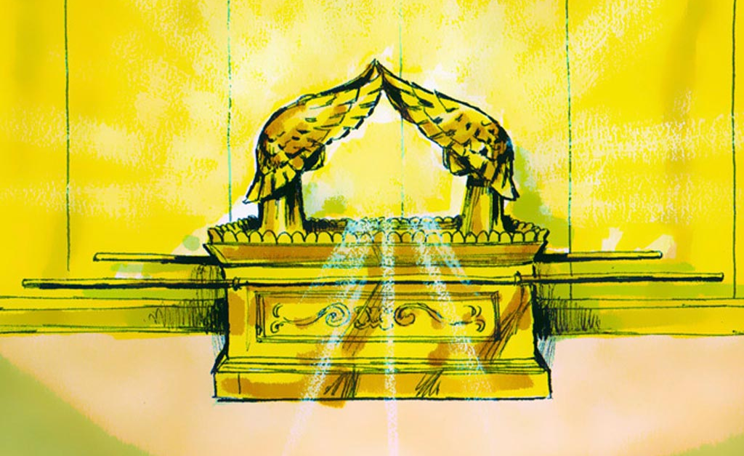 | Location:  Made of:  Purpose:  Lesson:

