CSSA STAGE 1 JUNIOR Handout #5 NAME ___________________________________

The Mistake of Nadab and Abihu

Multiple Choice: Circle ALL the Correct Answers!

1. How many priests were left after Nadab and Abihu died?
a) two b) three c) five d) six

2. How many days did Aaron and his sons have to stay in the Tabernacle during their special preparation:
a) five b) seven c) ten d) fifteen

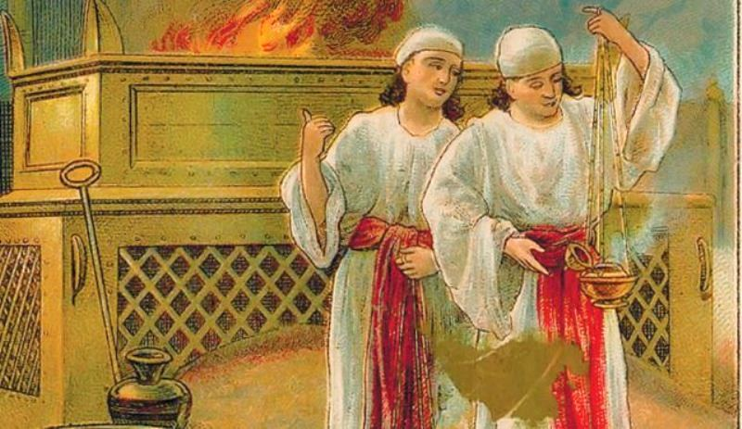
3. Nadab and Abihu were:
a) burned up
b) Aaron’s eldest sons
c) too old to serve as priests
d) disobedient

4. The way people showed their grief in Moses’ time when someone died was by:
a) tearing their clothes
b) letting their hair hang loose
c) cutting their fingernails
d) wearing black clothing

5. God can change us into people prepared for His Kingdom if we:
a) eat our vegetables b) read our Bibles
c) follow His laws d) serve in the ecclesia

True or False

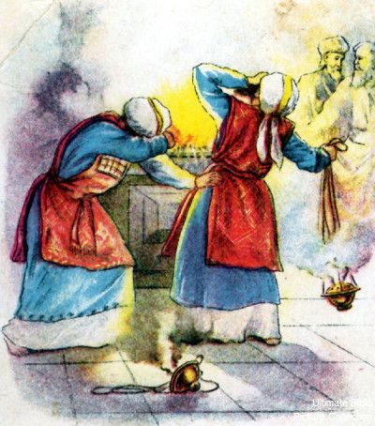
_____ 6. Aaron sprinkled his sons with anointing oil and blood to prepare them as priests.

_____ 7. Nadab and Abihu took their hot coals from the altar of burnt offering.

_____ 8. Aaron was not allowed to mourn the death of his sons.

_____ 9. If you are drunk, you are not responsible for your actions.

_____ 10. Drunkards will not be in the Kingdom of God.

_____ 11. Nadab and Abihu did not treat God’s laws seriously.

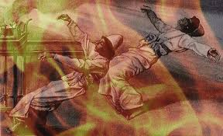
Short Answer

12. How long did it take to make the Tabernacle and all it’s furniture?
_______________________________________________

13. What were the names of Aaron’s four sons? ____________

_______________________________________________________________

14. Where were the priests supposed to get the coals from for their bowls? _________________

___________________________________________________________________________________________________

15. How many days had the Tabernacle been open for worship when Nadab and Abihu were killed?

____________________________________________________________________________________________________

16. What does scripture imply Nadab and Abihu had been doing before worshipping in the Tabernacle?

____________________________________________________________________________________________________

Fill in the Blank

17. On the priests first day in office, fire came from the _____________ and consumed the offering on the altar.

18. God was displeased with Nadab and Abihu because they did not follow His

______________________________.

19. God commanded Aaron not to drink ______________________ when he went into the tent of meeting.

20. Nadab and Abihu were probably _____________________ when they disobeyed God’s instructions.

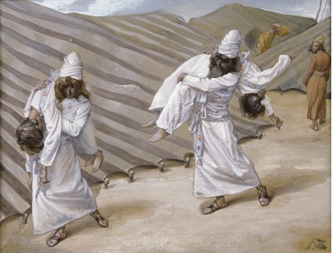
Thought Questions

21. Why wasn’t Aaron and his sons allowed to mourn for Nadab and Abihu?
________________________________________________

________________________________________________________________

________________________________________________________________

22. What is one lesson we should learn about serving God from Nadab and Abihu’s mistake?

___________________________________________________________________________________________________

___________________________________________________________________________________________________

