CSSA STAGE 1 JUNIOR Handout #4 NAME ________________________________

Sacrifices and Offerings

Multiple Choice: Circle ALL the Correct Answers!

1. What were the offerings designed to teach?
- How to kill an animal and drain its blood.
- Everyone about the redeeming work of the Lord Jesus Christ.
- How to survive in the wilderness.
- The people about what they must do to be saved through Jesus.

2. The five types of sacrifices and offerings were:
- Burnt, meal, nice, sin and trespass. c) Burnt, food, peace, sin and trespass.
- Burnt, meal, peace, sin and trespass. d) Burnt, meal, peace, mistakes and trespass.

3. The Burnt Offering:
- The animals represented the evil desires we have that lead us away from God.
- The high priest killed the animal.
- Everything but the skin was placed on the altar.
- Came up to God as a pleasing odor.

4. The Trespass (Guilt) Offering was:
a) only to do with me
b) always a ram
- offered for violating the rights of someone else
- showing when we make mistakes against others we must go overboard to pay them back.

Short Answer

5. In the Burnt Offering why didn’t God want the skin on the altar? ________________________

__________________________________________________________________________

- In the Meal Offering, the grains that were ground into flour that took many months to produce were to teach the offerer what? _________________________________________________

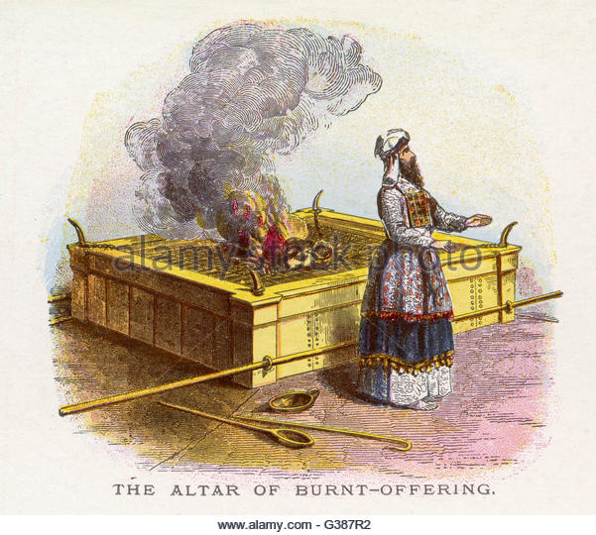
_____________________________________________

- Who was the Peace Offering divided up between? Why?

_____________________________________________

_____________________________________________

- List two lessons we can learn from the Sin Offering.

- __________________________________________

- __________________________________________

True or False

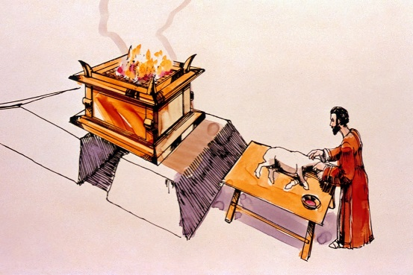
_________ 9. The Meal Offering was designed to teach the offerer that he must be willing to consistently work for God in order to be saved.

_________ 10. In the Burnt Offering the animals represented the evil desires we have that lead us away from God.

_________ 11. The sacrifices did not predict the work of the Lord Jesus Christ.

_________ 12. Jesus willingly poured out his life to God in sinless obedience and then was raised up to eternal life

_________ 13. We no longer live under the Law of Moses with its animal sacrifices, but we still must live by the principles in that law.

_________ 14. In the Trespass Offering it was good enough to just pay the exact value of the mistake.

Fill in the Blanks

15. “Put to ____________ therefore what is _______________ in you _________________

Impurity, passion, _________ ______________, and covetousness, which is idolatry.”

16. “For the bodies of those ______________ whose blood is brought into the sanctuary

by the high priest as a ___________________ for sin are burned outside the camp.”

17. “So Jesus also ________________ outside the _______ in order to sanctify the people

through his own _______________.”

18. We no longer ________ under the Law of __________ with its animal ______________,

but we still must live by the __________________ in that law.

Thought Question

19. How can you apply the principles of the Law in your life? ____________________________

__________________________________________________________________________________

__________________________________________________________________________________

