CSSA STAGE 1 JUNIOR #23 NAME ___________________________________

The Furniture of the Tabernacle

Multiple Choice: Circle ALL the Correct Answers!

1. The following piece of furniture was found in the Most Holy Place:
a) laver b) lampstand c) ark of the covenant d) altar of incense

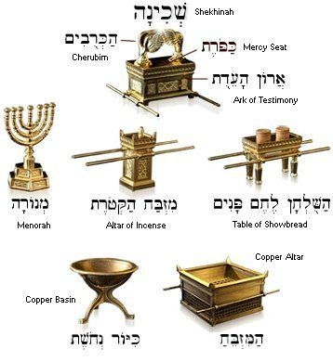
2. The following pieces of furniture were found in the Holy Place:
a) lampstand & altar of incense
b) ark of the covenant
c) table of shewbread
d) laver & altar of burnt offering

3. The oil for the lampstand was supplied by the:
a) priests
b) Levites
c) children of Israel
d) slaves

4. The Most Holy Place was special because:
a) it contained the altar b) only the High Priest could go in every week
c) God dwelt there d) only the High Priest could go in once a year

5. The Mercy Seat was:
a) the lid of the ark b) where the High Priest sat
c) God’s meeting place d) where the people received mercy

6. Inside the Ark were:
a) the 10 commandments b) a pot of manna c) Aaron’s rod d) the golden calf

Short Answer

7. What were the two pieces of furniture in the outer court? _________________________________________

8. What was the Laver used for?____________________________________________________

9. What were the horns of the Altar of Burnt Offering used for? ____________________________

10. Which piece of furniture stood at the end of the Holy Place close to the Vail? _______________

11. Where did the priests get the fire to burn the incense on the Altar of Incense? ___________________

_____________________________________________________________________________________________________

12. What day could the High Priest go into the Most Holy Place? ___________________________

13. What was the Ark made of? _______________________________________________________________________

True or False
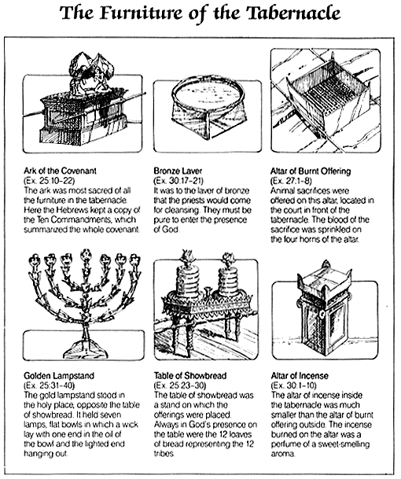
_____ 14. The Altar of Burnt Offering was located at the western end of the court.

_____ 15. The fire under the Altar of Burnt Offering was to burn continuously.

_____ 16. A series of steps led up the Altar of Burnt Offering.

_____ 17. The lampstand was the only light in the Holy Place.

_____ 18. Only Moses and Aaron could eat the shewbread.

_____ 19. Both the Altar of Burnt Offering and the Altar of Incense had four horns.

Fill in the Blank

20. The Altar of Burnt Offering was made of ______________ wood and covered with _________.

21. Water cleans our skin but the _____________ of ______________ cleans our hearts and minds.

22. The twelve loaves represented the work of the _______________ _______________ of Israel.

23. Incense was burned _____________ daily on the Altar of Incense at the time of ___________.

24. The walls of the Most Holy Place were covered with _____________________ .

25. The Ark had figures of pure gold on the lid called ________________________.

Thought Questions

26. The Vail divided the Tabernacle into the Holy Place and the Most Holy Place. They represent our service to God. Which one do you think represents our present work for God and which one represents our future immortal service? Why?

___________________________________________________________________________

___________________________________________________________________________

___________________________________________________________________________

27. The Lampstand gave light to the Holy Place. What do you think gave light to the Most Holy Place? Why?

___________________________________________________________________________

___________________________________________________________________________

