CSSA STAGE 1 JUNIOR #24 NAME ___________________________________

Teachers for Israel

Multiple Choice: Circle ALL the Correct Answers!

1. The Levites became God’s teachers because they:
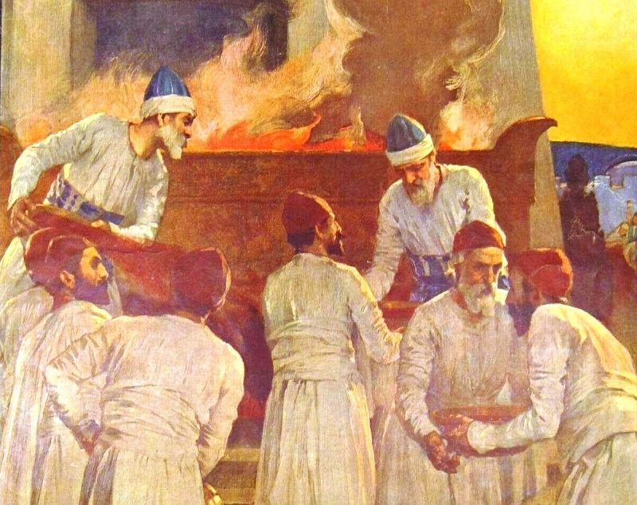
a) separated themselves from sin
b) were handsome
c) joined God’s side in the incident of the bitter water
d) were ready to punish anybody that sinned against God

2. The Levites were chosen to:
a) teach the people
b) do the work of the Tabernacle
c) study the law
d) provide physical food for the Israelites

3. The High Priest was special because:
a) there was only one High Priest at a time
b) he wore the breastplate
c) he was the only one who could go into the Most Holy Place
d) his clothes were designed by God

4. The High Priest wore a blue coat trimmed with:
a) apples b) pears c) pomegranates d) bells

5. Some of the colors on the garments of the High Priest were:
a) gold b) white c) green d) blue

True or False

_____ 6. Reuben received the blessing of a double portion.

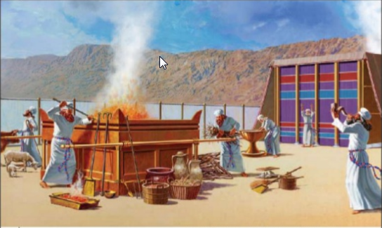
_____ 7. God must come first in our lives.

_____ 8. Only the priests were allowed inside the Tabernacle.

_____ 9. Only the priests could go into the Most Holy Place.

_____ 10. The High Priest wore blue linen trousers.

_____ 11. The Levites were not given any land to grow crops.

_____ 12. The other tribes had to pay a tenth of all they earned every year to the Levites.

Short Answer

13. What were the names of Joseph’s two sons who became tribes? _______________________

___________________________________________________________________________________________________

14. How did the Levites help with the Tabernacle?______________________________________

___________________________________________________________________________________________________

15. List four jobs the priests performed?

- ________________________________________________________________________

- ________________________________________________________________________

- ________________________________________________________________________

- ________________________________________________________________________

16. Who was chosen as the first High Priest? _________________________________________

17. What was on the Breastplate? ___________________________________________________________________

____________________________________________________________________________________________________

18. What did the golden plate on the High Priest’s hat teach him and us about God? ______________

___________________________________________________________________________

Fill in the Blank

19. The name Levi means ____________________________.

20. The priests were chosen from the family of _________________________.

21. The High Priest wore a linen head covering with a plate of gold which said: _______________

___________________________________________________________________________

22. The Levites had to give a ______________ of what they received to the _________________

Thought Questions

23. Why was the land spoken of as belonging to the twelve tribes when there were really thirteen?

___________________________________________________________________________

___________________________________________________________________________

24. The Levites were Israel’s helpers, who are our helpers now? ___________________________________

___________________________________________________________________________

___________________________________________________________________________

