CSSA STAGE 1 JUNIOR #25 NAME ___________________________________

The Three Feasts of Israel

Multiple Choice: Circle ALL the Correct Answers!

1. God gave laws to Israel to teach them how to:
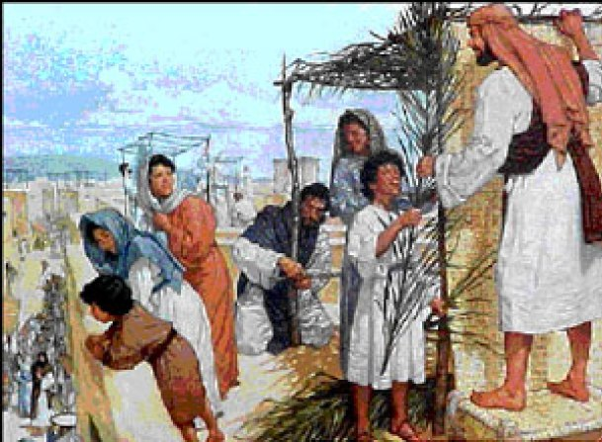
a) treat their neighbors
b) plant their crops
c) live and stay healthy
d) worship Him

2. At the Feast of Weeks the following was offered to God:
a) a turkey
b) two mushrooms
c) two loaves of bread
d) a ram

3. The Passover was celebrated:
a) on the first day of the first month
b) on the same day the Passover lamb was first killed
c) to remind the Israelites how they had been delivered from the Egyptians
d) in and around the Tabernacle

4. During the Feast of Tabernacles:
a) many sacrifices were offered b) no work was permitted
c) boats were built d) the harvest began

5. As the years passed, the Israelites failed to keep God’s laws by:
a) sacrificing sick or deformed animals b) putting themselves first
c) destroying the Temple d) not serving God in love

True or False

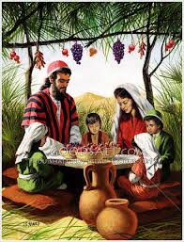
_____ 6. The Feasts of Yahweh were a time of eating and merry making only.

_____ 7. The Feasts of Weeks started 50 days after the Passover.

_____ 8. The Feasts of Weeks was celebrated at harvest time.

_____ 9. The Feast of Tabernacles took place in the same month as the Day of Atonement.

_____ 10. The Feast of Tabernacles took place at the end of the farming year on the 15th day of the 7th month.

_____ 11. The Israelites built new homes of stone during the Feast of Tabernacles.
Short Answer

12. What did God intend His people to do at His Feasts besides eating and making merry? _____

___________________________________________________________________________________________________

___________________________________________________________________________________________________

13. Why is the Feast of Pentecost called the Feast of Weeks?____________________________

___________________________________________________________________________________________________

14. What lesson did the Feast of Weeks teach the Israelites about God? ____________________

___________________________________________________________________________________________________

15. What did living in booths during the Feast of Tabernacles remind the Israelites about? ________

____________________________________________________________________________________________________

____________________________________________________________________________________________________

Fill in the Blank

16. The name of the three feasts God appointed were:

- ________________________________________________________________________

- ________________________________________________________________________

- ________________________________________________________________________

17. Pentecost means_________ day and is another name for the Feast of __________________

18. The word Tabernacle means booth or ______________________________.

19. Many years later, God sent the prophet ______________________ to tell the people of Israel how they had failed to keep God’s laws.

20. God wanted the children of Israel to settle in Canaan and _____________________ the land.

Matching
- Servants

- Harvest

- Farmer

- Seed
21. _____ Good News
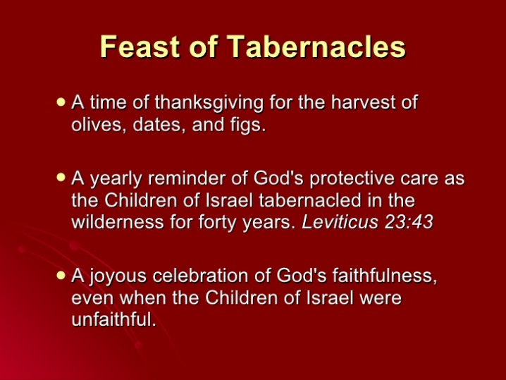
22. _____ God

23. _____ Prophets

24. _____ Return of Christ

