Joseph | I Seek  My Brethren
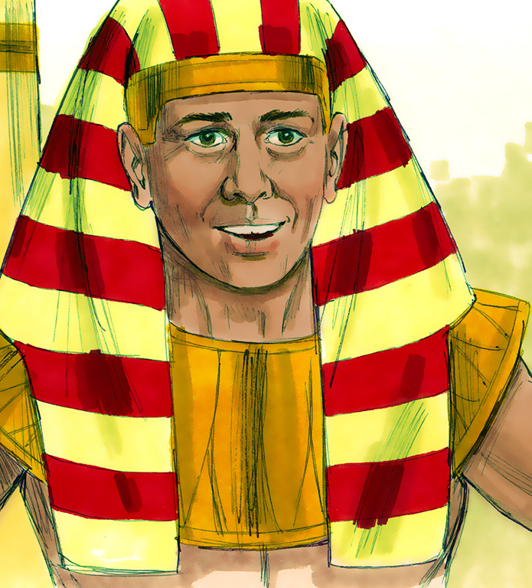
Image from www.freebibleimages.org
Images from www.freebibleimages.org
GRADES 2 & 3

Family Tree of Joseph

Circle Joseph and his mother, Rachel, and his father, Jacob, in the family tree below.
Who is the only son of Jacob that has the same mother as Joseph? ____________________

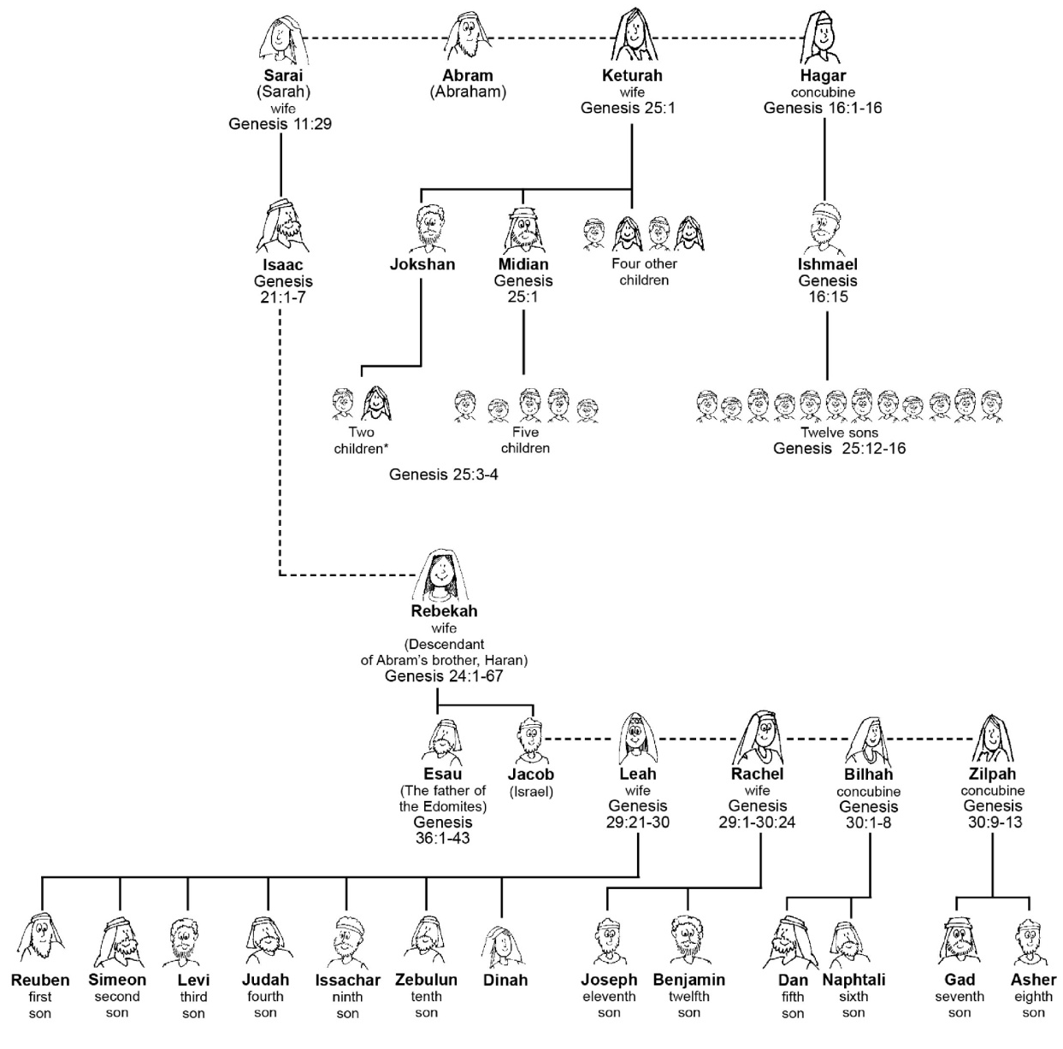

Joseph’s Dreams – Genesis 37:5-11
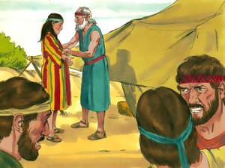
Jacob and his family lived in Canaan. Jacob had twelve sons, but he loved Joseph more than all of them. Jacob gave Joseph a special tunic, or coat, of many colors. This made his brothers jealous and full of hatred for Joseph!

⁵ Now Joseph had a dream, and he told it to his brothers; and they hated him even more.
⁶ So he said to them, “Please hear this dream which I have dreamed:
⁷ There we were, binding sheaves in the field. Then behold, my sheaf arose and also stood upright; and indeed your sheaves stood all around and bowed down to my sheaf.”
⁸ And his brothers said to him, “Shall you indeed reign over us? Or shall you indeed have dominion over us?” So they hated him even more for his dreams and for his words.
⁹ Then he dreamed still another dream and told it to his brothers, and said, “Look, I have dreamed another dream. And this time, the sun, the moon, and the eleven stars bowed down to me.”
¹⁰ So he told it to his father and his brothers; and his father rebuked him and said to him, “What is this dream that you have dreamed? Shall your mother and I and your brothers indeed come to bow down to the earth before you?”
¹¹ And his brothers envied him, but his father kept the matter in mind.

v.5 Joseph had a dream that he told to his brothers. Using your red pencil, color how they felt about him now.
v.7 Draw a picture of Joseph’s first dream –
“There we were, binding sheaves in the field. Then behold, my sheaf arose and also stood upright; and indeed your sheaves stood all around and bowed down to my sheaf.”

v.8 Using your orange pencil, color what Joseph’s brothers thought that the dream meant.

v.9 Draw a picture of Joseph’s second dream –
“Look, I have dreamed another dream. And this time, the sun, the moon, and the eleven stars bowed down to me.”

v.11 Using your red pencil, color how the brothers felt about Joseph after he told them the dreams.

Color the picture of Joseph’s special tunic using the color code below.
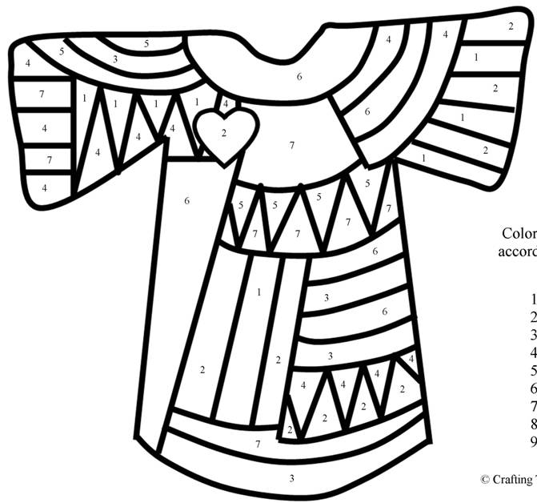
COLOR CODE

1 = Yellow
2 = Red
3 = Orange
4 = Green
5 = Pink
6 = Purple
7 = Blue
Source: www.craftingthewordofgod.com
Joseph’s Brothers Plot Against Him (Part 1) – Genesis 37:19-24
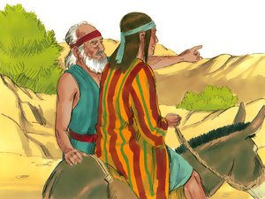
One day, Jacob asked Joseph to go and check on his brothers who were taking care of Jacob’s sheep. The brothers saw Joseph coming from far off. They hated him so much they wanted to kill him!

¹⁹ Then they said to one another, “Look, this dreamer is coming!
²⁰ Come therefore, let us now kill him and cast him into some pit; and we shall say, ‘Some wild beast has devoured him.’ We shall see what will become of his dreams!”
²¹ But Reuben heard it, and he delivered him out of their hands, and said, “Let us not kill him.”
²² And Reuben said to them, “Shed no blood, but cast him into this pit which is in the wilderness, and do not lay a hand on him”—that he might deliver him out of their hands, and bring him back to his father.
²³ So it came to pass, when Joseph had come to his brothers, that they stripped Joseph of his tunic, the tunic of many colors that was on him.
²⁴ Then they took him and cast him into a pit. And the pit was empty; there was no water in it.

v.19 What was the name the brothers called Joseph?
v.21-22 With your green pencil, color the name of the brother who said that they should not kill Joseph but throw him into a pit instead.
v.23 With your purple pencil, color what the brothers took away from Joseph before they threw him into the pit.
Fill in the crossword with the words listed. “Plotted” has already been done!

DRY
LET’S
WILD
HEARD
THREW
DREAMS
ANIMAL
KILLED
RIPPED
PLOTTED
DISTANCE
WILDERNESS
 |  |  | P | L | O | T | T | E | D

Joseph’s Brothers Plot Against Him (Part 2) – Genesis 37:25-35

²⁵ And they sat down to eat a meal. Then they lifted their eyes and looked, and there was a company of Ishmaelites, coming from Gilead with their camels, bearing spices, balm, and myrrh, on their way to carry them down to Egypt.
²⁶ So Judah said to his brothers, “What profit is there if we kill our brother and conceal his blood?
²⁷ Come and let us sell him to the Ishmaelites, and let not our hand be upon him, for he is our brother and our flesh.” And his brothers listened.
²⁸ Then Midianite traders passed by; so the brothers pulled Joseph up and lifted him out of the pit, and sold him to the Ishmaelites for twenty shekels of silver. And they took Joseph to Egypt.
²⁹ Then Reuben returned to the pit, and indeed Joseph was not in the pit; and he tore his clothes.
³⁰ And he returned to his brothers and said, “The lad is no more; and I, where shall I go?”
³¹ So they took Joseph’s tunic, killed a kid of the goats, and dipped the tunic in the blood.
³² Then they sent the tunic of many colors, and they brought it to their father and said, “We have found this. Do you know whether it is your son’s tunic or not?”
³³ And he recognized it and said, “It is my son’s tunic. A wild beast has devoured him. Without doubt Joseph is torn to pieces.”
³⁴ Then Jacob tore his clothes, put sackcloth on his waist, and mourned for his son many days.
³⁵ And all his sons and all his daughters arose to comfort him; but he refused to be comforted, and he said, “For I shall go down into the grave to my son in mourning.” Thus his father wept for him.

v.25 With your orange pencil, color what the brothers were doing while Joseph was crying from the pit.
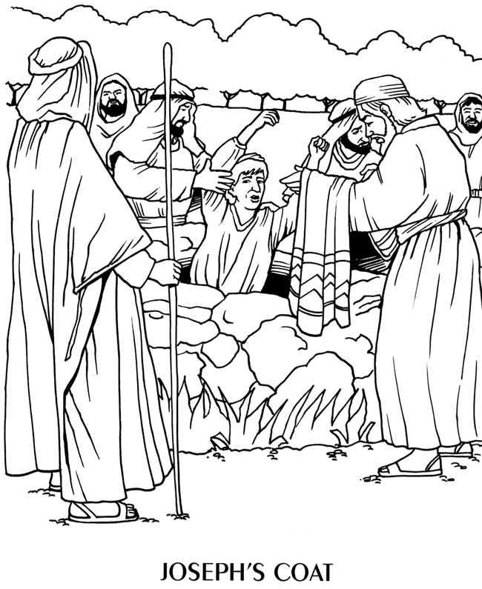
v.26-27 With your red pencil, color the name of the brother who had the idea to sell Joseph instead of kill him.
v.28 With your gray pencil, color the amount of silver that the brothers sold Joseph for.
v.29 With your yellow pencil, color what Reuben did when he realized Joseph was not in the pit.
v.31-32 What did the brothers do with Joseph’s tunic to trick Jacob?

v.33-34 With your yellow pencil, color what Jacob did when he saw Joseph’s tunic.
Source: www.sermons4kids.com
Find the list of words on the right in the word search.
F | G | N | J | E | A | L | O | U | S | Y | D | K | A | E | Benjamin  Blood  Brothers  Coat  Dreams  Egypt  Families  Famine  Forgave  Jealousy  Joseph  King  Ring  Slave  Sold
W | O | T | I | Z | C | B | S | S | R | D | O | I | I | M
A | R | R | N | X | K | O | E | Q | E | R | O | N | Q | Q
D | U | G | G | E | E | I | A | X | H | E | L | G | M | E
Q | B | K | G | A | L | J | C | T | T | A | B | O | N | T
V | P | N | K | I | V | A | U | L | O | M | D | I | P | B
D | I | D | M | L | E | E | T | E | R | S | M | Y | Q | D
R | I | A | J | O | S | E | P | H | B | A | G | D | D | Y
I | F | S | L | A | V | E | E | I | F | E | D | L | O | S
T | Y | N | B | E | N | J | A | M | I | N | E | N | I | O

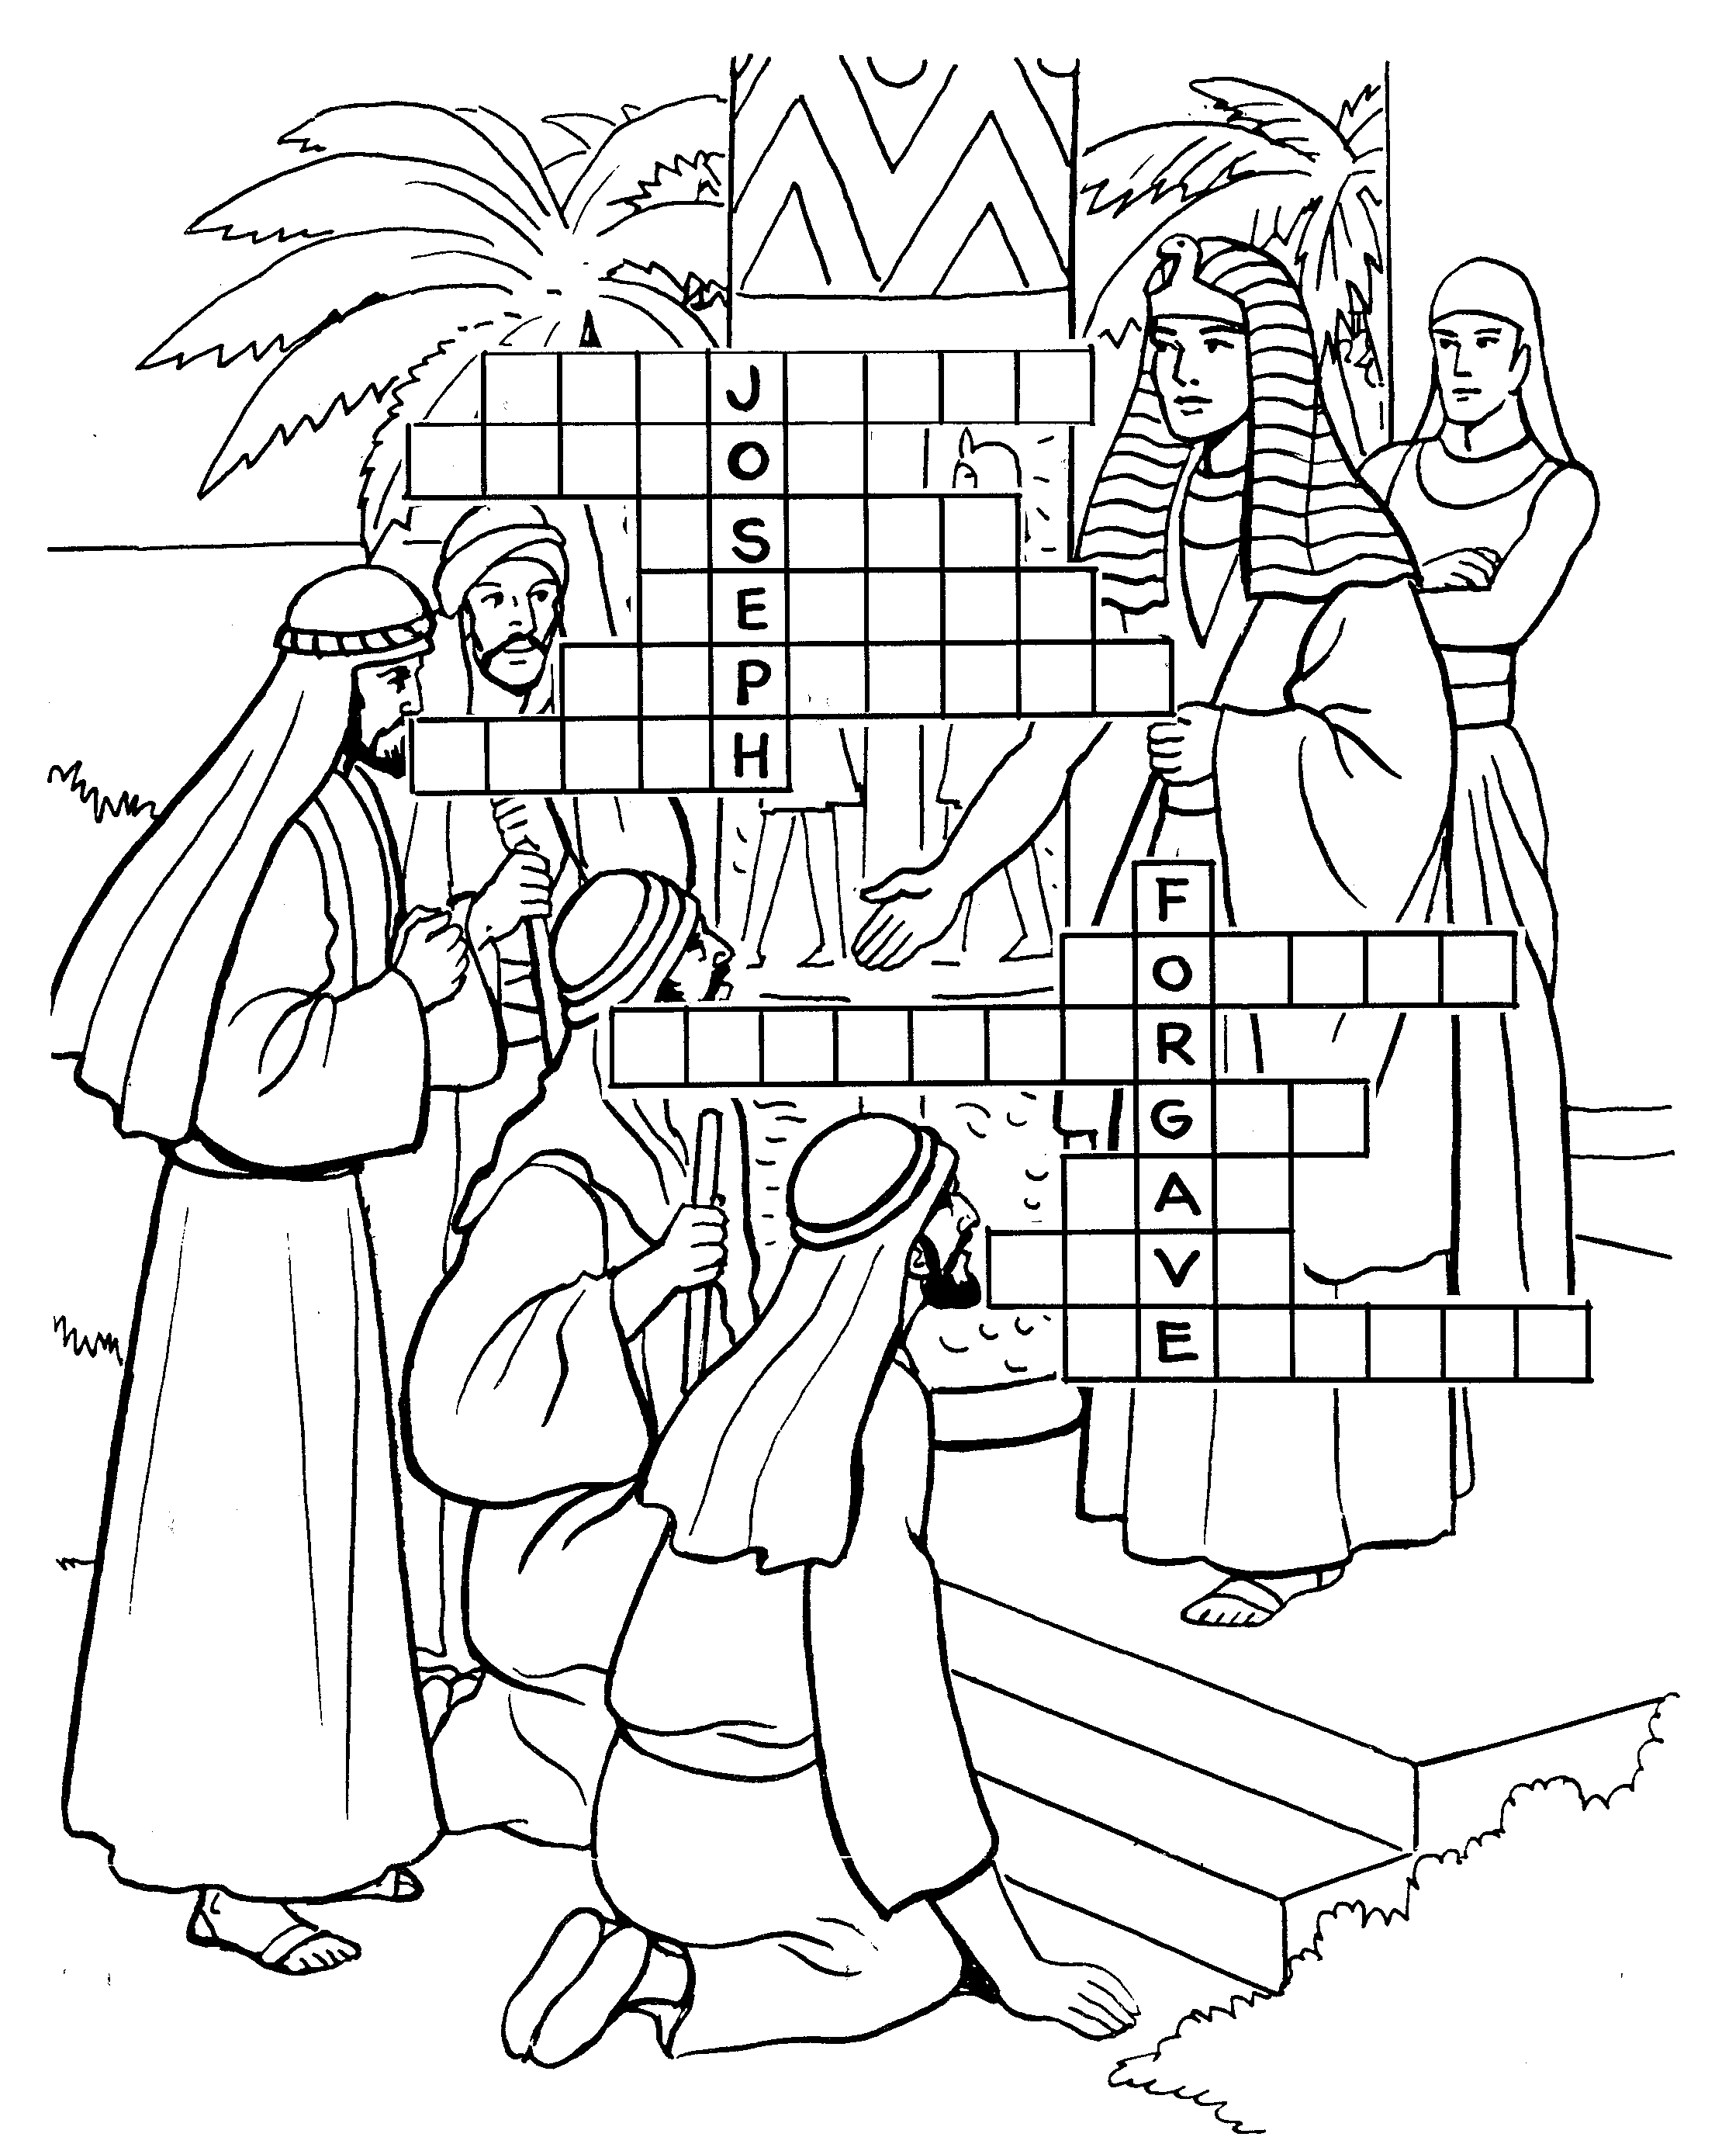 | Fill in the names of Jacob’s 12 sons.  The names are in order from top to bottom.  Benjamin  Simeon  Asher  Reuben  Naphtali  Judah  Joseph  Issachar  Gad  Dan  Levi  Zebulun

In Potipher’s House – Genesis 39:1-23

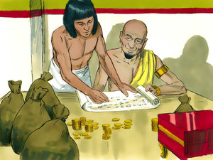
While Jacob was mourning over the death of Joseph, Joseph was actually alive and on his way to Egypt! In Egypt, Joseph was sold to Potipher, an officer of Pharaoh. God was with Joseph in Egypt. Potipher could see that whatever Joseph did prospered, and put him in charge of all of his house.

Although Joseph obeyed God, Potipher’s wife lied to her husband telling him that Joseph had done wrong. Because of this lie, Potipher threw Joseph into prison.

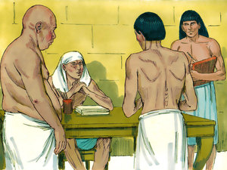
But God took care of Joseph in prison, too. The keeper of the prison liked Joseph and put him in charge of all the prisoners!

One day, Pharoah became angry at his butler and baker and threw them in prison!
Pharaoh’s Butler and Baker – Genesis 40:5-8

⁵ Then the butler and the baker of the king of Egypt, who were confined in the prison, had a dream, both of them, each man’s dream in one night and each man’s dream with its own interpretation.
⁶ And Joseph came in to them in the morning and looked at them, and saw that they were sad.
⁷ So he asked Pharaoh’s officers who were with him in the custody of his lord’s house, saying, “Why do you look so sad today?”
⁸ And they said to him, “We each have had a dream, and there is no interpreter of it.” So Joseph said to them, “Do not interpretations belong to God? Tell them to me, please.”

v.5 With your green pencil, color who had dreams while in prison.
v.6 Joseph came in the morning to see how the butler and baker were doing. With your yellow pencil, color how the butler and baker were feeling.
v.8 Who did Joseph say interpretation of dreams belonged to?
The butler had a dream about grapes.
See if you can find your way through the grape maze.
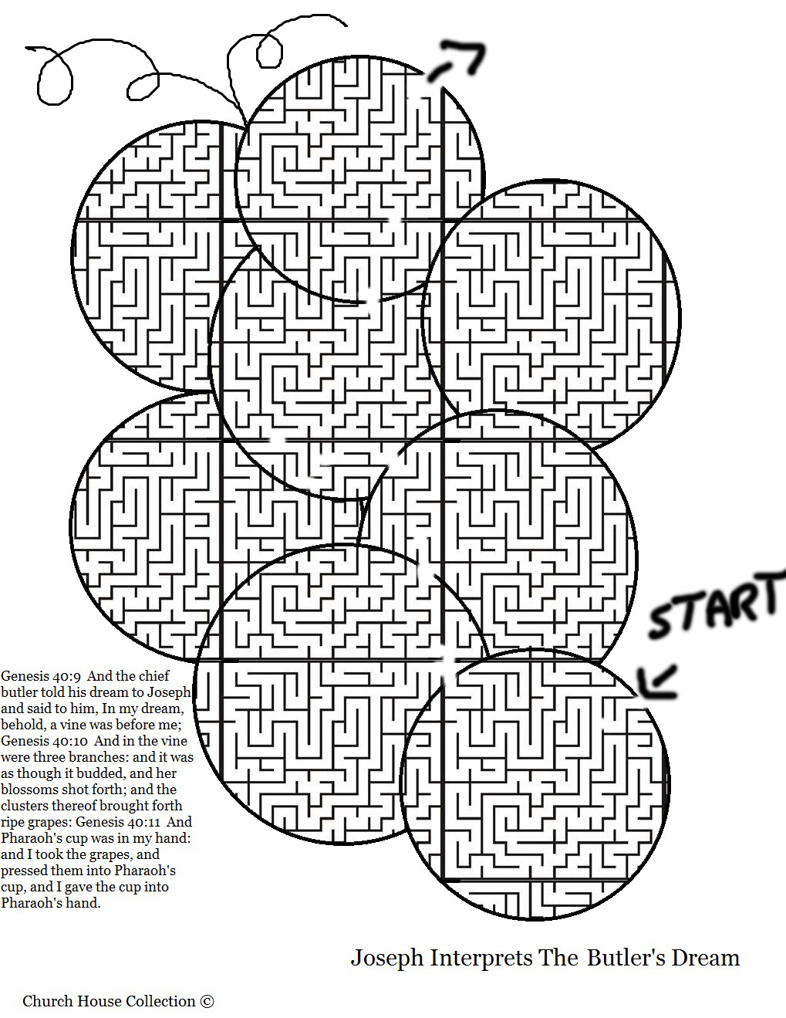
Source: www.churchhousecollection.com

START
END
The Butler’s Dream – Genesis 40:9-15

⁹ Then the chief butler told his dream to Joseph, and said to him, “Behold, in my dream a vine was before me,
¹⁰ and in the vine were three branches; it was as though it budded, its blossoms shot forth, and its clusters brought forth ripe grapes.
¹¹ Then Pharaoh’s cup was in my hand; and I took the grapes and pressed them into Pharaoh’s cup, and placed the cup in Pharaoh’s hand.”
¹² And Joseph said to him, “This is the interpretation of it: The three branches are three days.
¹³ Now within three days Pharaoh will lift up your head and restore you to your place, and you will put Pharaoh’s cup in his hand according to the former manner, when you were his butler.
¹⁴ But remember me when it is well with you, and please show kindness to me; make mention of me to Pharaoh, and get me out of this house.
¹⁵ For indeed I was stolen away from the land of the Hebrews; and also I have done nothing here that they should put me into the dungeon.”

v.9-11 Draw the Butler’s dream –

v.12-13 In the interpretation of the dream, what would Pharaoh do to the butler after three days?

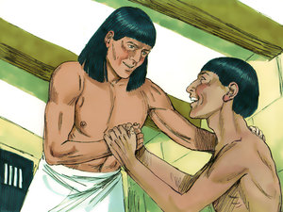
v.14 What did Joseph ask the chief butler to do?

The Baker’s Dream – Genesis 40:16-23

¹⁶ When the chief baker saw that the interpretation was good, he said to Joseph, “I also was in my dream, and there were three white baskets on my head.
¹⁷ In the uppermost basket were all kinds of baked goods for Pharaoh, and the birds ate them out of the basket on my head.”
¹⁸ So Joseph answered and said, “This is the interpretation of it: The three baskets are three days.
¹⁹ Within three days Pharaoh will lift off your head from you and hang you on a tree; and the birds will eat your flesh from you.”
²⁰ Now it came to pass on the third day, which was Pharaoh’s birthday, that he made a feast for all his servants; and he lifted up the head of the chief butler and of the chief baker among his servants.
²¹ Then he restored the chief butler to his butlership again, and he placed the cup in Pharaoh’s hand.
²² But he hanged the chief baker, as Joseph had interpreted to them.
²³ Yet the chief butler did not remember Joseph, but forgot him.

v.16-17 Draw the baker’s dream –

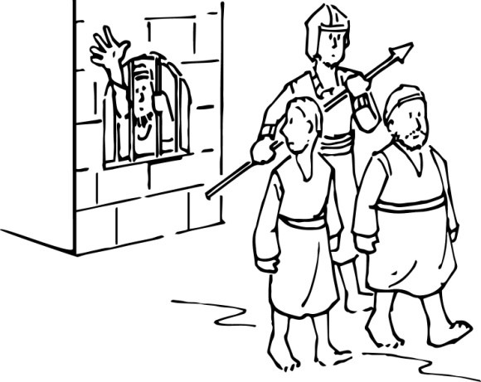
v.18-19 With your orange pencil, color what would happen to the baker after three days.
v.20-22 Were the interpretations that Joseph gave to these men from God fulfilled? __________
v.23 Did the butler remember Joseph? ___________

See if you can find your way through the baker’s hat maze.
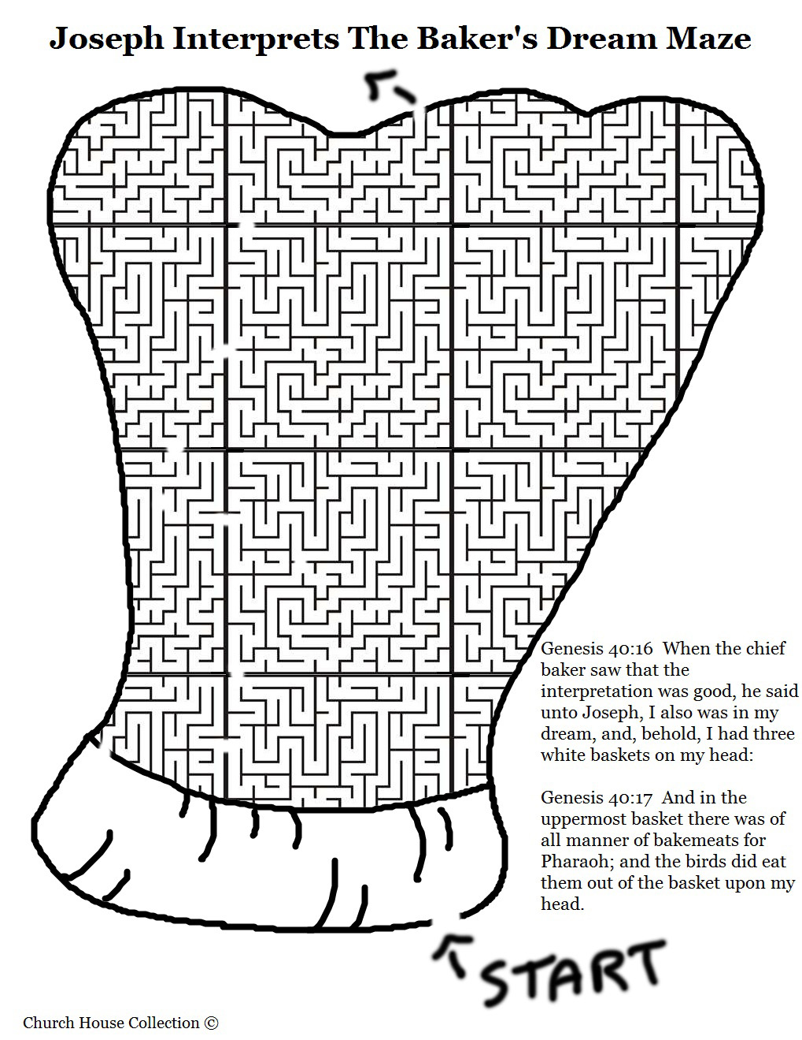
Source: www.churchhousecollection.com

START
END

Complete the crossword. There is a word bank at the bottom to help you.

 |  |  |  |  | 1 |  | 2 |  |  | 3 |  |  | Across  1. The person who took the King’s wine.  4. The baker dreamed these were on top of his head.  10. Joseph told the baker that in 3 days he would _____.  11. Pharaoh dreamed about this.  12. Joseph’s youngest brother.  Down  1. The person who baked the King’s bread.  2. Even in prison, Joseph put his ______ in God.  3. Joseph asked the butler to ______ him when he went back to Pharaoh.  5. The number of years of the famine.  7. Pharaoh dreamed about these animals.  9. The ugly skinny cows came up from the ______.  10. Joseph told Pharaoh what his ______ meant.
 | 4 |  | 5
 | 7 |  |  |  | 9 |  |  | 10
11
 |  |  |  | 12

WORD BANK: Benjamin river remember dream baskets baker butler die cows trust seven corn
Pharaoh’s Dreams (Part 1) – Genesis 41:1-8

¹ Then it came to pass, at the end of two full years, that Pharaoh had a dream; and behold, he stood by the river.
² Suddenly there came up out of the river seven cows, fine looking and fat; and they fed in the meadow.
³ Then behold, seven other cows came up after them out of the river, ugly and gaunt, and stood by the other cows on the bank of the river.
⁴ And the ugly and gaunt cows ate up the seven fine looking and fat cows. So Pharaoh awoke.
⁵ He slept and dreamed a second time; and suddenly seven heads of grain came up on one stalk, plump and good.
⁶ Then behold, seven thin heads, blighted by the east wind, sprang up after them.
⁷ And the seven thin heads devoured the seven plump and full heads. So Pharaoh awoke, and indeed, it was a dream.
⁸ Now it came to pass in the morning that his spirit was troubled, and he sent and called for all the magicians of Egypt and all its wise men. And Pharaoh told them his dreams, but there was no one who could interpret them for Pharaoh.

v.1 With your green pencil, color how much time had passed since Joseph asked the butler to remember him.
v.1-4 Draw Pharaoh’s first dream –

v.5-7 Draw Pharaoh’s second dream –

v. 8 Could any of Pharaoh’s wise men tell him the meaning of his dreams? ______
Joseph Tells the Meaning of Pharaoh’s Dreams – Genesis 41:25-31

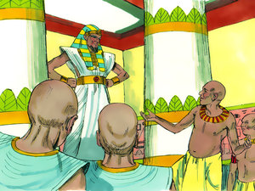
None of Pharaoh’s magicians or wise men could interpret his dreams. Suddenly the chief butler remembered the man who had accurately interpreted his and the baker’s dreams in prison! Quickly, Pharaoh sent and brought Joseph out of prison. Joseph told Pharaoh that it was not him, but God, that could interpret his dreams!
²⁵ Then Joseph said to Pharaoh…
²⁶ The seven good cows are seven years, and the seven good heads are seven years; the dreams are one.
²⁷ And the seven thin and ugly cows which came up after them are seven years, and the seven empty heads blighted by the east wind are seven years of famine.
²⁸ This is the thing which I have spoken to Pharaoh. God has shown Pharaoh what He is about to do.
²⁹ Indeed seven years of great plenty will come throughout all the land of Egypt;
³⁰ but after them seven years of famine will arise, and all the plenty will be forgotten in the land of Egypt; and the famine will deplete the land.
³¹ So the plenty will not be known in the land because of the famine following, for it will be very severe.

v.26-31 Joseph said the two dreams of Pharaoh were one, which meant that they had the same meaning. Write what the parts of the dreams meant:
The number 7 represents (v.26)
Good cows and good ears represent (v.29)
Thin & ill cows and empty ears represent (v.30)
With God’s help, Joseph tells Pharaoh the meaning of his dreams.  Spot the differences in the two pictures.  Source: www.biblewise.com | 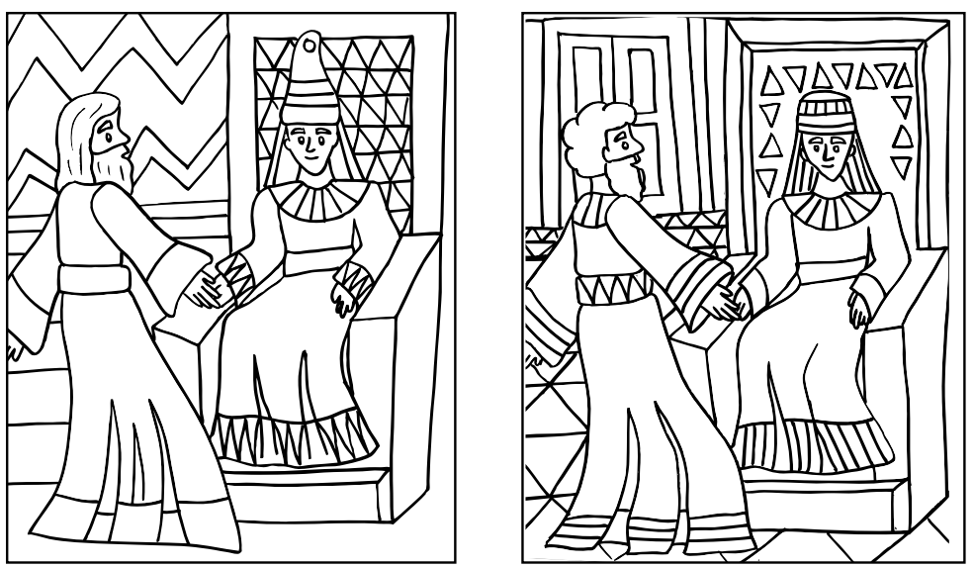
Use the code to work out the meaning of Pharaoh’s dreams.

A | B | D | E | F | I | L | M | N | O | P | R | S | T | W | Y | 7

 |  | ____ |  | ____ | ____ | ____ | ____ | ____
 | ____ | ____ |  | ____ | ____ | ____ | ____ | ____ | ____
____ | ____ | ____ | ____ | ____ | ____ | ____ | ____ |  | ____ | ____
 |  | ____ |  | ____ | ____ | ____ | ____ | ____
 | ____ | ____ |  | ____ | ____ | ____ | ____ | ____ | ____
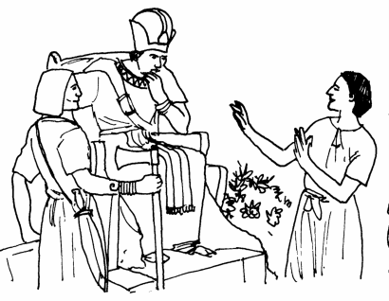
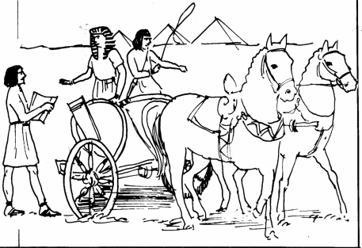
Joseph Rises to Power – Genesis 41:37-57
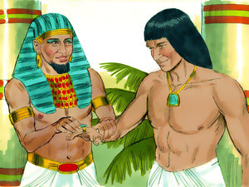
Pharaoh appointed Joseph ruler in Egypt, second only to Pharaoh himself! Joseph spent the seven years of plenty gathering food to prepare for the famine that God had revealed would soon come to Egypt.

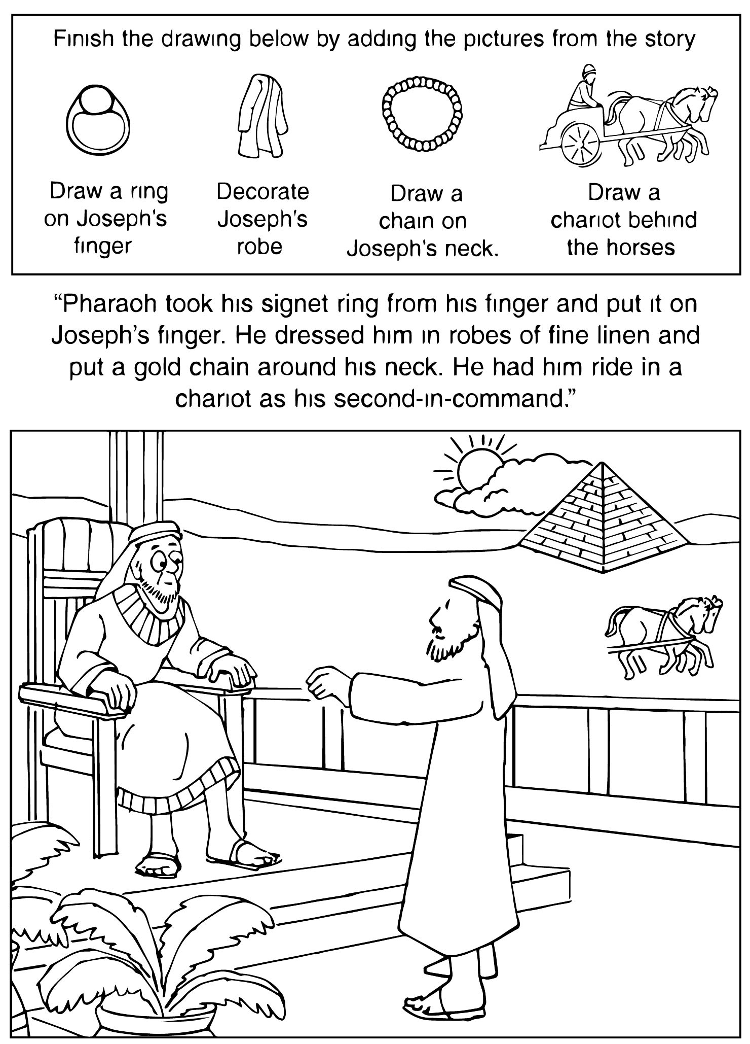
Joseph’s Brothers Come to Egypt to Buy Food – Genesis 42:6-11

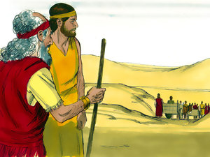
Before long, the seven years of plenty were over and the famine had begun. Far away in Canaan, Jacob and Joseph’s brothers heard that they could find food in Egypt. Ten of Joseph’s brothers went to Egypt to buy grain. However, Jacob would not allow Benjamin, his youngest son, to go to Egypt because he was concerned something bad could happen to him.
⁶ Now Joseph was governor over the land; and it was he who sold to all the people of the land. And Joseph’s brothers came and bowed down before him with their faces to the earth.
⁷ Joseph saw his brothers and recognized them, but he acted as a stranger to them and spoke roughly to them. Then he said to them, “Where do you come from?”
And they said, “From the land of Canaan to buy food.”
⁸ So Joseph recognized his brothers, but they did not recognize him.
⁹ Then Joseph remembered the dreams which he had dreamed about them, and said to them, “You are spies! You have come to see the nakedness of the land!”
¹⁰ And they said to him, “No, my lord, but your servants have come to buy food.
¹¹ We are all one man’s sons; we are honest men; your servants are not spies.”

v.6 With your blue pencil, color what Joseph’s brothers did when they came before him.
Who’s dream is coming true now? ____________________
v.7 With your red pencil, color how Joseph spoke to his brothers.
v.8 Did his brothers know who he was? _________
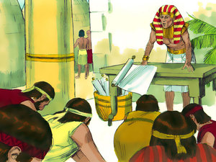
v.9 With your red pencil, color what Joseph accused his brothers of being.
v.10 What did Joseph’s brothers say their reason for coming was?

Joseph’s Brothers in Egypt – Genesis 42:19-24

Joseph said,
¹⁹ If you are honest men, let one of your brothers be confined to your prison house; but you, go and carry grain for the famine of your houses.
²⁰ And bring your youngest brother to me; so your words will be verified, and you shall not die.” And they did so.
²¹ Then they said to one another, “We are truly guilty concerning our brother, for we saw the anguish of his soul when he pleaded with us, and we would not hear; therefore this distress has come upon us.”
²² And Reuben answered them, saying, “Did I not speak to you, saying, ‘Do not sin against the boy’; and you would not listen? Therefore behold, his blood is now required of us.”
²³ But they did not know that Joseph understood them, for he spoke to them through an interpreter.
²⁴ And he turned himself away from them and wept. Then he returned to them again, and talked with them. And he took Simeon from them and bound him before their eyes.

v.20 With your blue pencil, color who Joseph wanted the brothers to bring to him.
v.21 Why did Joseph’s brothers think that this was happening to them?

v.21-23 Joseph’s brothers then had a discussion about the past. Could Joseph understand them? (v.23) ______
Did Joseph’s brothers know that Joseph could understand them? (v.23) _______
v.24 With your green pencil, color what Joseph did when he heard his brothers talking.
With your orange pencil, color the name of the brother who was selected to stay bound in Egypt.
Starting with the letter “S” and moving clockwise, write down every 3rd letter to
find out:
- the name of the brother who was kept in Egypt, and
- the brother who had to come down to Egypt the next time the brothers came.

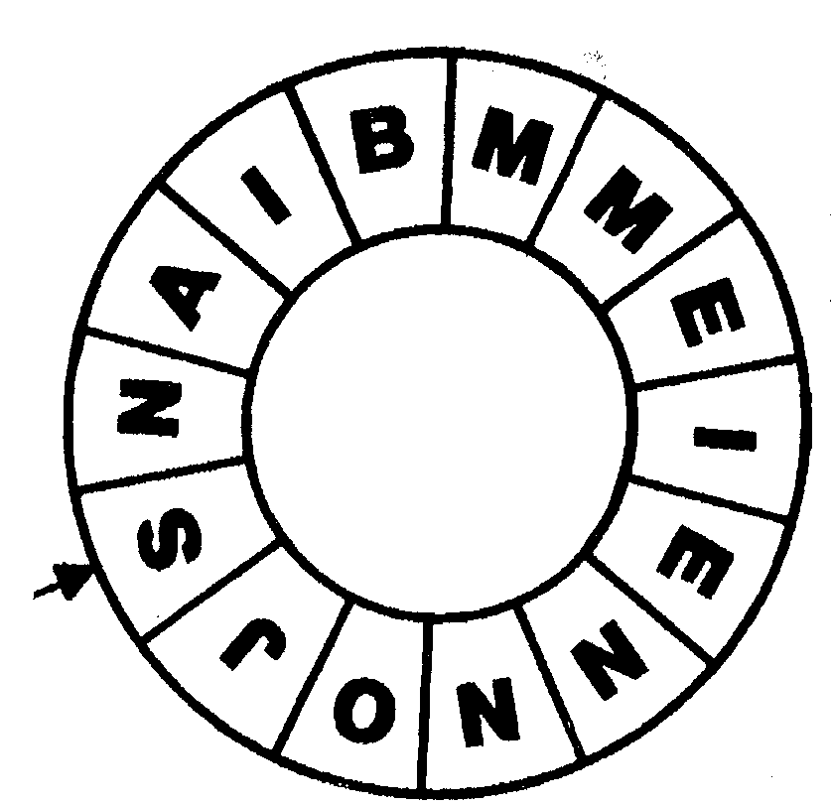  START | S ____ ____ ____ ____ ____  B ____ ____ ____ ____ ____ ____ ____

Joseph’s Brothers Bring Benjamin to Egypt – Genesis 43

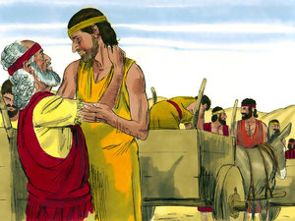
The brothers returned home, leaving Simeon bound in Egypt. Soon the grain from Egypt had run out and Jacob asked his sons to return to buy more grain. Judah reminded Jacob that the governor of Egypt warned them not to come unless they brought Benjamin with them. Jacob did not want to allow Benjamin to go, but Judah assured his father that he would not let anything bad happen to Benjamin. Finally, Jacob allowed them to return to Egypt, sending them with double the money and many presents.

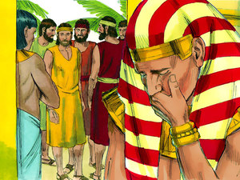
When they returned to Egypt, they presented their gifts to Joseph and bowed before him. But instead of treating them roughly like before, Joseph asked, “How is your father – the old man whom you told me about? Is he still alive?” The brothers answered, “Your servant our father is in good health, and is still alive.” Then Joseph looked up and saw his brother Benjamin, and his heart yearned for him. Joseph quickly went into his own chamber and wept.

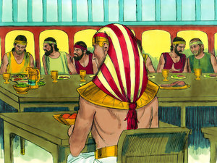
Afterwards, Joseph invited his brothers for a great feast. The brothers realized in astonishment that they had been seated in order of their age! They must have wondered how the governor of Egypt knew so much about them! When the servings of food were brought out to the men, Benjamin’s serving was five times as much as any of the brothers!
Money and Joseph’s Cup Put in Sacks – Genesis 44:1-4

¹ And he commanded the steward of his house, saying, “Fill the men’s sacks with food, as much as they can carry, and put each man’s money in the mouth of his sack.
² Also put my cup, the silver cup, in the mouth of the sack of the youngest, and his grain money.” So he did according to the word that Joseph had spoken.
³ As soon as the morning dawned, the men were sent away, they and their donkeys.
⁴ When they had gone out of the city, and were not yet far off, Joseph said to his steward, “Get up, follow the men; and when you overtake them, say to them, ‘Why have you repaid evil for good?’”
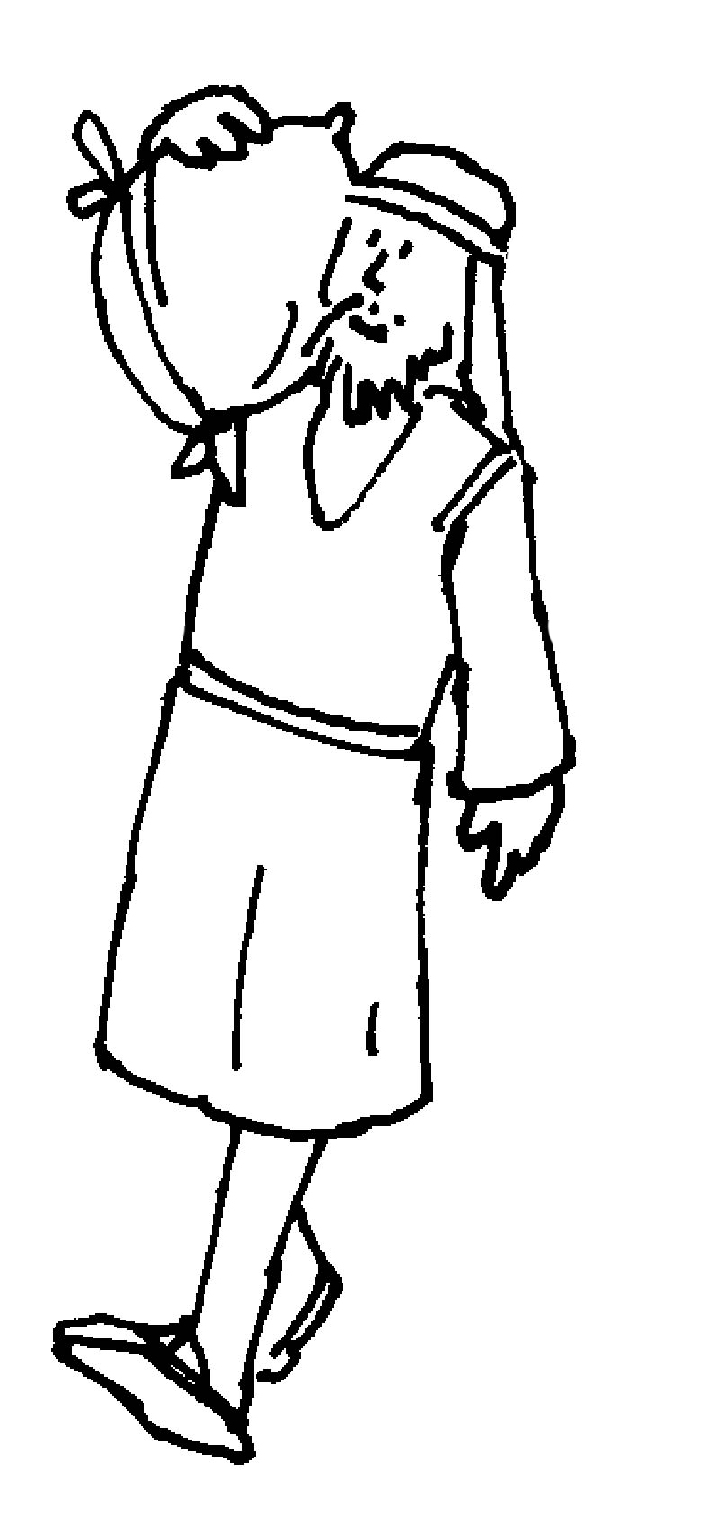
v.1 With your green pencil, color what Joseph commanded the steward to put in the mouth of each of the man’s sacks.
v.2 With your yellow pencil, color where Joseph commanded the steward to put his silver cup.
v.4 With your orange pencil, color what Joseph told the steward to say to his brothers when he caught up with them.
Joseph’s Cup

Color and decorate
Joseph’s cup.
You can use glitter,
stickers, shiny paper, etc.
Source: CSSA Handbook
Silver Cup Found in Benjamin’s Sack – Genesis 44:6-13

⁶ So he overtook them, and he spoke to them these same words.
⁷ And they said to him, “Why does my lord say these words? Far be it from us that your servants should do such a thing.
⁸ Look, we brought back to you from the land of Canaan the money which we found in the mouth of our sacks. How then could we steal silver or gold from your lord’s house?
⁹ With whomever of your servants it is found, let him die, and we also will be my lord’s slaves.”
¹⁰ And he said, “Now also let it be according to your words; he with whom it is found shall be my slave, and you shall be blameless.”
¹¹ Then each man speedily let down his sack to the ground, and each opened his sack.
¹² So he searched. He began with the oldest and left off with the youngest; and the cup was found in Benjamin’s sack.
¹³ Then they tore their clothes, and each man loaded his donkey and returned to the city.

v.7-8 Did the brothers think they had done anything wrong in this incident?
v.9 With your red pencil, color what the brothers said should happen to the man who had the cup in his sack.
With your red pencil, also color what the brothers said should happen to the rest of them.
v.10 With your orange pencil, color what the steward said would happen to the one who had the cup.
With your orange pencil, also color what the steward said would happen to the rest of the brothers.
v.12 With your green pencil, color the man’s name in whose sack the silver cup was found.
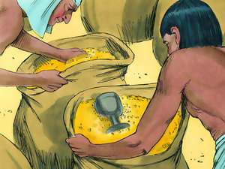
v.13 With your yellow pencil, color what the brothers did when the silver cup was found in Benjamin’s sack.
The brothers had not listened to Joseph when he cried out to them from the pit. How are they treating Benjamin’s trouble differently now?

Judah Offers His Life to Spare Benjamin – Genesis 44:18-34

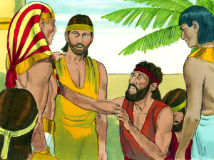
Benjamin and his brothers all returned back to Joseph, and fell before him on the ground. Joseph said, “What is this you have done?!” Judah replied, “What can we say? How can we clear ourselves? We will all be your slaves.” “No,” Joseph said, “Only the one in whose hand the cup was found will be my slave. The rest of you return to your father.”
¹⁸ Then Judah came near to him and said: “O my lord, please let your servant speak a word in my lord’s hearing, and do not let your anger burn against your servant; for you are even like Pharaoh…
³⁰ “Now therefore, when I come to your servant my father, and the lad is not with us, since his life is bound up in the lad’s life,
³¹ it will happen, when he sees that the lad is not with us, that he will die. So your servants will bring down the gray hair of your servant our father with sorrow to the grave…
³³ Now therefore, please let your servant remain instead of the lad as a slave to my lord, and let the lad go up with his brothers.
³⁴ For how shall I go up to my father if the lad is not with me, lest perhaps I see the evil that would come upon my father?”

v.18 With your green pencil, color what Judah calls Joseph.
v.31 With your red pencil, color what Judah says will happen to Jacob if they return home without Benjamin.
v.33 What did Judah want Joseph to let Benjamin (“the lad”) do?

v.34 Who was Judah most concerned about?
Color the squares below that have a dot in them, to find out who wanted to stay behind in Egypt as a slave to Joseph, so Benjamin could go back to Jacob.

Joseph Reveals Himself to His Brothers (Part 1) – Genesis 45:1-8

¹ Then Joseph could not restrain himself before all those who stood by him, and he cried out, “Make everyone go out from me!” So no one stood with him while Joseph made himself known to his brothers.
² And he wept aloud, and the Egyptians and the house of Pharaoh heard it.
³ Then Joseph said to his brothers, “I am Joseph; does my father still live?” But his brothers could not answer him, for they were dismayed in his presence.
⁴ And Joseph said to his brothers, “Please come near to me.” So they came near. Then he said: “I am Joseph your brother, whom you sold into Egypt.
⁵ But now, do not therefore be grieved or angry with yourselves because you sold me here; for God sent me before you to preserve life.
⁶ For these two years the famine has been in the land, and there are still five years in which there will be neither plowing nor harvesting.
⁷ And God sent me before you to preserve a posterity for you in the earth, and to save your lives by a great deliverance.
⁸ So now it was not you who sent me here, but God; and He has made me a father to Pharaoh, and lord of all his house, and a ruler throughout all the land of Egypt.

v.1 With your green pencil, color what Joseph commanded all the servants standing by to do.
v.2 With your yellow pencil, color who could hear Joseph’s weeping it was so loud.
v.3 With your orange pencil, color how his brothers felt when they found out that the governor of Egypt was Joseph.
Why do you think that they felt this way?

v.5 With your blue pencil, color what Joseph told his brothers they should NOT feel.
v.7 With your blue pencil, color why Joseph said God had sent him to Egypt.

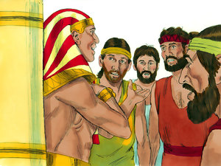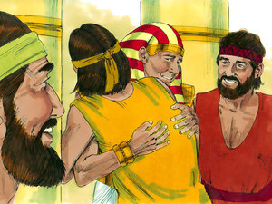
Joseph Reveals Himself to His Brothers (Part 2) – Genesis 45:9-15

⁹ “Hurry and go up to my father, and say to him, ‘Thus says your son Joseph: “God has made me lord of all Egypt; come down to me, do not tarry.
¹⁰ You shall dwell in the land of Goshen, and you shall be near to me, you and your children, your children’s children, your flocks and your herds, and all that you have.
¹¹ There I will provide for you, lest you and your household, and all that you have, come to poverty; for there are still five years of famine.”’
¹² “And behold, your eyes and the eyes of my brother Benjamin see that it is my mouth that speaks to you.
¹³ So you shall tell my father of all my glory in Egypt, and of all that you have seen; and you shall hurry and bring my father down here.”
¹⁴ Then he fell on his brother Benjamin’s neck and wept, and Benjamin wept on his neck.
¹⁵ Moreover he kissed all his brothers and wept over them, and after that his brothers talked with him.

v.9 With your blue pencil, color who Joseph wanted to give a message to.
v.10 Where did Joseph want his family to live?
v.13 With your blue pencil, color who Joseph wanted the brothers to bring to him.
v.15 With your yellow pencil, color what two things Joseph did before his brothers talked with him.
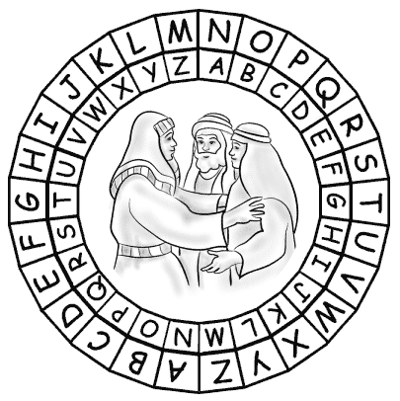 | To find out what Joseph said to his brothers, when he revealed himself to them, use the code to solve the puzzle. Find the letter in the message on the outside circle and match it with the letter under it on the inside circle.  Genesis 45v5-7 - "I am your brother Joseph, the one you sold into Egypt. . .  ___________________________________________  T B Q F R A G Z R N U R N Q  ___________________________________________  B S L B H G B C E R F R E I R  ___________________________________________  S B E L B H N E R Z A N A G  ___________________________________________  B A R N E G U N A Q G B  ___________________________________________  F N I R L B H E Y V I R F … "
Jacob Learns that Joseph is Alive – Genesis 45:25-28

²⁵ Then they went up out of Egypt, and came to the land of Canaan to Jacob their father.
²⁶ And they told him, saying, “Joseph is still alive, and he is governor over all the land of Egypt.” And Jacob’s heart stood still, because he did not believe them.
²⁷ But when they told him all the words which Joseph had said to them, and when he saw the carts which Joseph had sent to carry him, the spirit of Jacob their father revived.
²⁸ Then Israel said, “It is enough. Joseph my son is still alive. I will go and see him before I die.”

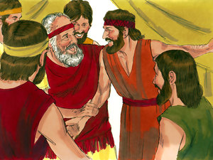
v.26 Did Jacob believe his sons at first when they told him that Joseph was alive and the governor of Egypt?______________
v.27 With your green pencil, color what Jacob saw that Joseph had sent.
v.28 With your purple pencil, color what Jacob decided to do.

Jacob Takes His Family to Egypt
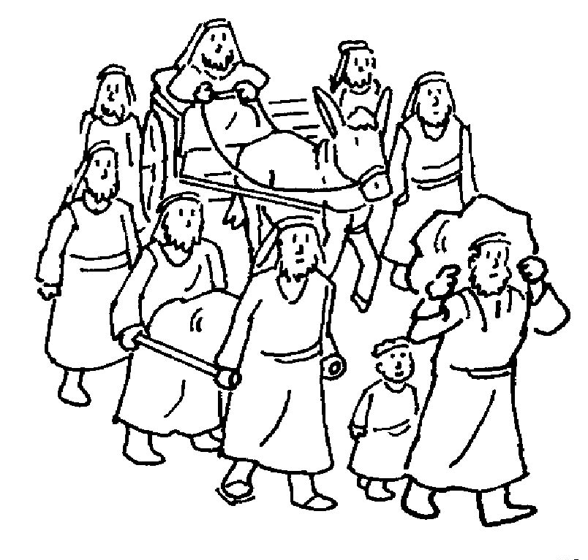
Help Jacob and his family get to Egypt.

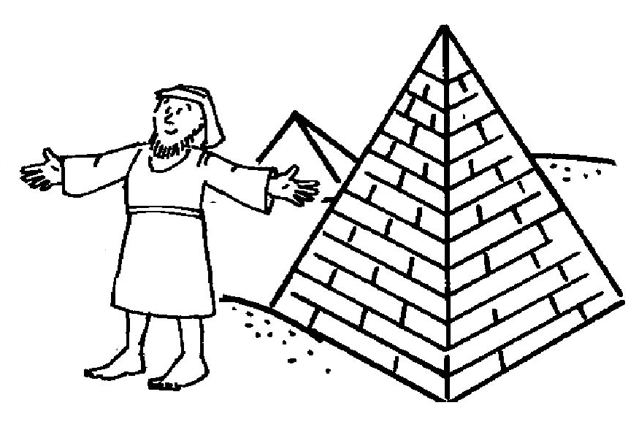
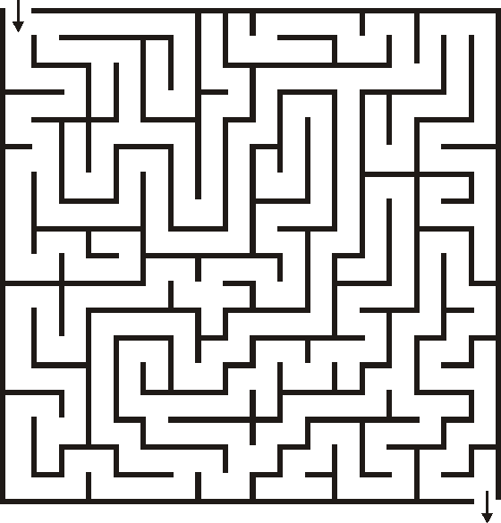
Jacob Takes His Family to Egypt – Genesis 46:26-30

²⁶ All the persons who went with Jacob to Egypt, who came from his body, besides Jacob’s sons’ wives, were sixty-six persons in all.
²⁷ And the sons of Joseph who were born to him in Egypt were two persons. All the persons of the house of Jacob who went to Egypt were seventy.
²⁸ Then he sent Judah before him to Joseph, to point out before him the way to Goshen. And they came to the land of Goshen.
²⁹ So Joseph made ready his chariot and went up to Goshen to meet his father Israel; and he presented himself to him, and fell on his neck and wept on his neck a good while.
³⁰ And Israel said to Joseph, “Now let me die, since I have seen your face, because you are still alive.”

v.27 With your orange pencil, color the total number listed in this verse of the family of Jacob that came to Egypt.
v.28 Who did Jacob send ahead of him to Joseph?
With your green pencil, color the name of the land that they arrived at.
v.29 With your yellow pencil, color what Joseph did when he saw his father.
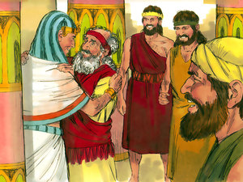
v.30 What was Jacob's response? (fill in the blanks)
“Now let me ______________, since I have
seen your ___________________, because
you are still _____________________.”

Did you know the family of Joseph stayed in Egypt after the famine was over? They were there a pretty long time! They had children and grandchildren and great-grandchildren down in Egypt, and their family got bigger and bigger. After a while it was so big that the Egyptians started to be afraid of them! A new Pharaoh came along and decided to make the family of Joseph his slaves. Things got so bad that God sent someone to save them and get them out of Egypt. But that’s another story! Do you know the name of the man God sent? (Hint – it starts with an “M”)

Colored images in the workbook from www.freebibleimages.com

