Joseph | I Seek  My Brethren
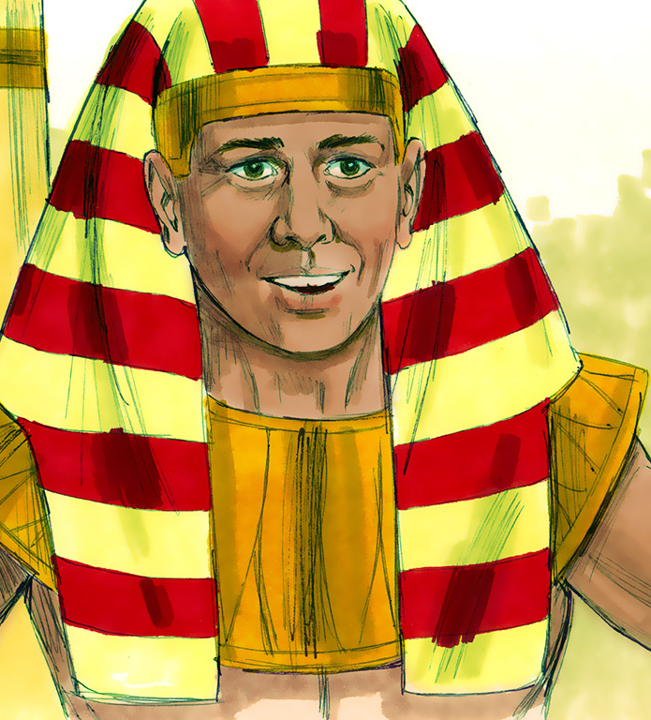
Image from www.freebibleimages.org
Images from www.freebibleimages.org
PRE-K & JK

SECTION 1 - JOSEPH SOLD BY HIS BROTHERS - GEN 37

Please read the story below with someone and answer the questions at the end.

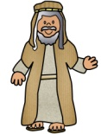 | had |  | sons but he |  |  | the most and gave
Jacob |  | twelve |  | loved | Joseph

him a special |  | This made |  | 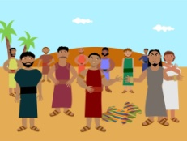 | very
 | coat. |  | Joseph’s | brothers

jealous and they hated |  | One |  |  | had
 | Joseph. |  | night, | Joseph |  | two

 | The first was about |  | and his |  | in a
dreams. |  | Joseph |  | brothers

 | putting |  | of |  | together.
field, |  | bunches |  | grain |  | Joseph’s | bunch

stood up straight and the other
 | eleven | bunches | bowed

down to |  | His |  | were really |  | and said
 | Joseph’s. |  | brothers |  | angry

they didn’t want |  |  |  |  |  | to rule over them. |  |  |  |  | had another
 |  |  |  | Joseph |  |  |  |  | Joseph
 | The |  |  |  | and |  |  |  |  | down to
dream. |  | sun, | moon |  |  |  | 11 stars | bowed |  |  |  | Joseph.

One day, when |  | went to check on his |  | in the
 | Joseph |  | brothers

 | they grabbed him, took off his special |  | and
field, |  | coat

threw him in a |  | Then they sold |  | for
 | pit. |  | Joseph |  | twenty

pieces of |  | to some Ishmeelite traders who were
 | silver

going to | 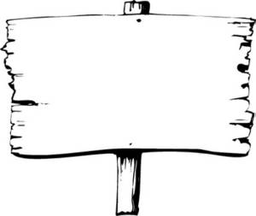  Egypt | The |  | took |  |  | and
 | Egypt. |  | brothers |  | Joseph’s | coat

dipped it in |  |  | thought that |  | had been
 | blood. | Jacob |  | Joseph

eaten by a
wild animal.

Questions to Discuss Together:

- What did Joseph’s father give him that was special?
- How many dreams did Joseph have?
- What did Joseph’s brothers do to him? And what did they do with his coat?
JOSEPH’S SPECIAL COAT

Jacob had 12 sons and he loved Joseph most of all. Jacob gave Joseph a special coat of many colors (pieces). This made Joseph’s brothers very jealous of him.

Color the squares below that have a dot in them, to find out who Jacob loved the most.

Color the picture of Joseph’s coat.
Source: www.biblefunforkids.com
JOSEPH’S DREAMS

Joseph had two dreams which showed that his brothers, and his father and mother would bow down to him. Joseph would one day rule over them.

Color the picture of the first dream about 11 bunches of grain bowing down to Joseph’s bunch.
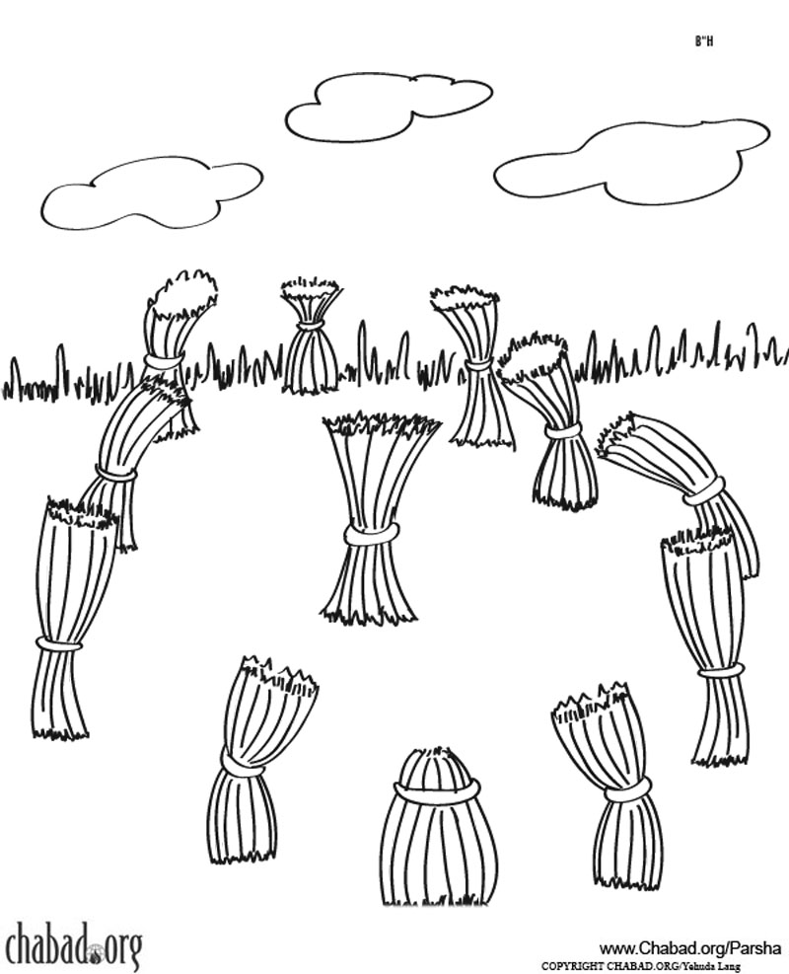
Joseph
Joseph’s
11 brothers
Source: www.chabad.org

Joseph had another dream about the sun, moon and 11 stars bowing down to him. Trace the sun, moon and stars below and color them in.

Joseph’s
11 brothers
Joseph’s
mother and father
JOSEPH GOES TO FIND HIS BROTHERS

Joseph’s brothers went to feed their father’s sheep in Shechem. Jacob sent Joseph to look for his brothers to see that they were OK. Joseph ended up finding his brothers in Dothan.

Help Joseph find his brothers.

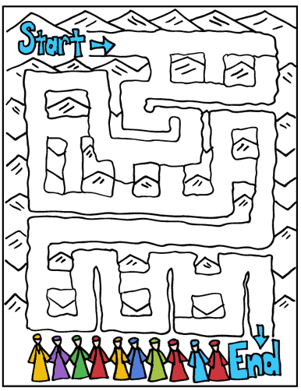
Source: www.biblewise.com
JOSEPH SOLD BY HIS BROTHERS

Joseph’s brothers saw him coming in the distance and they decided to throw him into a pit. They later sold him to a group of Ishmeelites who were heading to Egypt.

Color the pictures of Joseph being put in a pit by his brothers, and then being sold to a group of Ishmeelite traders.

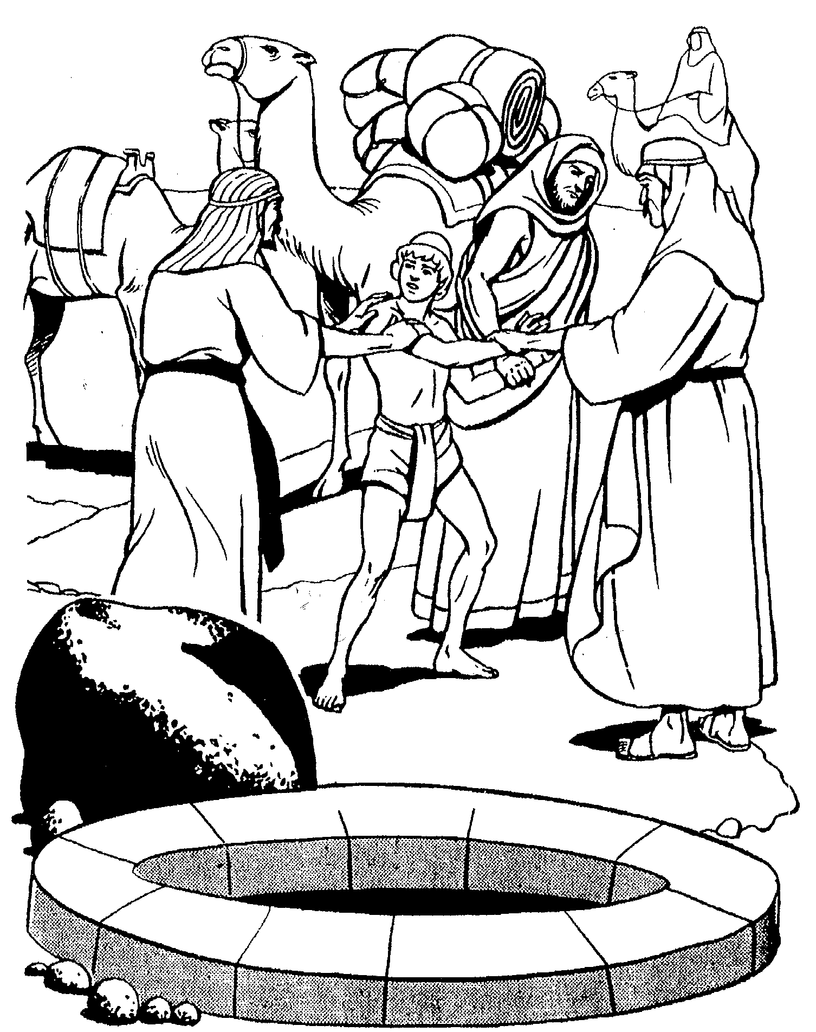
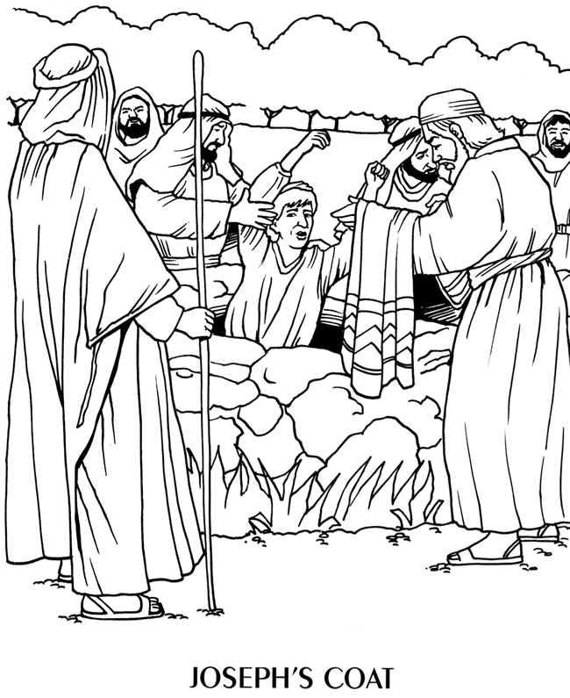
Joseph put in a pit
Source: www.sermons4kids.com

Then sold as a slave

Source: www.cssa.asn.au
SECTION 2 - JOSEPH SENT TO EGYPT - GEN 39-40

Please read the story below with someone and answer the questions at the end.

In | Egypt |  | was sold to Potiphar and was soon placed
 | Egypt, | Joseph

in charge of Potiphar’s whole |  | But Potiphar’s wife
 | house.

told a lie about |  | and he was put in |  | Sometime
 | Joseph |  | prison.

later, |  | 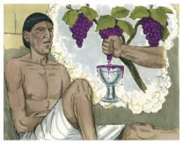 | and |  | were put in |  | They
 | Pharaoh’s | butler |  | baker |  | prison.

both had a |  | one |  | The |  | had a
 | dream |  | night. |  | butler |  | dream

about a |  | that had |  |  | He took the
 | vine |  | three | branches. |  | grapes

off the |  | squeezed them into |  | 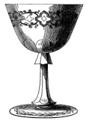 | and gave
 | vine, |  | Pharaoh’s | cup

the |  | to |  |  | told the |  | that in
 | cup |  | Pharaoh. | Joseph |  | butler |  | three

days, he would be taken out of |  | and | would work for
 | prison

 | again. The |  | had a |  | about
Pharaoh |  | baker |  | dream |  | three

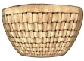 | of |  | on his |  | and |  | were eating
baskets |  | bread |  | head |  | birds

the |  |  | told the |  | that in |  | days,
 | bread. | Joseph |  | baker |  | three

 | would command he be | 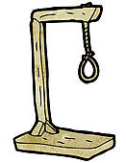 |  | asked the
Pharaoh |  | hanged. | Joseph

to remember him when he returned to work for
butler

 | But the |  | forgot about |  | and he stayed
Pharaoh. |  | butler |  | Joseph

in |  | for another |  | years.
 | prison |  | two

Questions to Discuss Together:

- When Potiphar’s wife told a lie about Joseph, where did he end up going?
- What did Pharaoh’s butler have a dream about?
- What did Pharaoh’s baker have a dream about?
JOSEPH PUT IN PRISON

Joseph was bought by Potiphar and he was soon put in charge of his whole house. But sadly, Potiphar’s wife told a lie about Joseph and he was put in prison.

Follow the instructions on the next page to create a scene of Joseph in prison.

Glue prison frame here, from the next page

Source of picture: CSSA Handbook
JOSEPH IN PRISON CRAFT

- On the previous page, color the picture of Joseph.
- Glue pipe cleaners on to make bars so it looks like Joseph is in prison.
- Color in the prison frame below.
- Glue to a sheet of cardstock.
- Cut out frame and glue in place on the previous page.
Cut this shaded part out as well.
… but God looked after him.
Joseph was put in prison …
This page is left blank intentionally.

THE BUTLER AND BAKER HAVE A DREAM

While Joseph was in prison, Pharaoh’s butler and baker were also put in prison. One day, Joseph noticed they looked sad. They both had a strange dream and didn’t know what it meant.

Circle how many bunches of grapes and how many baskets were in the dreams of the butler and baker. Trace the number at the bottom.

BUTLER’S DREAM |  | BAKER’S DREAM
3 |  | 3
JOSEPH TELLS THE MEANING OF DREAMS

With God’s help, Joseph was able to tell the butler and the baker the meaning of their dreams. In three days, the butler was going to be taken out of prison and would again work for Pharaoh. But in three days, the baker was going to be hanged.

Cut out the pictures on the following page and put them in order below.

1. |  | 2.
Joseph was in prison with Pharaoh’s butler and baker. |  | The butler had a dream about three bunches of grapes.
3. |  | 4.
With God’s help, Joseph could tell the meaning of the dream. |  | Joseph told the butler, in 3 days he would work for Pharaoh again.
5. | 6.
The baker also had a dream about three baskets of bread. |  | Joseph told the baker, in 3 days he would be taken out to be hanged.

Images from www.freebibleimages.org
JOSEPH’S TIME IN PRISON SEQUENCING ACTIVITY

- Cut out the pictures below.
- Glue them in order on the previous page.

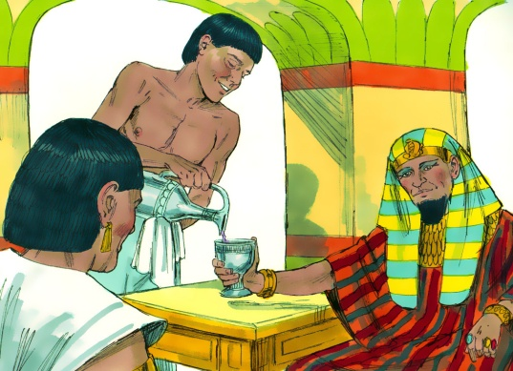 |  | 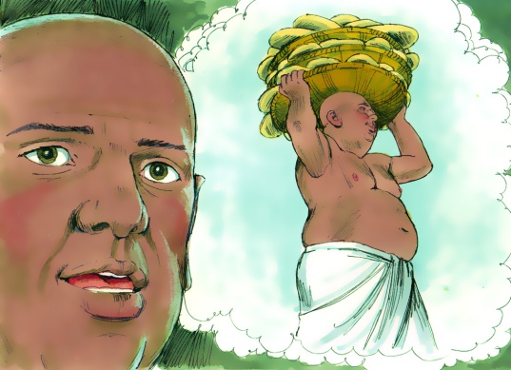
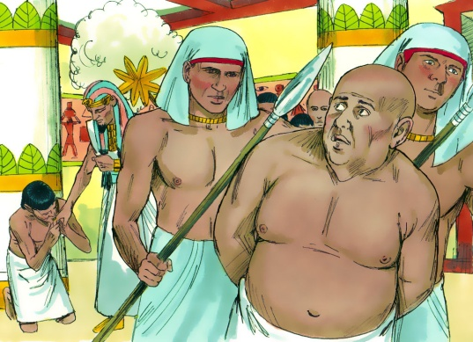
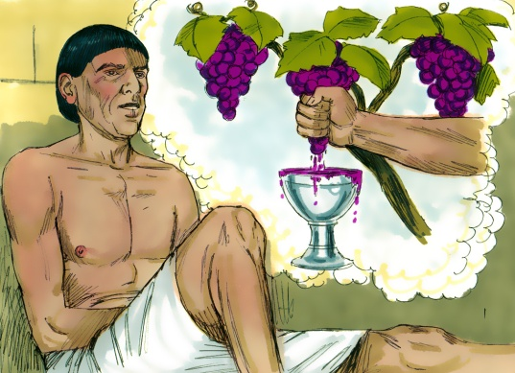 |  | 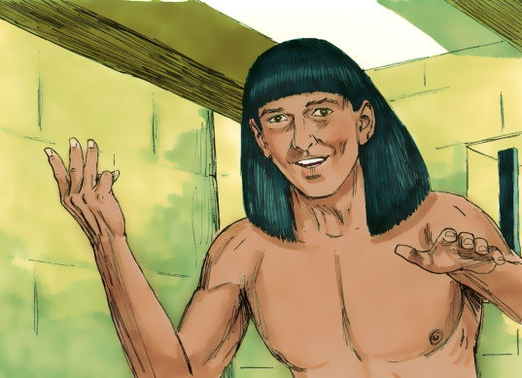
Images from www.freebibleimages.org

This page is left blank intentionally.

THE DREAMS COME TO PASS

Just as Joseph had said, the butler was taken from prison and worked for Pharaoh again. But the baker was taken and hung on a tree.

On the faces below, draw how the butler and the baker might have felt after they heard the meaning of their dream.

The Butler

The Baker
SECTION 3 - JOSEPH IN EGYPT - GEN 41

Please read the story below with someone and answer the questions at the end.

One |  |  | had a |  | about |  | healthy, fat
 | night, | Pharaoh |  | dream |  | seven

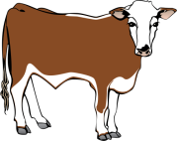 | coming out of the |  | After that, |  | thin
cows |  | river. |  | seven

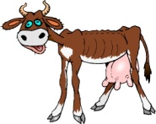 | came out of the |  | The thin |  | ate the fat
cows |  | river. |  | cows

 | but they didn’t become any fatter! |  | had
cows |  | Pharaoh

another |  | about |  | healthy heads of |  | which
 | dream |  | seven |  | grain

were eaten by |  | thin heads of |  | But the thin heads
 | seven |  | grain.

didn’t get any fatter. |  | was worried and asked his wise
 | Pharaoh

 | to tell the meaning of his |  | but no one could.
men |  | dreams,

The |  | remembered |  | and he was brought out
 | butler |  | Joseph

of |  | to explain |  |  | With God’s help,
 | prison |  | Pharaoh’s | dreams.

 | was able to tell |  | what his |  | meant.
Joseph |  | Pharaoh |  | dreams

There was going to be |  | good years with lots of
 | seven |  | food,

but then there was going to be |  | years of
 | seven |  | famine. | Joseph

was made second in charge to |  | Over the next
 | Pharaoh. |  | seven

years, |  | stored away lots of |  | so | Egypt | could be
 | Joseph |  | food, |  | Egypt

prepared for the
famine.

Questions to Discuss Together:

- What two things did Pharaoh have a dreams about?
- Who was able to tell Pharaoh the meaning of his dreams?
- What happened to Joseph after he told Pharaoh the meaning of his dreams?
PHARAOH’S DREAMS - Part 1

One night, Pharaoh had two dreams. One was about cows and the other one was about heads of grain.

Color and cut out the pictures on the next page and glue them in the correct box below.

Pharaoh had a dream about  7 fat cows coming out of the river. |  | Then 7 thin cows came out  of the river …  … and ate the fat cows.
In another dream, there were  7 healthy heads of grain. |  | Then 7 thin heads of grain ate the  7 healthy heads of grain.

PHARAOH’S DREAMS CRAFT

- Color in the pictures below.
- Cut them out.
- Glue in the correct box on the previous page.

This page is left blank intentionally.

PHARAOH’S DREAMS - Part 2

The dreams that Pharaoh had really troubled him and he wanted to know what they meant! He asked his wise men to tell him the meaning of his dreams, but they couldn’t.

Draw a line between the picture on the left that belongs with the picture on the right.

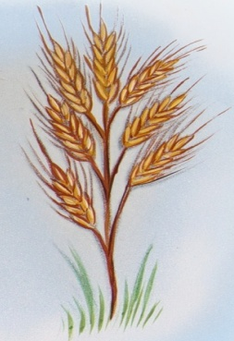
JOSEPH SPEAKS TO PHARAOH

The butler remembered Joseph and how he was able to tell him the meaning of his dream when he was in prison. The butler told Pharaoh about Joseph and Joseph was brought out of prison.

Color in the picture below of Joseph telling Pharaoh the meaning of his dreams.

Source: www.coloring-style.net
MEANING OF PHARAOH’S DREAMS

With God’s help, Joseph was able to tell Pharaoh what his dreams meant. He told him there was going to be 7 years where there would be lots of food. But this was going to be followed by 7 years of famine … there would be no rain and nothing to eat.

Color and trace the numbers and words below.

Joseph told Pharaoh there was going to be

7 years
of plenty, with lots of food.

Then there was going to be

7 years
of famine.

SECTION 4 - JOSEPH’S BROTHERS IN EGYPT - GEN 42-45

Please read the story below with someone and answer the questions at the end.

 |  | went |  | to | Egypt | to buy |  | during the
Joseph’s | brothers |  | down |  | Egypt |  | grain

 | When |  |  | got to | Egypt | they
famine. |  | Joseph’s | brothers |  | Egypt, |  | bowed | down

to |  |  | recognized his |  | but they did not
 | Joseph. | Joseph |  | brothers,

recognize him. |  | wanted to see if his |  | had
 | Joseph |  | brothers

changed. |  | accused his |  | of being spies.
 | Joseph |  | brothers |  | Joseph

said they could only leave | Egypt | if they returned with their
 | Egypt

brother, Benjamin. On the way |  | the |  | found
 | home, |  | brothers

their |  | in their | 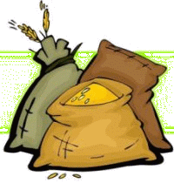 | Time went on and the | grain
 | money |  | sacks.

they had bought from | Egypt | was running out. The
 | Egypt |  | brothers

went back to | Egypt | with Benjamin to buy more |  | On the
 | Egypt |  | grain.

way |  | an Egyptian chased after them and said one of
 | home,

the |  | had stolen |  | special | 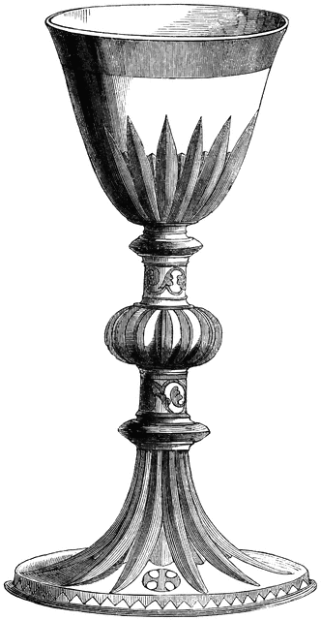 | It was found
 | brothers |  | Joseph’s |  | cup.

in Benjamin’s |  | The |  | had to go back to | Egypt
 | sack. |  | brothers |  | Egypt

and then |  | told them he was their long lost brother.
 | Joseph

The |  | hurried back to | Canaan | to tell |  | that
 | brothers |  | Canaan |  | Jacob |  | Joseph

was alive! |  | was able to see |  | again before he died.
 | Jacob |  | Joseph

Questions to Discuss Together:

- Did Joseph’s brothers recognize him in Egypt?
- What did the brothers find in their sacks on the way home from Egypt?
- Did Jacob get to see Joseph again before he died?

OFF TO EGYPT

Jacob heard that there was corn in Egypt, so he sent ten of his sons to buy corn. He kept Benjamin at home because he didn’t want to lose him as well.

Help Joseph’s brothers find their way to Egypt to buy grain.

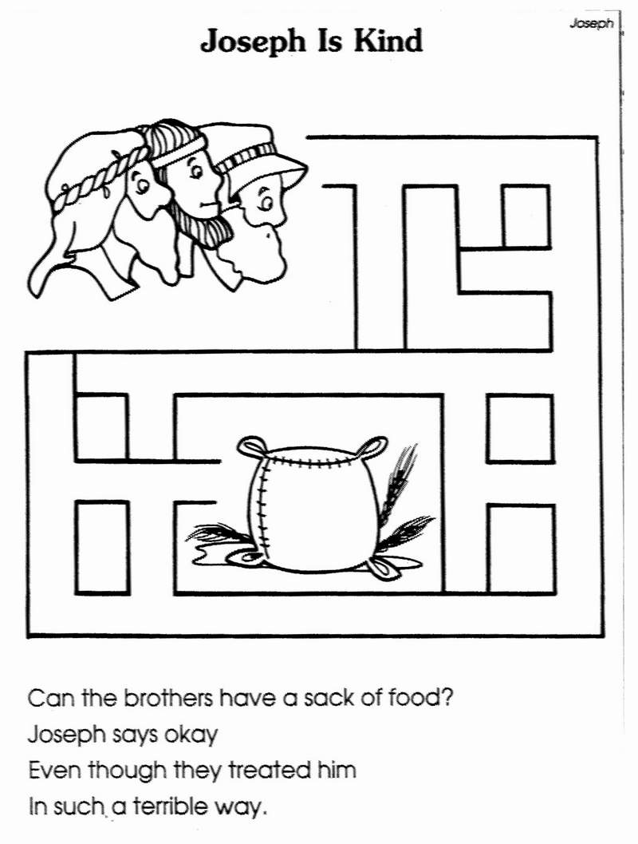Source: www.listcoloring.com
BROTHERS BOW DOWN TO JOSEPH

Joseph recognized his brothers when they came to buy corn. The brothers bowed down to Joseph but they didn’t recognize him as their brother! The dreams that Joseph had about his brothers bowing down to him, were fulfilled.

Color the picture of Joseph with the bags of grain. Glue seeds (or something that looks like grain ) on the top of each sack.

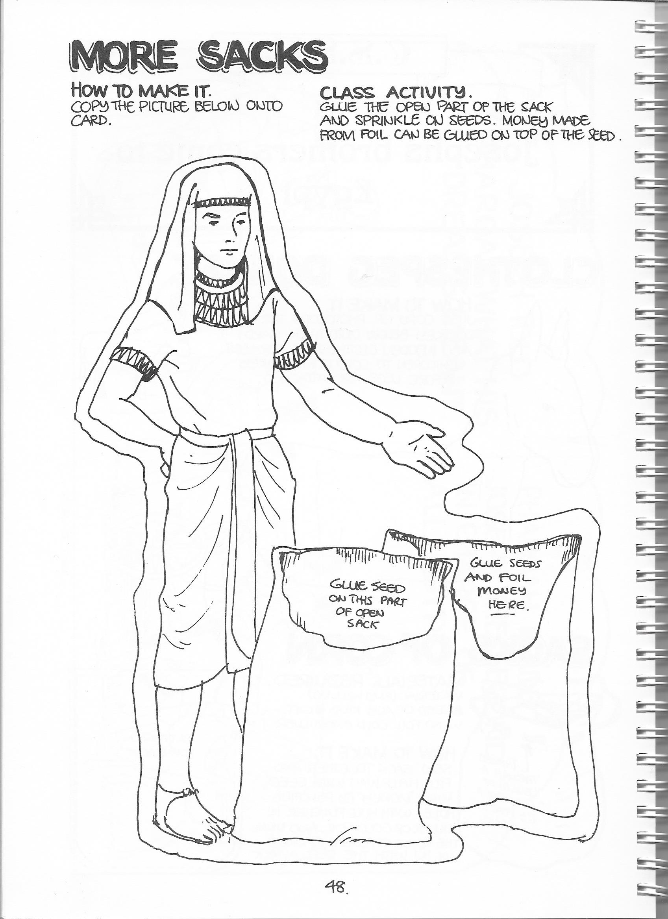
Glue seed / grain here.
Glue seed / grain here.
Source: CSSA Handbook
JOSEPH’S CUP

After some time, the grain Joseph’s brothers had bought in Egypt started to run out. So they returned to Egypt to buy more … this time Benjamin went with them. When they were travelling home, they found their money in their sacks and Joseph’s silver cup was in Benjamin’s sack.

Color and decorate Joseph’s cup. You can use glitter, stickers, shiny paper, etc.

Joseph’s Cup
Source: CSSA Handbook
JACOB SEES JOSEPH AGAIN

Joseph told his brothers who he was. His brothers were so surprised! They went home and told their father that Joseph was still alive. Jacob travelled down to Egypt to see Joseph again.

Cut out the pictures on the following page and put them in order below.

1. |  | 2.
The brothers went to Egypt to buy grain and bowed down to Joseph. |  | On the way home, the brothers found their money in their sacks.
3.
4.
After a while, Benjamin went back to Egypt with his brothers to buy grain. Jacob didn’t want him to go. |  | Again, the brothers found their money in their sacks and Joseph’s cup was in Benjamin’s sack.
5. | 6.
Joseph told his brothers who he was! The brothers were surprised. |  | Jacob came down to Egypt and was so happy to see Joseph again!

Images from www.freebibleimages.org
This page is left blank intentionally.

JOSEPH’S BROTHERS COME TO EGYPT SEQUENCING ACTIVITY

- Cut out the pictures below.
- Glue them in order on the previous page.

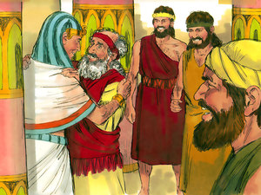 |  | 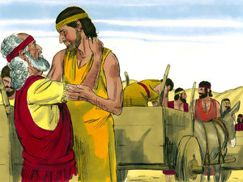
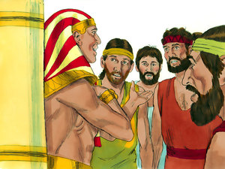 |  | 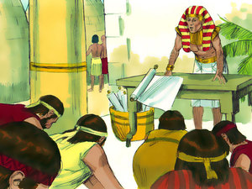
 |  | 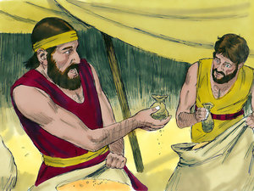
Images from www.freebibleimages.org

