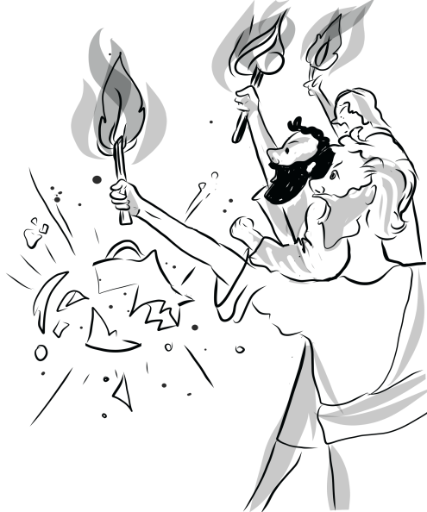

**Name:________________________________**

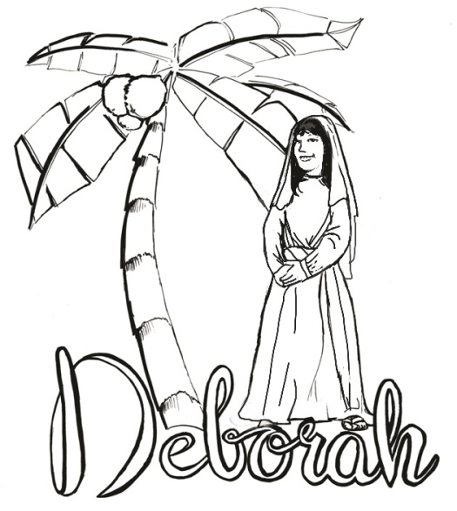

Lessons

from the

Judges

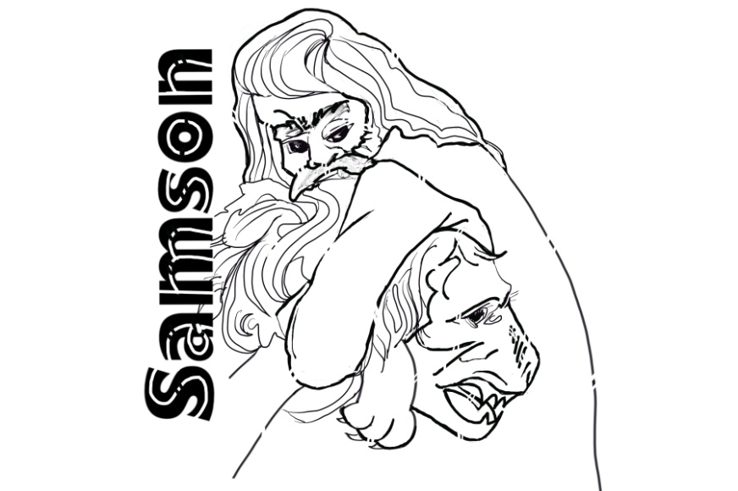

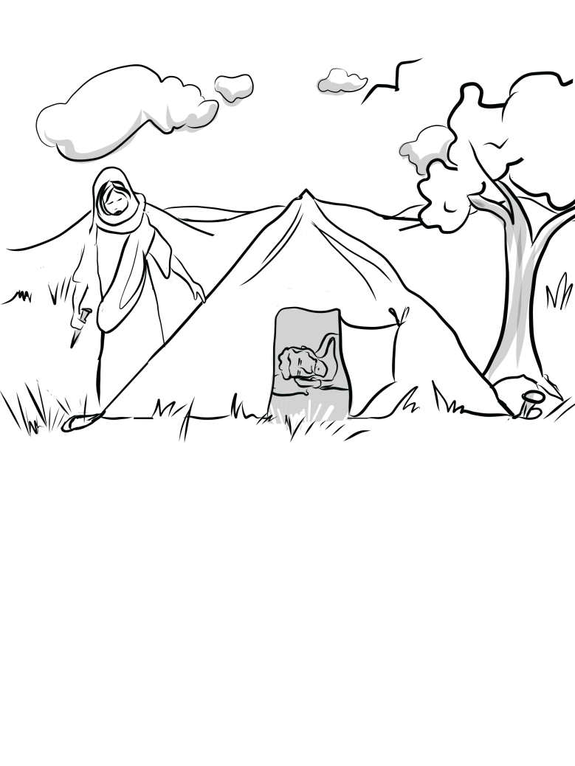

|  |
| --- |
| **LESSON 1 - DEATH OF JOSHUA / INTRO TO JUDGES**  **7-9 Year Old Class** |

**Colour the important words that Joshua said to the children of Israel:**

“…but as for me and my house,   
we will serve the LORD.”

**Joshua 24v15**

**What are some ways that you can “SERVE THE LORD” today?**

|  |  |  |  |  |
| --- | --- | --- | --- | --- |
|  |  |  |  |  |

**Complete the crossword:**

|  |  |  |  |  |  |  |  |  |  |  |  |  |
| --- | --- | --- | --- | --- | --- | --- | --- | --- | --- | --- | --- | --- |
|  | 1 |  |  |  | 2 |  | 3 |  | 4 |  |  |  |
| 5 |  |  |  |  |  |  |  |  |  |  |  |  |
|  |  |  |  |  |  |  |  |  |  |  |  |  |
|  |  |  |  |  |  |  |  |  |  |  |  |  |
|  |  |  |  |  | 6 |  | 7 |  |  |  |  |  |
|  |  |  |  |  |  |  |  |  |  |  |  |  |
|  |  |  |  |  |  |  | 8 |  |  |  |  |  |

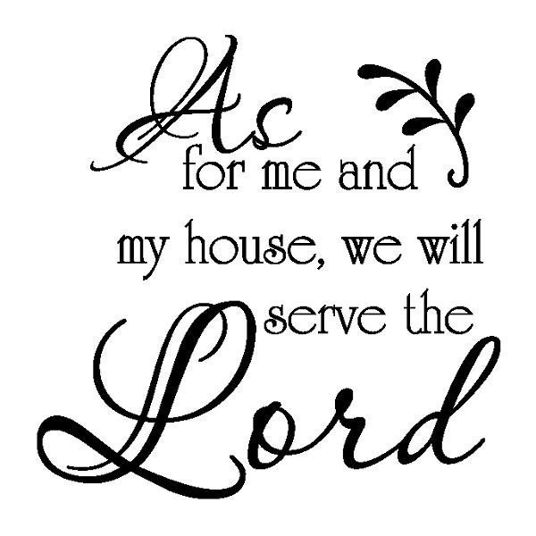**CLUES ACROSS**

3. ………… said “As for me and my house, we will serve the LORD.”

5. The only true God is …………

6. Joshua set a ………….. under a tree to remind Israel of their promise.

8. Israel meant to ………… their promise.

**CLUES DOWN**

1. God had given Israel the land of ……..

2. Joshua told Israel to …………… between God and the idols of Canaan.

4. Joshua wanted Israel to ……………. God.

7. Joshua set a stone under an ………….. tree.

|  |
| --- |
| **http://www.clipartillustration.com/wp-content/uploads/symbiostock_rf_content/57648-stock-image-by-leo-blanchette.jpg**  **MEANING OF JUDGES**  “Judges” comes from a Hebrew word meaning: |

**THE CYCLE OF SIN IN JUDGES**

The Cycle of Sin

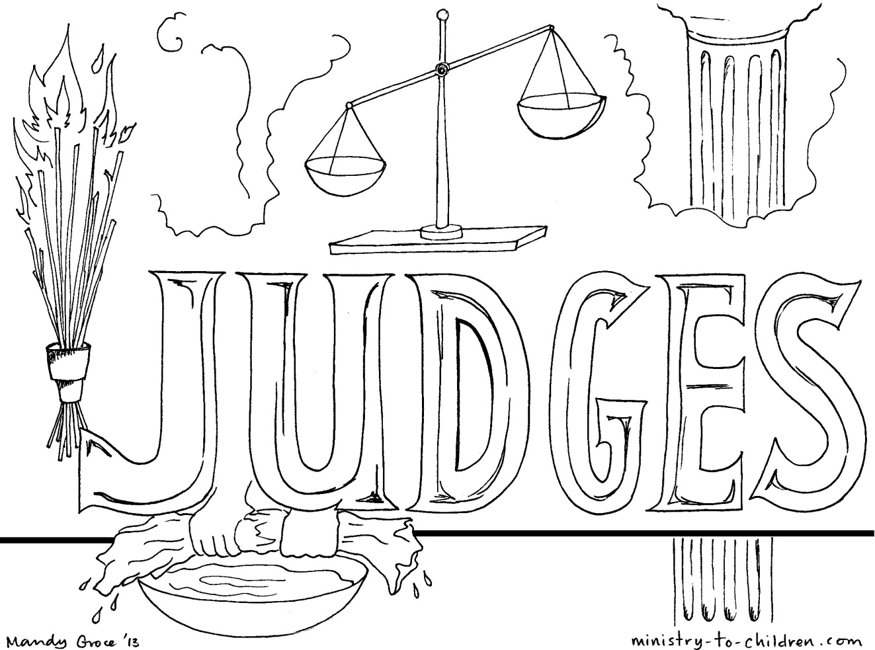

*Source:* [*www.ministry-to-children.com*](http://www.ministry-to-children.com)

|  |
| --- |
| **LESSON 2 - EHUD AND EGLON**  **7-9 Year Old Class** |

**Help Ehud find his way to Eglon:**

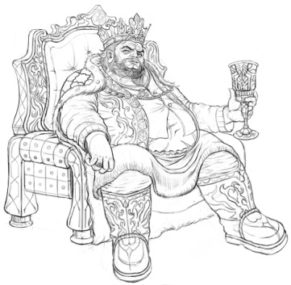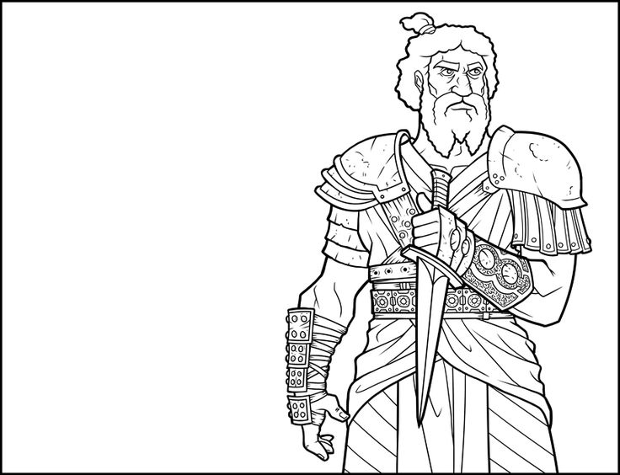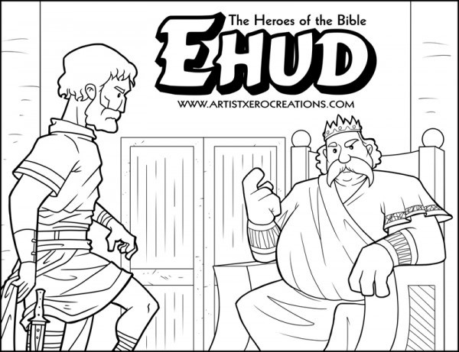

|  |  |  |  |
| --- | --- | --- | --- |
| E |  | E |  |
| H |  | G |  |
| U |  | L |  |
| D |  | O |  |
|  |  | N |  |

|  |  |  |  |  |
| --- | --- | --- | --- | --- |
| Eglon was a king of this nation |  | 26 | 3 |  |

The two nations that banded together with Eglon to defeat Israel

|  |  |  |  |  |  |  |  |  |  |  |  |  |
| --- | --- | --- | --- | --- | --- | --- | --- | --- | --- | --- | --- | --- |
| 6 |  | 13 | 24 | 29 |  |  |  |  | 17 |  | 5 | 27 |

Israel served Eglon this long

|  |  |  |  |  |  |  |  |  |  |  |  |  |  |
| --- | --- | --- | --- | --- | --- | --- | --- | --- | --- | --- | --- | --- | --- |
| 8 | 28 |  | 2 |  | 11 | 14 |  |  | 23 | 19 |  | 10 | 7 |

|  |  |  |  |  |  |  |
| --- | --- | --- | --- | --- | --- | --- |
| Ehud made himself this |  |  |  |  |  | 22 |

|  |  |  |  |  |  |
| --- | --- | --- | --- | --- | --- |
| Ehud’s dagger was hidden on this leg |  | 1 | 30 |  | 12 |

|  |  |  |  |  |  |  |  |  |  |  |  |  |
| --- | --- | --- | --- | --- | --- | --- | --- | --- | --- | --- | --- | --- |
| Eglon said this to Ehud |  |  |  |  |  | 15 |  |  |  |  | 9 |  |



What was special about Ehud’s dagger?

|  |  |  |  |  |  |  |  |  |  |  |  |
| --- | --- | --- | --- | --- | --- | --- | --- | --- | --- | --- | --- |
|  | 24 | 25 |  |  |  |  |  |  | 18 |  |  |

|  |  |  |  |  |  |  |  |  |  |  |  |  |  |  |
| --- | --- | --- | --- | --- | --- | --- | --- | --- | --- | --- | --- | --- | --- | --- |
|  |  |  |  | v |  |  |  |  |  |  |  |  |  |  |

|  |  |  |  |  |  |  |  |  |  |  |  |  |  |  |
| --- | --- | --- | --- | --- | --- | --- | --- | --- | --- | --- | --- | --- | --- | --- |
|  |  |  | s |  |  |  |  | f |  |  |  |  |  |  |

|  |  |  |  |  |  |  |  |  |  |  |  |  |  |  |
| --- | --- | --- | --- | --- | --- | --- | --- | --- | --- | --- | --- | --- | --- | --- |
|  |  |  |  |  |  |  |  |  |  |  |  |  |  |  |
| **LESSON 3 - DEBORAH AND BARAK**  **7-9 Year Old Class** | | | | | | | | | | | | | | | | |

**Match the names on the left, with the correct statement on the right:**

|  |  |
| --- | --- |
| * Sisera | A prophetess and her name means “bee” |
| * Jabin | Captain of Jabin’s army |
| * Barak | Husband of Jael, a Kenite |
| * Deborah | King of Canaan |
| * Jael | Wife of Heber, killed Sisera with a tent peg |
| * Heber | Son of Abinoam, worked with Deborah to fight the army of Sisera |

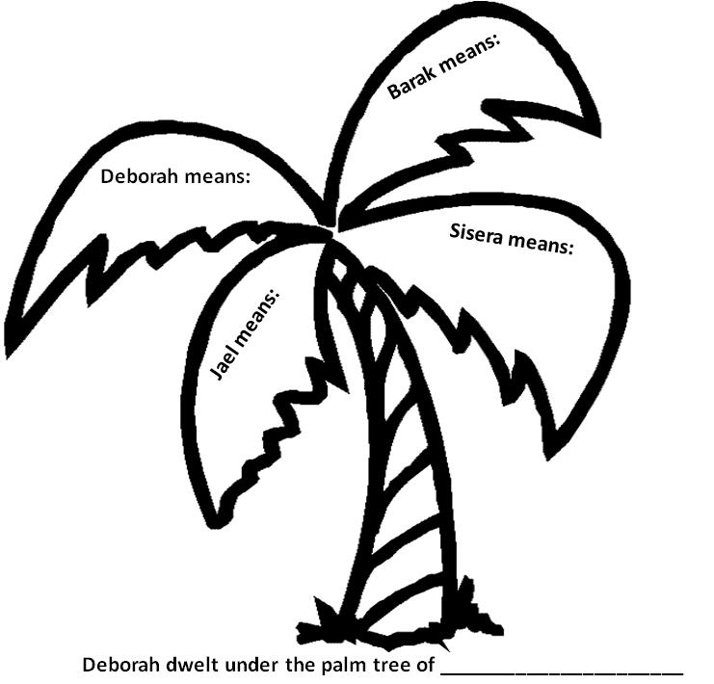**Complete the meanings of the names on the palm leaves:**

**Crack the Code!**

Find out what Deborah’s response was when Barak asked her to go and fight the battle with him!

|  |  |  |  |  |  |  |  |  |  |  |  |
| --- | --- | --- | --- | --- | --- | --- | --- | --- | --- | --- | --- |
| ☺ | 🟏 | 🖐 | 🞕 | ✡ | ✓ | 🙦 | ⇦ | ✀ | ◇ | 🙨 | 🞈 |
| E | G | H | I | L | O | R | S | T | U | W | Y |

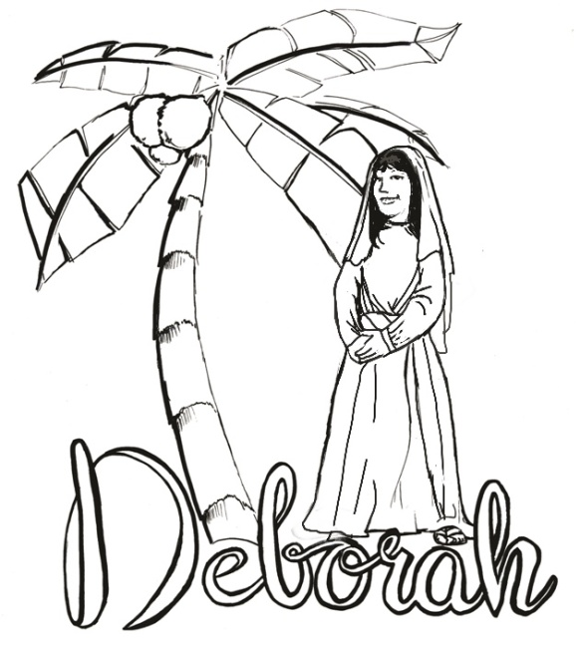

|  |  |  |  |  |  |  |  |  |
| --- | --- | --- | --- | --- | --- | --- | --- | --- |
|  | ___ |  | ___ | ___ | ___ | ___ |  |  |
|  | 🞕 |  | 🙨 | 🞕 | ✡ | ✡ |  |  |
| ___ | ___ | ___ | ___ | ___ | ___ |  | ___ | ___ |
| ⇦ | ◇ | 🙦 | ☺ | ✡ | 🞈 |  | 🟏 | ✓ |
| ___ | ___ | ___ | ___ |  | ___ | ___ | ___ | ! |
| 🙨 | 🞕 | ✀ | 🖐 |  | 🞈 | ✓ | ◇ |  |

**Help Sisera find his way to the tent of Jael:**

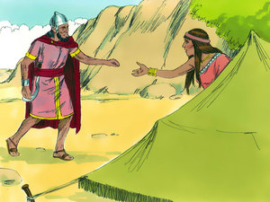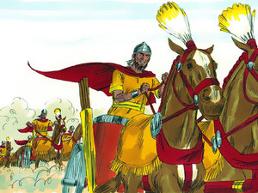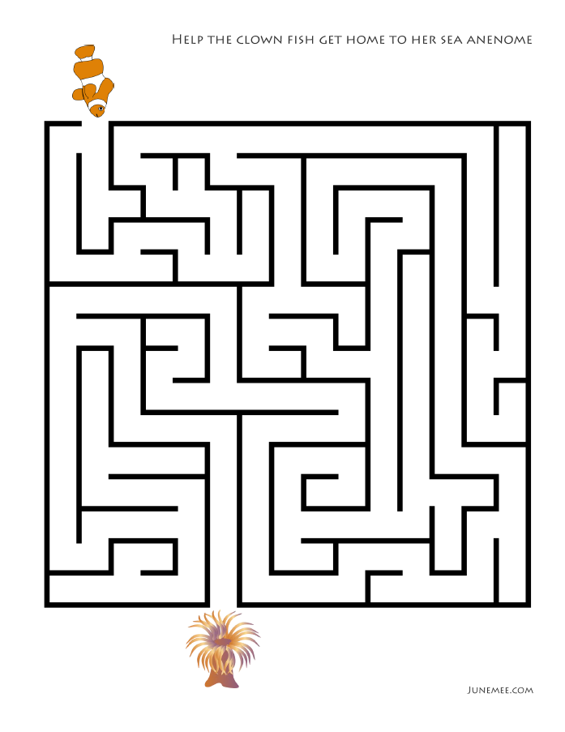

|  |
| --- |
| **LESSON 4 - GIDEON**  **7-9 Year Old Class** |

**Fill in the blank:**

There were so many enemies that they seemed to be like ________________________ in the valley. They had so many __________________ that the Israelites couldn’t begin to count them. God told Gideon to use only _____________________ men to fight the large army. Gideon chose his men by watching how they drank water from the stream. Every man who lapped water like a __________________ were chosen to be one of Gideon’s men. Their weapons were a ______________, an empty _________________, and a ____________________. All the soldiers were told to shout,___­___________________________________!”

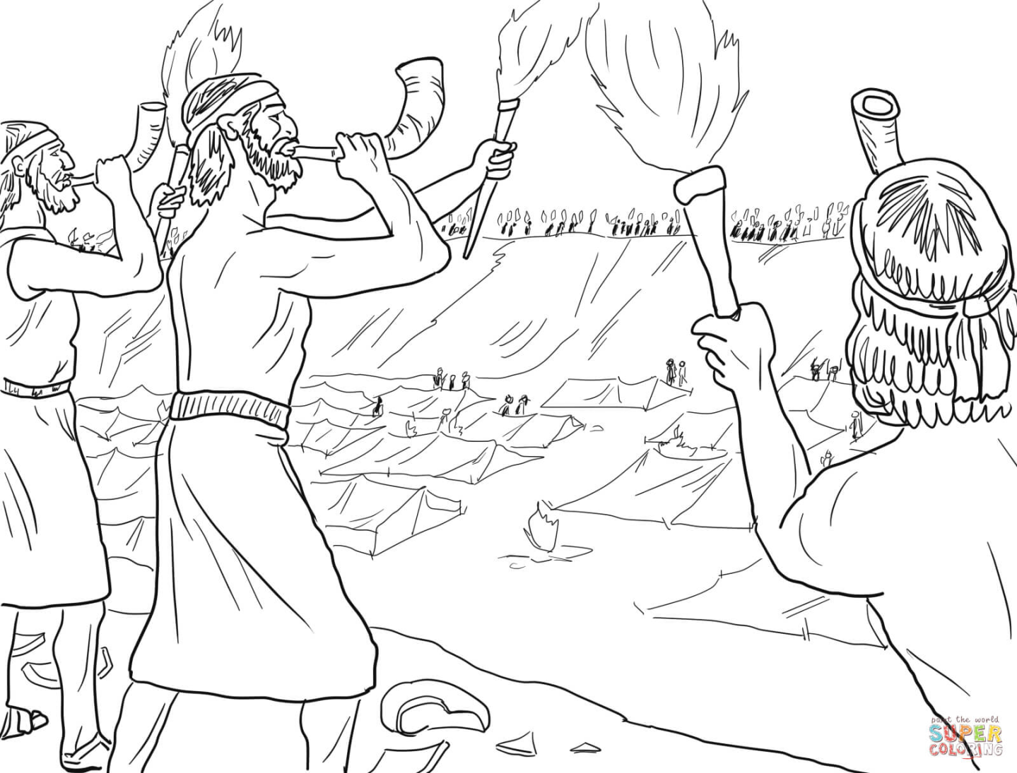

*Source:* [*www.supercoloring.com*](http://www.supercoloring.com)

Unscramble the words:

HET WORSD FO HTE OLDR NAD FO DOEGIN!

**Gideon word search:**

|  |  |  |  |  |  |  |  |  |  |  |  |  |  |  |
| --- | --- | --- | --- | --- | --- | --- | --- | --- | --- | --- | --- | --- | --- | --- |
| P | M | A | C | D | T | W | Y | S | V | M | K | D | T | A |
| S | A | B | R | T | A | B | R | H | I | S | C | E | O | N |
| F | D | I | H | R | W | A | T | D | D | M | A | P | R | G |
| P | N | R | R | U | J | G | I | F | R | L | T | I | C | E |
| K | E | I | S | D | N | A | S | U | O | H | T | H | H | L |
| E | O | M | R | E | N | D | B | Y | W | F | A | S | E | I |
| R | I | S | R | I | H | I | R | N | S | T | O | R | S | J |
| W | V | T | T | R | U | M | P | E | T | S | E | O | J | K |
| T | S | E | K | A | E | W | T | Z | D | M | M | W | R | N |
| A | S | F | L | E | E | C | E | S | D | N | A | H | T | P |

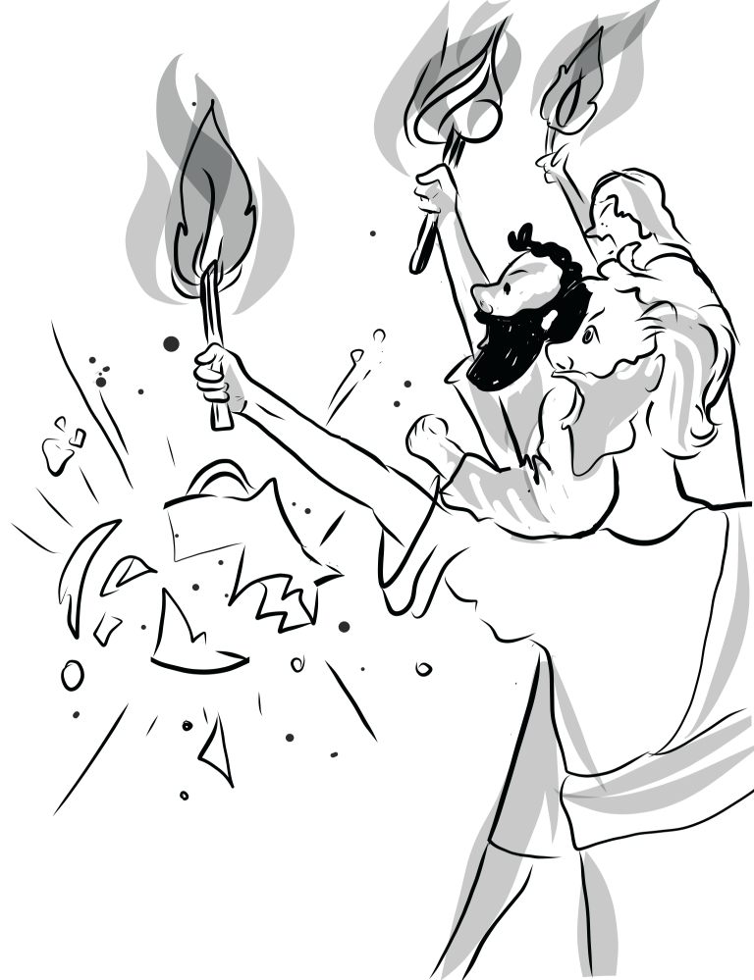

|  |  |
| --- | --- |
| Angel  Attack  Camp  Drink  Fleece  Hands  Jars  Midianites  Proof | Strength  Sword  Thousands  Three hundred  Torches  Trumpets  Warrior  Weakest  Worship |

|  |
| --- |
| **LESSON 5 - SAMSON**  **7-9 Year Old Class** |

**Sequence Activity …** Cut out the pictures on the last page and put them in order below.

|  |  |  |
| --- | --- | --- |
|  |  |  |
| Samson loved a woman named Delilah. When the Philistines found out they offered a very large amount of money, if she could find out where his great strength came from. |  | Delilah begged Samson to tell her where his strength came from, but Samson kept telling her lies about where his strength lay. This made Delilah very mad!  **1.**  **2.** |
|  |  |  |
|  |  |  |
| Delilah continued to pester Samson until he finally told her where his strength lay. He said, “If I am shaven, I will be as weak as any other man.”  **3.** |  | Delilah sent for the Philistines. She lulled Samson to sleep and cut off his hair. Then she cried out, “The Philistines are upon you.” When Samson awoke his strength was gone.  **4.** |
|  |  |  |
|  |  |  |
| The Philistines took Samson and put out his eyes. They bound him with chains and he became a grinder in the prison. But over time his hair began to grow again.  *Images from* [*www.freebibleimages.org*](http://www.freebibleimages.org)  **5.** |  | One day thousands of Philistines brought Samson to their temple to mock him. Samson cried out to God for help, and pushed the pillars down, killing them all!  **6.** |

**Find words from the story of Samson in the puzzle below:**

|  |  |  |  |  |  |  |  |  |  |  |  |  |  |  |
| --- | --- | --- | --- | --- | --- | --- | --- | --- | --- | --- | --- | --- | --- | --- |
| S | A | M | S | O | N | P | R | I | D | D | L | E | D | SAMSON  MANOAH  PHILISTINES  LION  HONEY  RIDDLE  FOXES  GAZA  CITY GATE  DELILAH  BLIND  LONG HAIR  WEAK  STRONG  PRISON  PILLARS |
| L | O | N | G | H | A | I | R | T | E | D | O | G | S |
| Q | I | D | E | L | I | L | A | H | T | C | G | E | B |
| B | F | O | X | E | S | P | B | N | A | C | T | R | C |
| L | R | L | N | V | D | S | H | R | G | A | Z | A | B |
| I | P | N | K | T | R | T | B | N | Y | E | N | O | H |
| N | B | W | E | A | K | R | V | B | T | K | U | L | A |
| D | E | X | L | G | R | O | P | R | I | S | O | N | O |
| C | B | L | F | Y | O | N | N | M | C | V | G | R | N |
| O | I | U | B | H | U | G | R | C | F | E | U | I | A |
| P | H | I | L | I | S | T | I | N | E | S | C | M | M |

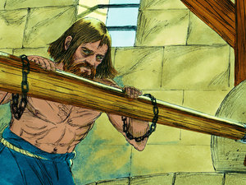

**Samson’s Three Punishments:**

1. Samson's eyes were

2. Samson was put in

3. There he was made to

**Good Choices vs Bad Choices**

Samson made some good choices and some bad choices in his life. Think about some good and bad choices we can make:

|  |  |
| --- | --- |
| **GOOD CHOICES** | **BAD CHOICES** |
|  |  |
|  |  |
|  |  |
|  |  |

**Who Am I?**

A summary of all the judges we have considered this week:

|  |  |
| --- | --- |
| **DESCRIPTION** | **PERSON** |
| I led the children of Israel into the Promised Land …. |  |
| I was a big fat king who reigned in Moab …. |  |
| I was a left-handed judge of the tribe of Benjamin …. |  |
| I didn’t want to go to battle unless Deborah came with me … |  |
| I was a prophetess who worked with Barak …. |  |
| I killed Sisera with a tent peg …. |  |
| I was the husband of Jael …. |  |
| I fought against the Midianites with just 300 men …. |  |
| I was a very strong judge who carried the gates of the city …. |  |

List of people to choose from:

|  |  |  |
| --- | --- | --- |
| Deborah  Joshua  Gideon | Eglon  Heber  Samson | Jael  Ehud  Barak |

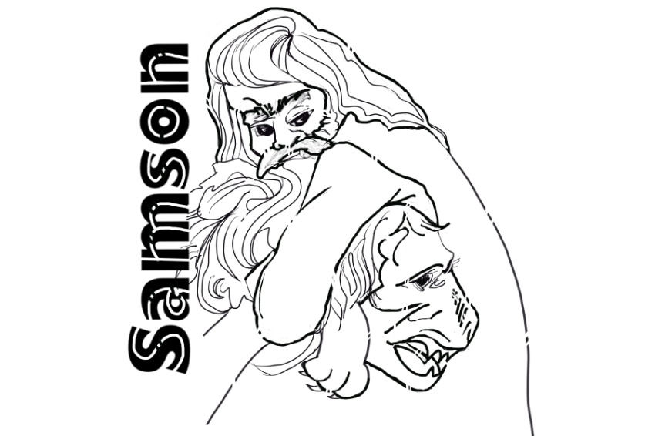

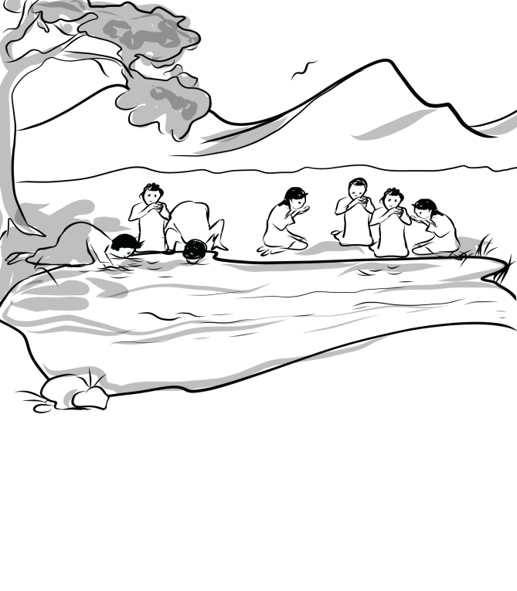

**Pictures for Samson Sequencing Activity**

|  |  |  |
| --- | --- | --- |
| Delilah lulled Samson to sleep with his head in her lap, and then she called in a man to shave off the seven locks of his hair. The Philistine rulers came with their money in their hands. Delilah cried out, ‘Samson! The Philistines have come to capture you!’ – Slide 11 |  | The rulers of the Philistines went to Delilah and said, ‘Entice Samson to tell you what makes him so strong and how he can be overpowered. Then each of us will give you 1,100 pieces of silver.’ – Slide 3 |
|  |  |  |
| Samson suddenly realised God’s power had left him. He was powerless. The Philistines captured him, gouged out his eyes, put him in chains and forced him to grind grain in prison. But before long, his hair began to grow back. – Slide 12 |  | Then Samson put his hands on the two central pillars that held up the temple. Pushing against them with both hands, he prayed, ‘Let me die with the Philistines.’ The temple crashed down on the Philistine rulers and all the people. So Samson killed more Philistines when he died than he had during his entire lifetime. Samson had judged Israel for twenty years. – Slide 16 |
|  |  |  |
| Delilah pouted, ‘How can you tell me, “I love you,” when you don’t share your secrets with me? You’ve made fun of me three times now, and you still haven’t told me what makes you so strong!’ Delilah kept nagging Samson until he shared his secret with her. ‘My hair has never been cut,’ he confessed, ‘for I was dedicated to God as a Nazirite from birth. If my head were shaved, my strength would leave me.’ – Slide 10 |  | So Delilah asked Samson, ‘Please tell me what makes you so strong and what it would take to tie you up securely.’Samson replied, ‘If I were tied up with seven new bowstrings, I would become as weak as anyone else.’ – Slide 4 |

*Images from* [*www.freebibleimages.org*](http://www.freebibleimages.org)