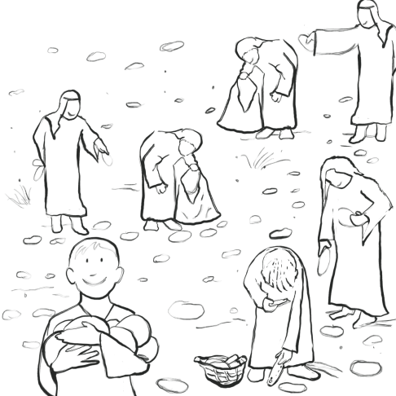
Name:________________________________
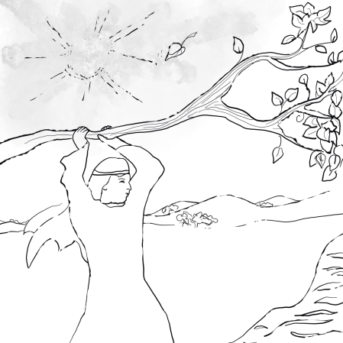

Wandering

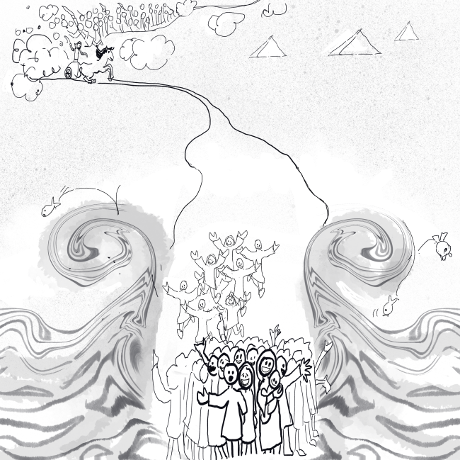
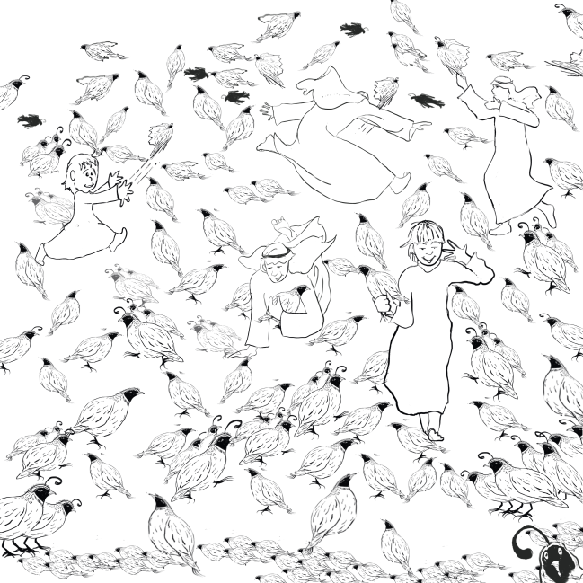
in the Wilderness

LESSON 1 - LIFE IN THE WILDERNESS

3-5 Year Old Class

OUT OF EGYPT

Help the Israelites find their way from Egypt to the Promised Land.
EGYPT

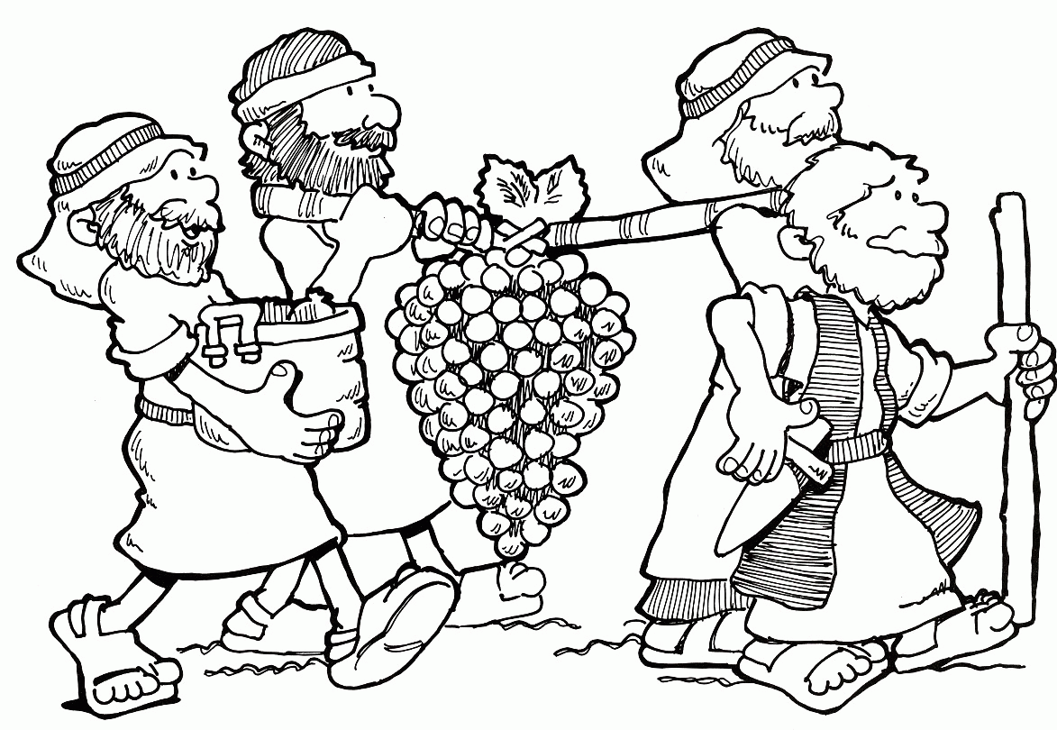
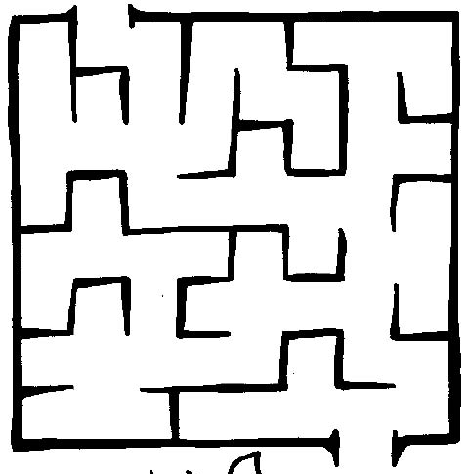

PROMISED LAND
Glue cotton wool to show the cloud by day, and tissue paper to show the fire by night.

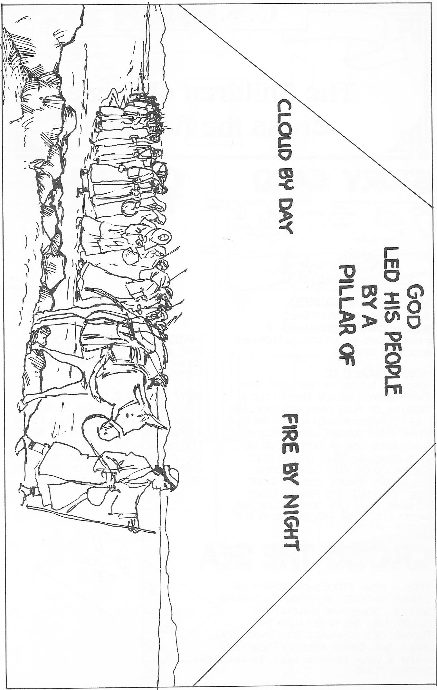
Source: www.cssa.asn.au
FOOD - QUAILS AND MANNA

Join the dots to make a quail. Glue feathers on the quail.

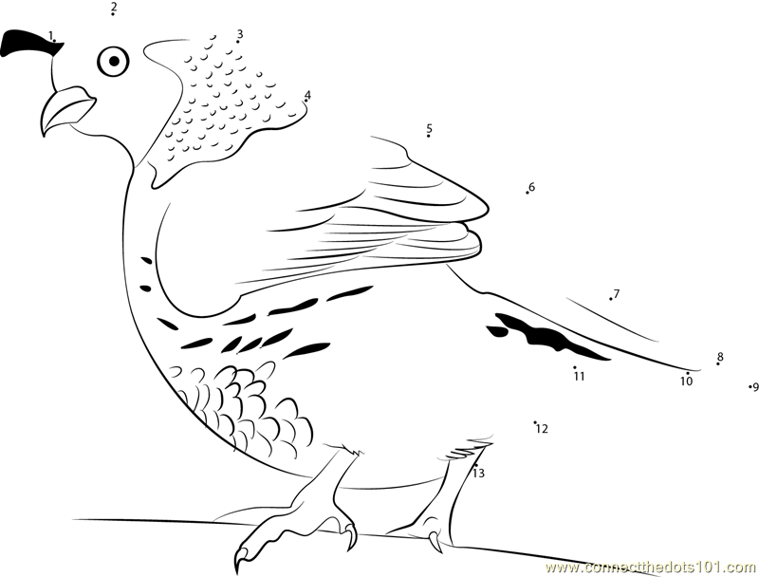
Source: www.connectthedots.101.com

Colour the shapes with a dot in them to find out what the children of Israel ate in the wilderness.

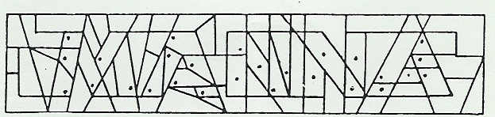

LESSON 2 - SPIES SENT TO THE PROMISED LAND

3-5 Year Old Class

SPYING OUT THE PROMISED LAND

Colour the two spies carrying a big bunch of grapes from the Promised Land. Put purple or green stickers on to show the grapes.

Source: www.cssa.asn.au

Trace the answers about the two faithful spies.

Out of the 12 spies sent to look at the Promised Land, how many were faithful?
two
Their names were Joshua and Caleb.

Joshua and Caleb encouraged the people to go and live in the Promised Land. Colour the words Caleb said to the children of Israel, and decorate the page with stickers.

And Caleb … said,
“Let us go up
at once, and possess it;
for we are
well able to overcome it.”

Numbers 13v30

LESSON 3 - KORAH, DATHAN, ABIRAM – AARON’S ROD

3-5 Year Old Class

REBELLION IN ISRAEL

Trace the names of the three men who were swallowed up by the earth for being jealous of Moses and Aaron.
Korah
Dathan
Abiram

Colour the picture of the earth swallowing up Korah and his followers.
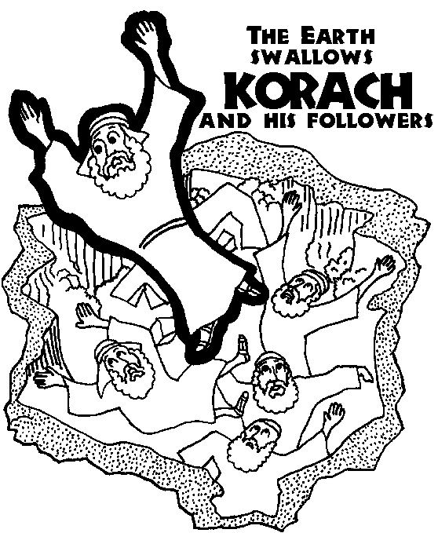
A SIGN FROM GOD

Stamp flowers and leaves on Aaron’s rod to show he was the one chosen by God to be the High Priest.

Aaron’s rod that budded

LESSON 4 - MOSES STRIKES THE ROCK

3-5 Year Old Class

MOSES STRIKES THE ROCK AT KADESH

Use blue tissue paper to show water pouring from the rock at Kadesh.
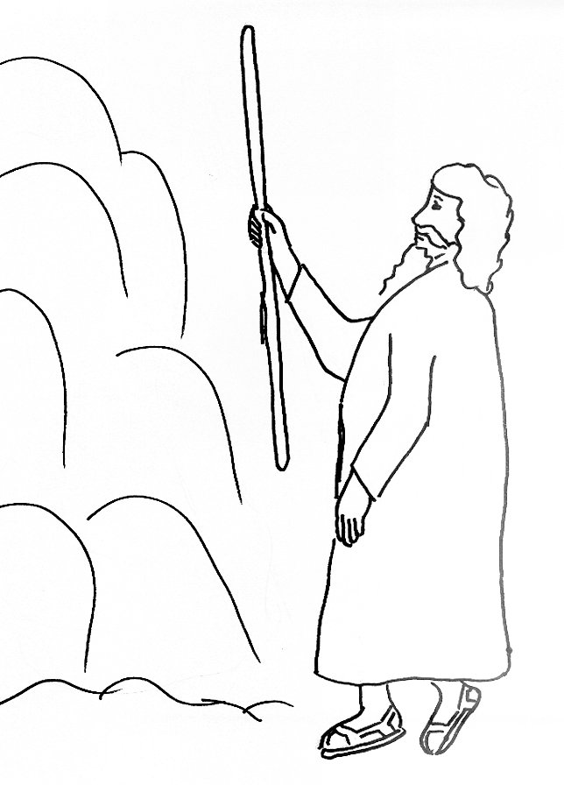
GOD IS ANGRY WITH MOSES

Colour in the words and the picture of Moses hitting the rock.

God asked Moses to
speak
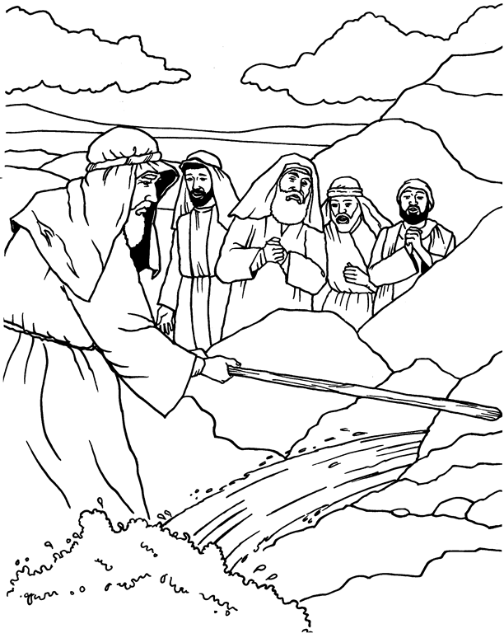
to the rock.
But instead, Moses
hit
the rock 2 times.
Source: www.coloring4fun.com

God was angry with Moses and said he couldn’t go into the Promised Land.

LESSON 5 - FIERY SERPENTS

3-5 Year Old Class

THE FIERY SERPENTS

Draw a head on the snake and put glitter on it. Draw some stick people around the pole.

Source: www.cssa.asn.au
Colour the picture of the brass serpent that Moses made.

