CSSA STAGE 2 JUNIOR #3 NAME ___________________________________

Rebellion in Israel

Multiple Choice: Circle ALL the Correct Answers!

1. Korah was:
a) Moses’ brother b) Moses’ cousin c) son of Izhar d) jealous of Moses & Aaron

2. Dathan and Abiram were:
a) friends of Korah b) from the tribe of Reuben
c) very nice men d) made rulers of the people

3. The 250 princes were:
a) told not to rebel anymore b) consumed by fire
c) Korah’s followers d) made rulers of the people

4. Because the people still complained about Moses and Aaron, God:
a) did not send rain b) was angry
c) forgave them d) sent a plague and 14,700 people died

5. The sons of Korah:
a) were on their father’s side b) stood with Moses
c) wrote Psalms d) had to watch some of their family die

Short Answer

6. What made Korah want to be the leader or High Priest of Israel? _________________________

____________________________________________________________________________

7. What did Moses tell Korah, the 250 princes, and Aaron to bring to the Tabernacle? __________

_______________________________________________

_______________________________________________

8. Did the sons of Korah agree with what their father had done? Why or why not?

_______________________________________________

_______________________________________________

9. What did God tell Moses to make out of the censers of brass left from the 250 princes?

____________________________________________________________________________

10. What “further sign” did God give that He had chosen Aaron as High Priest? ________________

____________________________________________________________________________

True or False
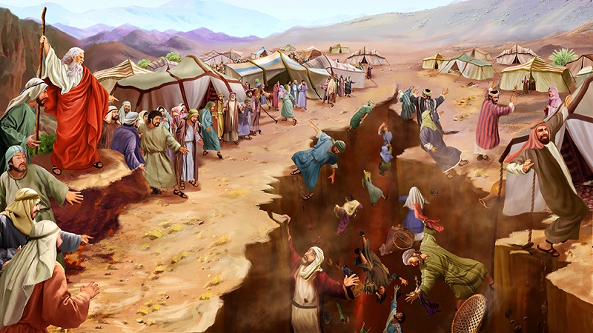
_____ 11. Dathan and Abiram were from the tribe of Reuben.

_____ 12. The sons of Korah were also swallowed up in the earth.

_____ 13. The people learned not to rebel ever again after what happened to Korah.

_____ 14. Moses and Aaron wanted God to destroy all the people.

_____ 15. Aaron was from the tribe of Levi.

_____ 16. Aaron’s rod that budded was put into the ark later on.

Fill in the Blanks

17. If the earth opened her mouth and swallowed the rebels, the people would know God had

______________________________ Moses.

18. Dathan and Abiram ________________________ come to the Tabernacle when Moses told them to.

19. Only when Moses and Aaron _______________________ for the people did God stop the plague.

20. Aaron’s rod had __________________, ______________________ and brought forth

_________________________ .

21. Aaron’s rod that budded is a good example for us of ________________________________ from the dead.

Thought Questions

22. When we become jealous like Korah, who are we trying to please? Why?_________________

___________________________________________________________________________

23. Who should we try to please all the time? Why? _____________________________________

___________________________________________________________________________

___________________________________________________________________________

