CSSA STAGE 2 JUNIOR #1 NAME ___________________________________

Meat for Israel

Multiple Choice: Circle ALL the Correct Answers!

1. God had brought the children of Israel out of Egypt to go to:
a) Babylon b) Canaan c) Lebanon d) Syria

2. While in the wilderness, God gave Moses instructions how to build the Tabernacle and its furniture. How long did it take to build the Tabernacle?
a) 6 days b) 6 weeks c) 6 months d) 6 years

3. The Tabernacle was a:
a) restaurant b) gas station c) place to worship God d) tent

4. When the cloud was taken up from the Tabernacle, the people:
a) worshipped God b) ate a meal c) slept d) got ready to go

5. The children of Israel began to complain on their trip through the wilderness because:
a) the way was dry and hot b) they stopped thinking of the promised land
c) they remembered the food in Egypt d) they didn’t have much water

Short Answer

6. What does the word holy mean. How do we show we are holy?

________________________________________________
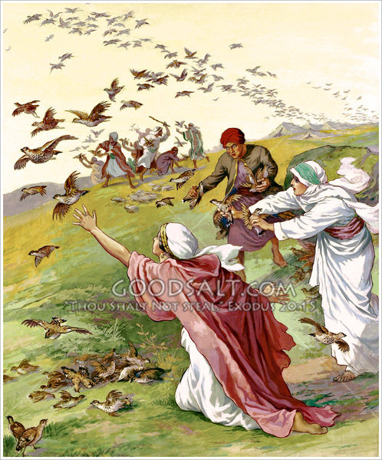
________________________________________________

7. How did Moses and the children of Israel know what direction to travel in the wilderness?

________________________________________________

8. Why did some people die who ate the quail? ____________

________________________________________________

________________________________________________

9. Why did Miriam and Aaron complain about Moses?

________________________________________________

________________________________________________

10. What happened to Miriam? ____________________________________________________

___________________________________________________________________________

True or False

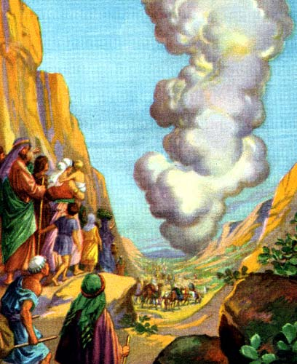
_____ 11. God showed His presence among His people with a cloud during the day and rain at night over the Tabernacle.

_____ 12. When the camp moved, the ark and the furniture were covered by Aaron and his sons and then carried by the Levites.

_____ 13. God gave quail to the children of Israel for one month.

_____ 14. Miriam was jealous about Moses’ authority so God gave her chicken pox.

_____ 15. Moses was a meek (humble) man and did not get angry when his jealous brother and sister complained about him.

Fill in the Blanks

16. The tribe of _______________ always led the way when the children of Israel traveled.

17. It was an _______________ day journey to Canaan but it took the children of Israel 40 years.

18. Kibroth Hattavah means _______________________________________________________.

19. God requires __________________ (belief) and _____________________ to His commandments.

20. The person I would like to be like the most in this story is _____________________ because

he was so _____________________________.
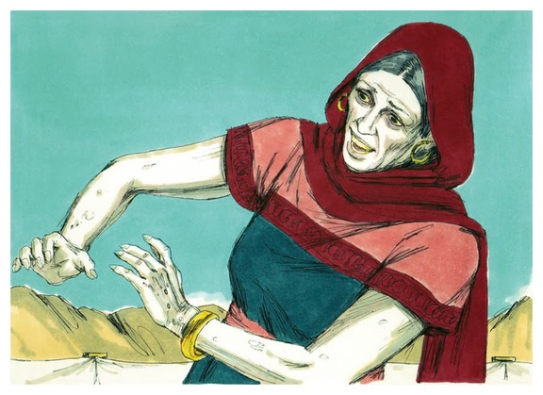
Thought Questions

21. Where do you think the children of Israel got the gold, silver, bronze, wood and other materials to build the Tabernacle in the wilderness?

_____________________________________

_____________________________________

_____________________________________

_____________________________________

22. What lessons can we learn from Aaron and Miriam’s mistake?
___________________________________________________________________________

___________________________________________________________________________

