CSSA STAGE 2 JUNIOR #2 NAME ___________________________________

Twelve Spies in the Land

Multiple Choice: Circle ALL the Correct Answers!

1. The 12 spies went through the land of Canaan for:
a) 4 days b) 40 days c) 40 months d) 4 years

2. The 12 spies brought the following fruit back:
a) figs b) pomegranates c) grapes d) dates

3. The 10 unfaithful spies said the land of Canaan had:
a) strong cities b) little people c) no food d) giants

4. Because the people didn’t have enough faith to believe that God would keep His promise and give them the land, God decided to:
a) starve them all to death
b) kill the babies 2 years old and younger
c) make them all blind
d) kill everyone at least 20 years old during the next 38 years of wilderness wandering

5. The following scripture is quoted in this lesson: (hint: look for parentheses)
a) Gal 4v26 b) Acts 16v14 c) Deut 8v14 d) Num 14v21

Short Answer

6. How did Moses decide how many spies to send out? __________________________________

____________________________________________________________________________

7. What did the ten unfaithful spies say when they returned? ______________________________

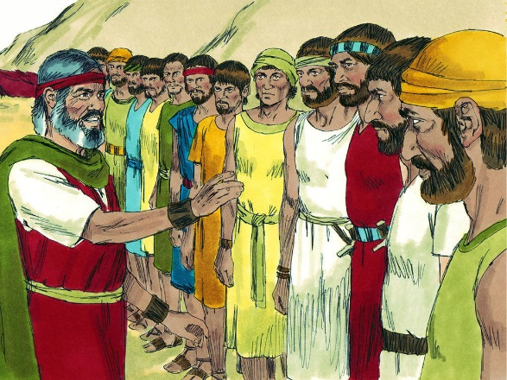
_______________________________________________

_______________________________________________

8. What did Caleb and Joshua say when they returned?

_______________________________________________

_______________________________________________

9. What happened to the 10 unfaithful spies? _____________

_______________________________________________

10. What did the people do when God told them they couldn’t enter the land for 40 years?

____________________________________________________________________________

____________________________________________________________________________

True or False
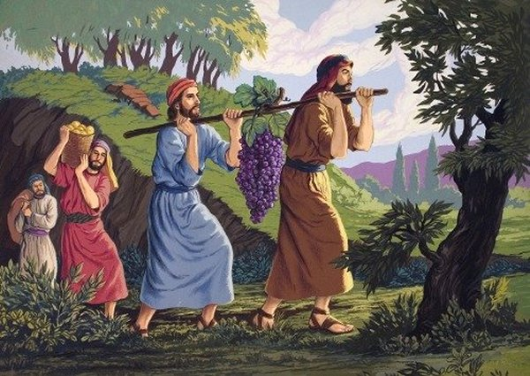
_____ 11. Moses sent 12 men, one from each tribe, to spy out the land.

_____ 12. The people were filled with fear when they heard the report of the ten spies because they did not believe God’s promise to give them the land.

_____ 13. God wants only the Jews to be in His kingdom.

_____ 14. The people wanted to give Joshua and Caleb a party.

_____ 15. God promised Joshua and Caleb they would live to enter the land of Canaan.

Fill in the Blanks

16. The land of _______________ was a good land the flowed with _________ and ___________.

17. The names of the two faithful spies were ___________________ and ___________________.

18. God told Moses, “As truly as I live, all the _____________ shall be filled with the ___________ of Yahweh.”

19. We can become the seed of Abraham and share the glorious promise of the kingdom by being

__________________ into the Lord Jesus Christ.

20. The wonderful hope God promised Israel will be fulfilled when _______________ returns.

Thought Questions

21. God said, “But as truly as I live, all the earth shall be filled with My Glory”.

- What was God’s purpose with the people of Israel who were at Sinai? _______________

_______________________________________________________________________

- How did the Israelites fail? __________________________________________________

_______________________________________________________________________

- What is God’s purpose today with people out of all nations who believe and obey His word?

_______________________________________________________________________

22. What lessons can we learn from the example of Joshua and Caleb? ___________________

___________________________________________________________________________

___________________________________________________________________________

