CSSA STAGE 2 JUNIOR #4 NAME ___________________________________
Near the End of the Journey:
Fiery Serpents

Multiple Choice: Circle ALL the Correct Answers!

1. Miriam died:
a) before Moses b) after Aaron c) at Kadesh d) near the Promised Land

2. Moses’ mistake at the rock was he:
a) hit the rock with a rod b) didn’t give God the glory
c) hit Aaron d) was angry

3. Aaron died:
a) in the 40th year after leaving Egypt b) on Mt Hor
c) with his priestly garments on d) at 123 years old

4. The children of Israel were bitten by serpents because they:
a) complained of being thirsty and tired of manna b) lacked faith
c) blamed God d) stoned Eleazar

5. The serpent on the pole:
a) allowed some bitten Israelites to live b) was made out of brass
c) foreshadowed Jesus on the cross d) was an idol made by man

Short Answer

6. How many more of the 40 years of wilderness wanderings are left? ______________________
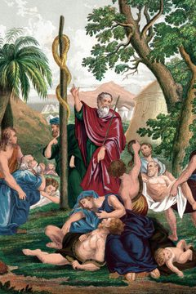
7. When the people complained and were punished by the bite of the serpents, what did God tell Moses to make?

______________________________________________

______________________________________________

______________________________________________

8. What were the people supposed to do to be healed from the serpent’s bite?

______________________________________________

______________________________________________

9. Who was lifted up on a pole like the serpent to bring life to others?

______________________________________________

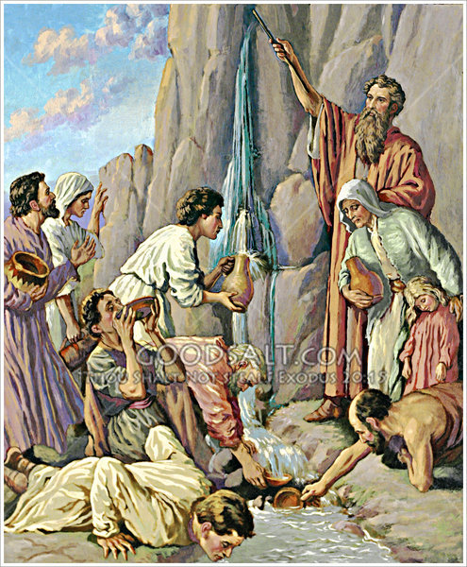
True or False

_____ 10. Because Moses hit the rock instead of speaking to it, he will not be in the kingdom.

_____ 11. Aaron, Miriam and Moses all died without entering the Promised Land.

_____ 12. The King of Edom let the children of Israel pass through his land so they could get to Canaan.

_____ 13. Jesus is like the brass serpent on the pole because looking to him in faith will give us life.

Fill in the Blanks

14. God told Moses to ______________ to the rock but

Moses struck the rock twice with his ______________.

15. When Aaron died, his son, _____________________ became High Priest.

16. The people of Israel complained, so God sent a plague of _______________________ that bit and killed them.

17. The people of Israel had to look on the brass serpent in ______________ in order to be healed.

Thought Questions

18. When was Jesus like the serpent on the pole?______________________________________

___________________________________________________________________________

19. How does Jesus being on the pole bring life to us? __________________________________

___________________________________________________________________________

20. Name one lesson you learned from this story? ________________________________________




