CSSA STAGE 2 REVISION: LESSONS 11-15

Joshua was __ __ __ years old when he died. He had been a __ __ __ __ __ __ __ __ leader. He wanted to make sure that they continued to serve God after he died. Before he died, he gathered the twelve tribes of Israel to Shechem and reminded them of all the great things __ __ __ had done for them. Joshua told the people that if they loved and served God with their whole heart then God would __ __ __ __ __ them. But if they turned to following other gods then he would bring __ __ __ __ upon them. Joshua said to the people “Choose you this day who you will serve, but as for me and my __ __ __ __ __ we will serve the __ __ __ __ ”. The people made a promise to Joshua saying “The Lord our God will we __ __ __ __ __ and His __ __ __ __ __ will we
__ __ __ __ ”. Joshua wrote this promise in the book of the __ __ __ and put a large
__ __ __ __ __ under an __ __ __ tree as a reminder of the promise they had made.

Match the words

After Joshua died the Israelites turned away from God and but the ground was dry

God allowed the Midianites to come into the land of Israel an altar to the Lord

When the people cried to God, fire came out of the rock and burnt it

An angel came to Gideon and called him a started worshipping idols

When the angel touched the food Gideon had prepared, God heard them

One night Gideon destroyed the altar to Baal and built but the ground was wet

One night Gideon put out a fleece of wool, in the morning it was wet for 7 years

The next day, the fleece was dry mighty man of valour

Circle the correct answer …
How many men did Gideon start off with in his army? 600 4,000 32,000 50,000

The army was too large and God wanted the people to know that it was because of Him they would win the battle, so Gideon told those who were afraid to go home. How many did he have left after he said this? 500 1,000 10,000 20,000

There were still too many men! Gideon tested the men at the edge of the water. Most of them drank with their heads down but others drank with their hands cupped so they could still look for the enemy. These men went to battle with Gideon. How many were there? 50 300 400 600

When Gideon crept into the Midianites camp, he heard a man telling a soldier about a dream he’d had. What was it that the man dreamt had fallen on the tent? Donuts barley bread a tree

What did Gideon and the Israelites take with them into battle? (choose 3 items)
drums trumpet plate jug sword shield flaming torch

Fill in the blanks with the words below
Bethlehem Boaz Gleaning
God Harvest Kind
Married Naomi Obed
Orpah People Ruth

There was a famine in Israel, so Elimelech and his wife ___________ went to live in Bethlehem. While they were there, Elimelech died and so did his two sons. That left Naomi and her two daughter in laws, _________ and __________ on their own. Naomi decided to go back to her own people in ____________. Ruth wanted to go back with Naomi and said “Your people will be my __________, and your God my _____”. After the long journey, they arrived in Bethlehem at the time of barley ____________. Ruth began __________ in the field of ________. Boaz was a _______ man who loved God. Boaz took notice of Ruth and told his reapers to look after her. Boaz __________ Ruth and they had a baby called ________ .
Down clues
- Samson was born to do God’s work and save Israel from the ___________
- Samson ________ to God and asked Him for strength.
- The Philistines held a feast and when Samson was led in by a boy they all _______ at him.
- Manoah and his wife were told they would have a ______
- What did Manoah and his wife call their child?

Across Clues
- The secret to Samson’s strength was his ______
- When the Philistines cut his hair, Samson became _______
- The Philistines offered Delilah eleven hundred pieces of _______ to find out the secret to Samson’s strength.
- What was the name of the lady Samson loved?
- Samson was a ______________
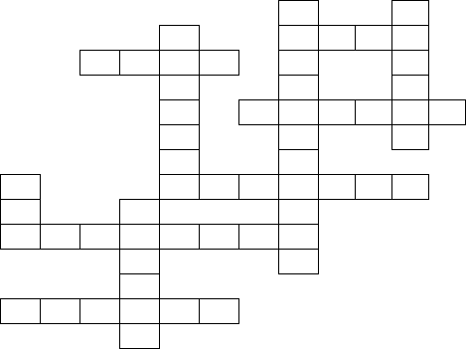
- God gave Samson a special power. He was __________
1
2
3
4
5
6
7
8
9
10
11

