CSSA STAGE 2 JUNIOR #6 NAME ___________________________________

The New Leader

Multiple Choice: Circle ALL the Correct Answers!

1. Joshua was a man of great:
a) courage b) faith c) wisdom d) experience

2. Joshua was to teach the people to:
a) obey God b) farm
c) love God d) write in Hebrew

3. Before entering the promised land, the people were camped:
a) at Shittim b) east of the River Jordan
c) in the forest d) opposite Jericho

4. We must be like Joshua and:
a) read the Bible every day b) trust in God
c) have faith d) go camping

Short Answer

5. What was Joshua commanded to read every day? ___________________________________

6. In your own words, what did God say to Joshua to encourage him in his new work as leader?

____________________________________________________________________________

____________________________________________________________________________

7. What “rule” did the lesson say should be part of our lives?
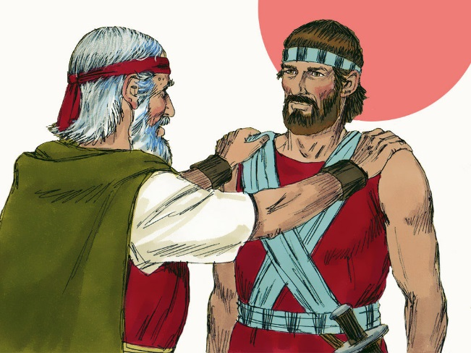
_____________________________________________

_____________________________________________

8. How many days were the Israelites commanded to prepare themselves before crossing into the promised land?

_____________________________________________

9. What were the people preparing to do once they were in the promised land?

_____________________________________________

____________________________________________________________________________

True or False

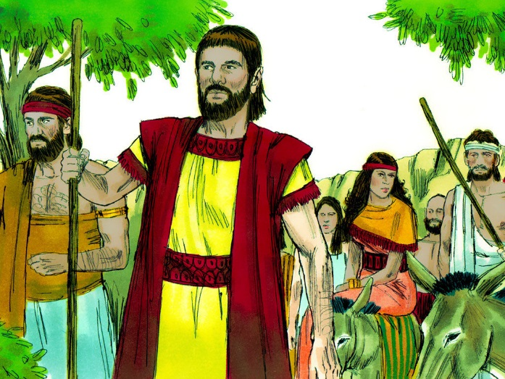
_____ 10. The children of Israel were now done wandering in the wilderness.

_____ 11. Joshua had at one time led Israel into battle against the Amalekites.

_____ 12. Joshua was Moses’ helper for only half of the wilderness wanderings.

_____ 13. Caleb was to be the new leader.

_____ 14. If Joshua thought on God’s law every day and night, he would not fail.

Fill in the Blanks

15. Not long before he died, _______________, was told by God that _______________ was the man to lead Israel into the Promised land.

16. Joshua was brought before ____________________ the High Priest and all the ___________ and told he was the new leader.

17. “Be ________________ and of good ___________________.”

18. God’s word is “able to make us ________________ unto _________________ through

___________________ which is in Christ Jesus.”

19. Faith means _____________________.

Thought Question

20. How can reading the Bible every day help us in our daily lives?


















