CSSA STAGE 2 JUNIOR #10 NAME ___________________________________

Joshua Overcomes the South

Multiple Choice: Circle ALL the Correct Answers!

1. The people of Gibeon:
a) realized Joshua would attack their city b) went out to meet Joshua in battle
c) planned to trick Joshua & the Israelites d) said they were from a far away country

2. As part of their trick, the Gibeonites:
a) dressed in old ragged clothes b) carried dry, moldy bread
c) shaved their heads d) had worn out shoes and sacks

3. As Joshua moved south in the land of Canaan:
a) he took Gibeonites with him b) he lost many battles
c) he was successful in conquering it d) 5 southern kings gathered to defeat Israel

4. Adoni-zedek:
a) was king of Jerusalem b) decided to attack Gibeon
c) was leader of the five kings of the south d) was a city in southern Canaan

5. Which things helped Joshua defeat the five kings of the south?
a) the sun was in their eyes b) God sent a great hail storm
c) Joshua had a lot of chariots d) God caused the sun to stand still

Short Answer

6. What did the men of Gibeon say when Joshua asked them where they were from? __________

____________________________________________________________________________

7. Why was it a mistake that Joshua made an agreement of friendship with the Gibeonites? _____

____________________________________________________________________________

8. What punishment did the Gibeonites get for tricking Joshua and the Israelites? _____________

____________________________________________________________________________
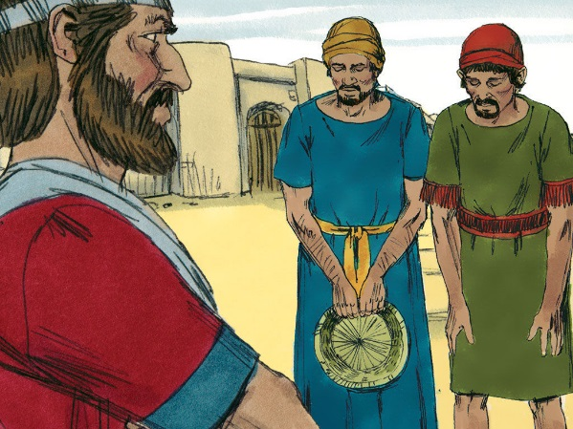
9. What did Joshua do first when the Gibeonites sent to him for help?
_____________________________________________

_____________________________________________

10. Why did Joshua pray for God to make the sun stand still?

_____________________________________________

_____________________________________________

True or False

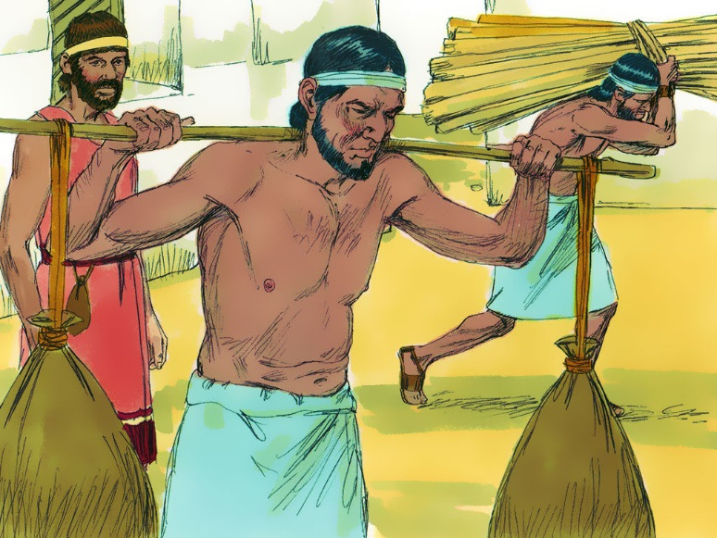
_____ 11. The Gibeonites wanted to attack the Israelites.

_____ 12. Joshua believed the men of Gibeon were from a far away country.

_____ 13. Once Joshua knew he was tricked he broke his promise.

_____ 14. Adoni-zedek was the king of Jerusalem.

_____ 15. The sun did not go down for about a whole day.

Fill in the Blanks

16. After Ai had been left in ruins, Joshua led the people into the ___________________ part of the land.

17. Joshua had been commanded that he was not to make any ______________________ with the people of Canaan.

18. “Fear them not, for I have delivered them into thine _________________, there shall not a

_______________ of them stand before thee.”

19. The Gibeonites became hewers of ________________ and drawers of _________________
for the Israelites.

Thought Question

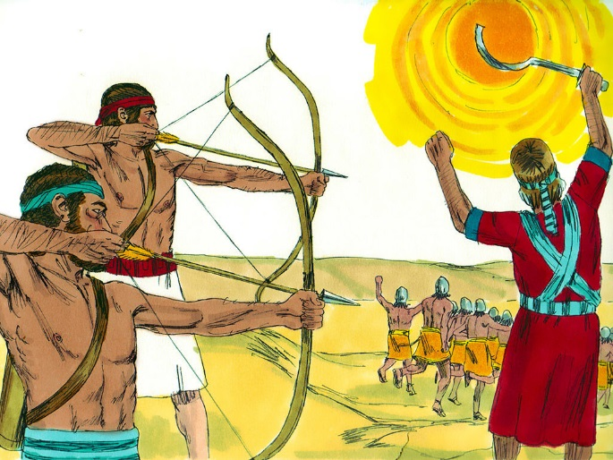
20. What does this lesson teach us about our thoughts?

___________________________________________

___________________________________________

___________________________________________

___________________________________________

___________________________________________

___________________________________________

___________________________________________

